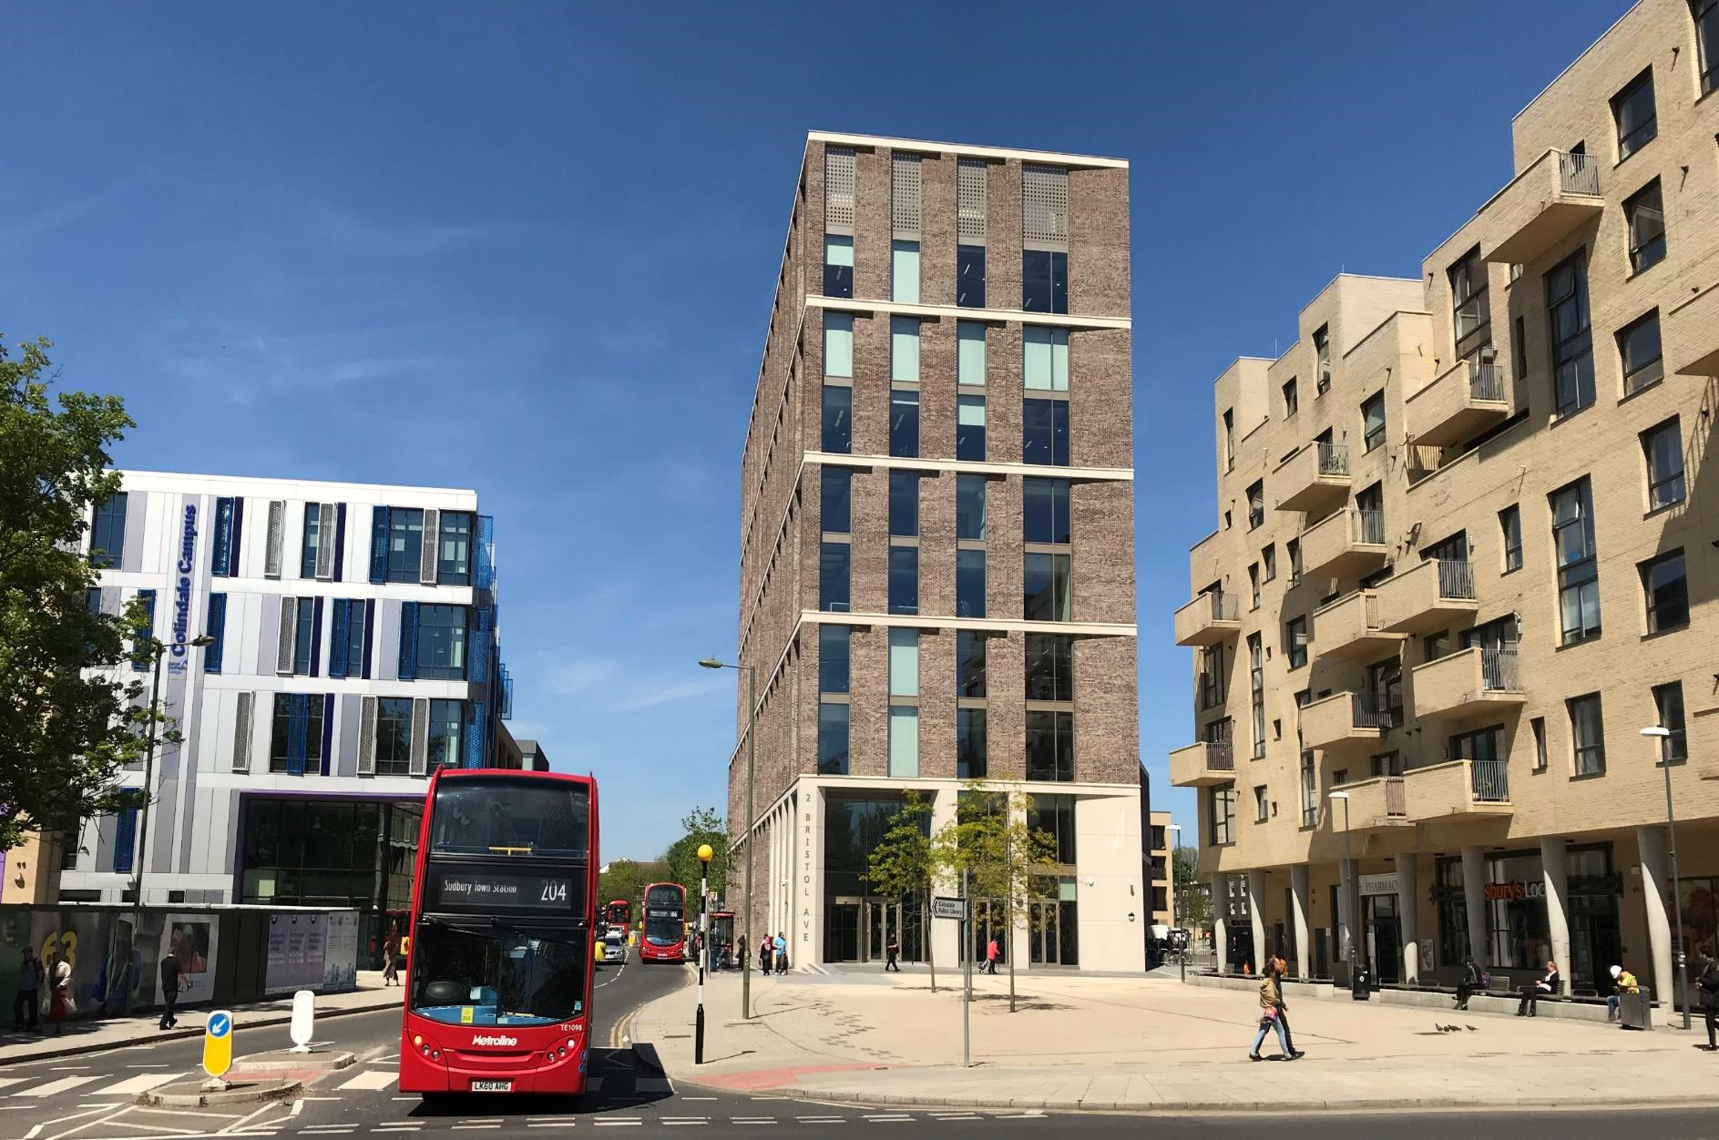
a
Temporary Traffic Order Application Form
Requests to be sent to ttro@barnet.gov.uk
Applicant Details
Date of Application: |  |  | Utility Promoter:  Highway Promoter:
Works Promoter Name: |  |  | Applicant Name:
Contact Email Address: |  |  | Contact Telephone No:
Postal Address:

Work Details
Permit Works Reference:

Street Name and Postcode:

Street Location: |  |  | USRN:
Description of Works:

Prohibition/Restriction
Prohibition/Restriction required: |  |  | Description/extent:
Date from: |  |  | Date to:
Diversion route (in event of pedestrian or vehicular diversion):

NB: Restrictions include but not limited to: No waiting and loading; road closure; diversion of traffic into a bus lane during hours of operation; closure of a footway where an alternative is not available; closure of a public right of way.
Traffic Management Plan provided: Y / N

Diversion plan provided: Y / N

 | Stakeholder Consultation
 | Stakeholder |  | Comments (Objection/Agreement) |  |  |  | Date | Evidence sent to NRSWA
 | Emergency Services
 | Bordering authorities
 | Residents and businesses (Letter drop)
 | Payment Details (Please select)
 | TTRO Application Type |  |  |  |  | Charge
 | Section 14 (1) – Planned Works |  |  |  |  | £2,173.65
 | Section 14 (2) – Emergency Works |  |  |  |  | £1,783.18
 | Section 16 – Special Event |  |  |  |  | £220.24
 | NB: Payments are to be made by phoning the Technical Officer to process your payment through Pay.Net
 | Signature: |  |  |  |  | Date:

We require a minimum of 6 weeks from the date the completed form, plans and payment of £2,173.65 s14(1) or £1,783.18 s14(2) are received to complete the necessary legal procedures.
Your application will not be processed until all these are received.

If your works are postponed, London Borough of Barnet must be informed a minimum of 21 days before your operational date for the fee to be refunded.

IT IS THE APPLICANTS RESPONSIBILITY TO INFORM ALL RESIDENTS AND BUSINESSES THAT MAY BE AFFECTED BY THE WORKS / EVENT

