London Borough of Barnet
East Finchley Ward
from 5 May 2022

Polling Districts and Polling Places
EFA: Green Man Community Centre EFB: St Mary's Catholic Church Hall EFC: Bishop Douglass RC High School EFD: Finchley Youth Centre

Green Man Community Centre

EFA
CGP Cttee Jan 2022

Bishop Douglass RC High School
St Mary's
Catholic Church Hall

EFB

EFC

EFD

Finchley Youth Centre
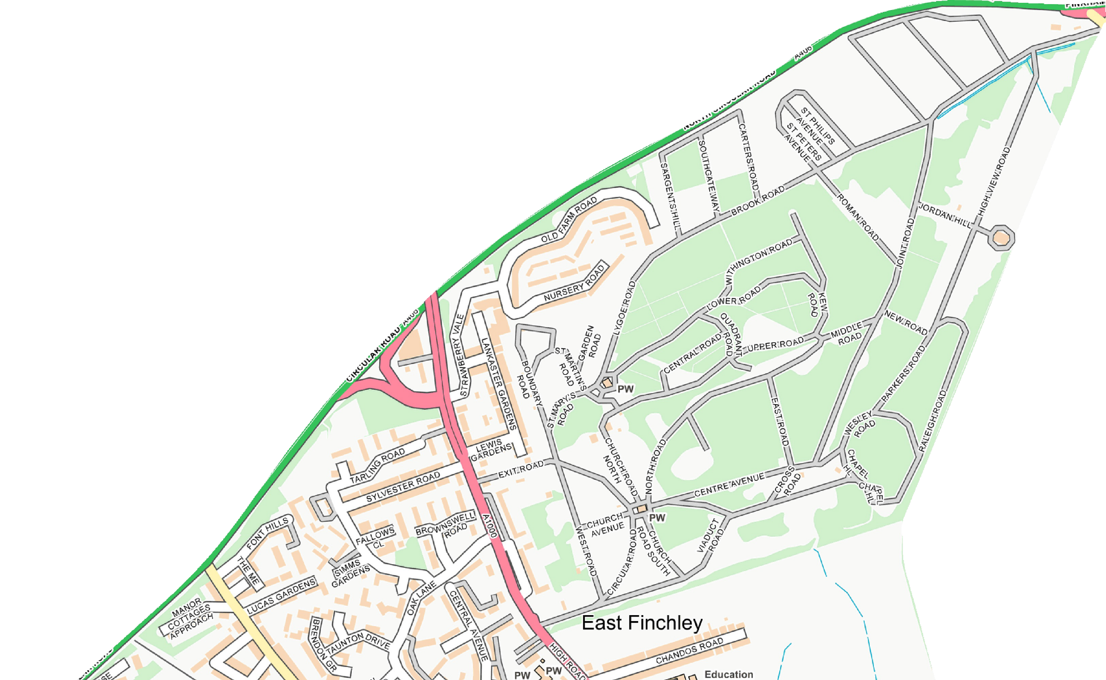
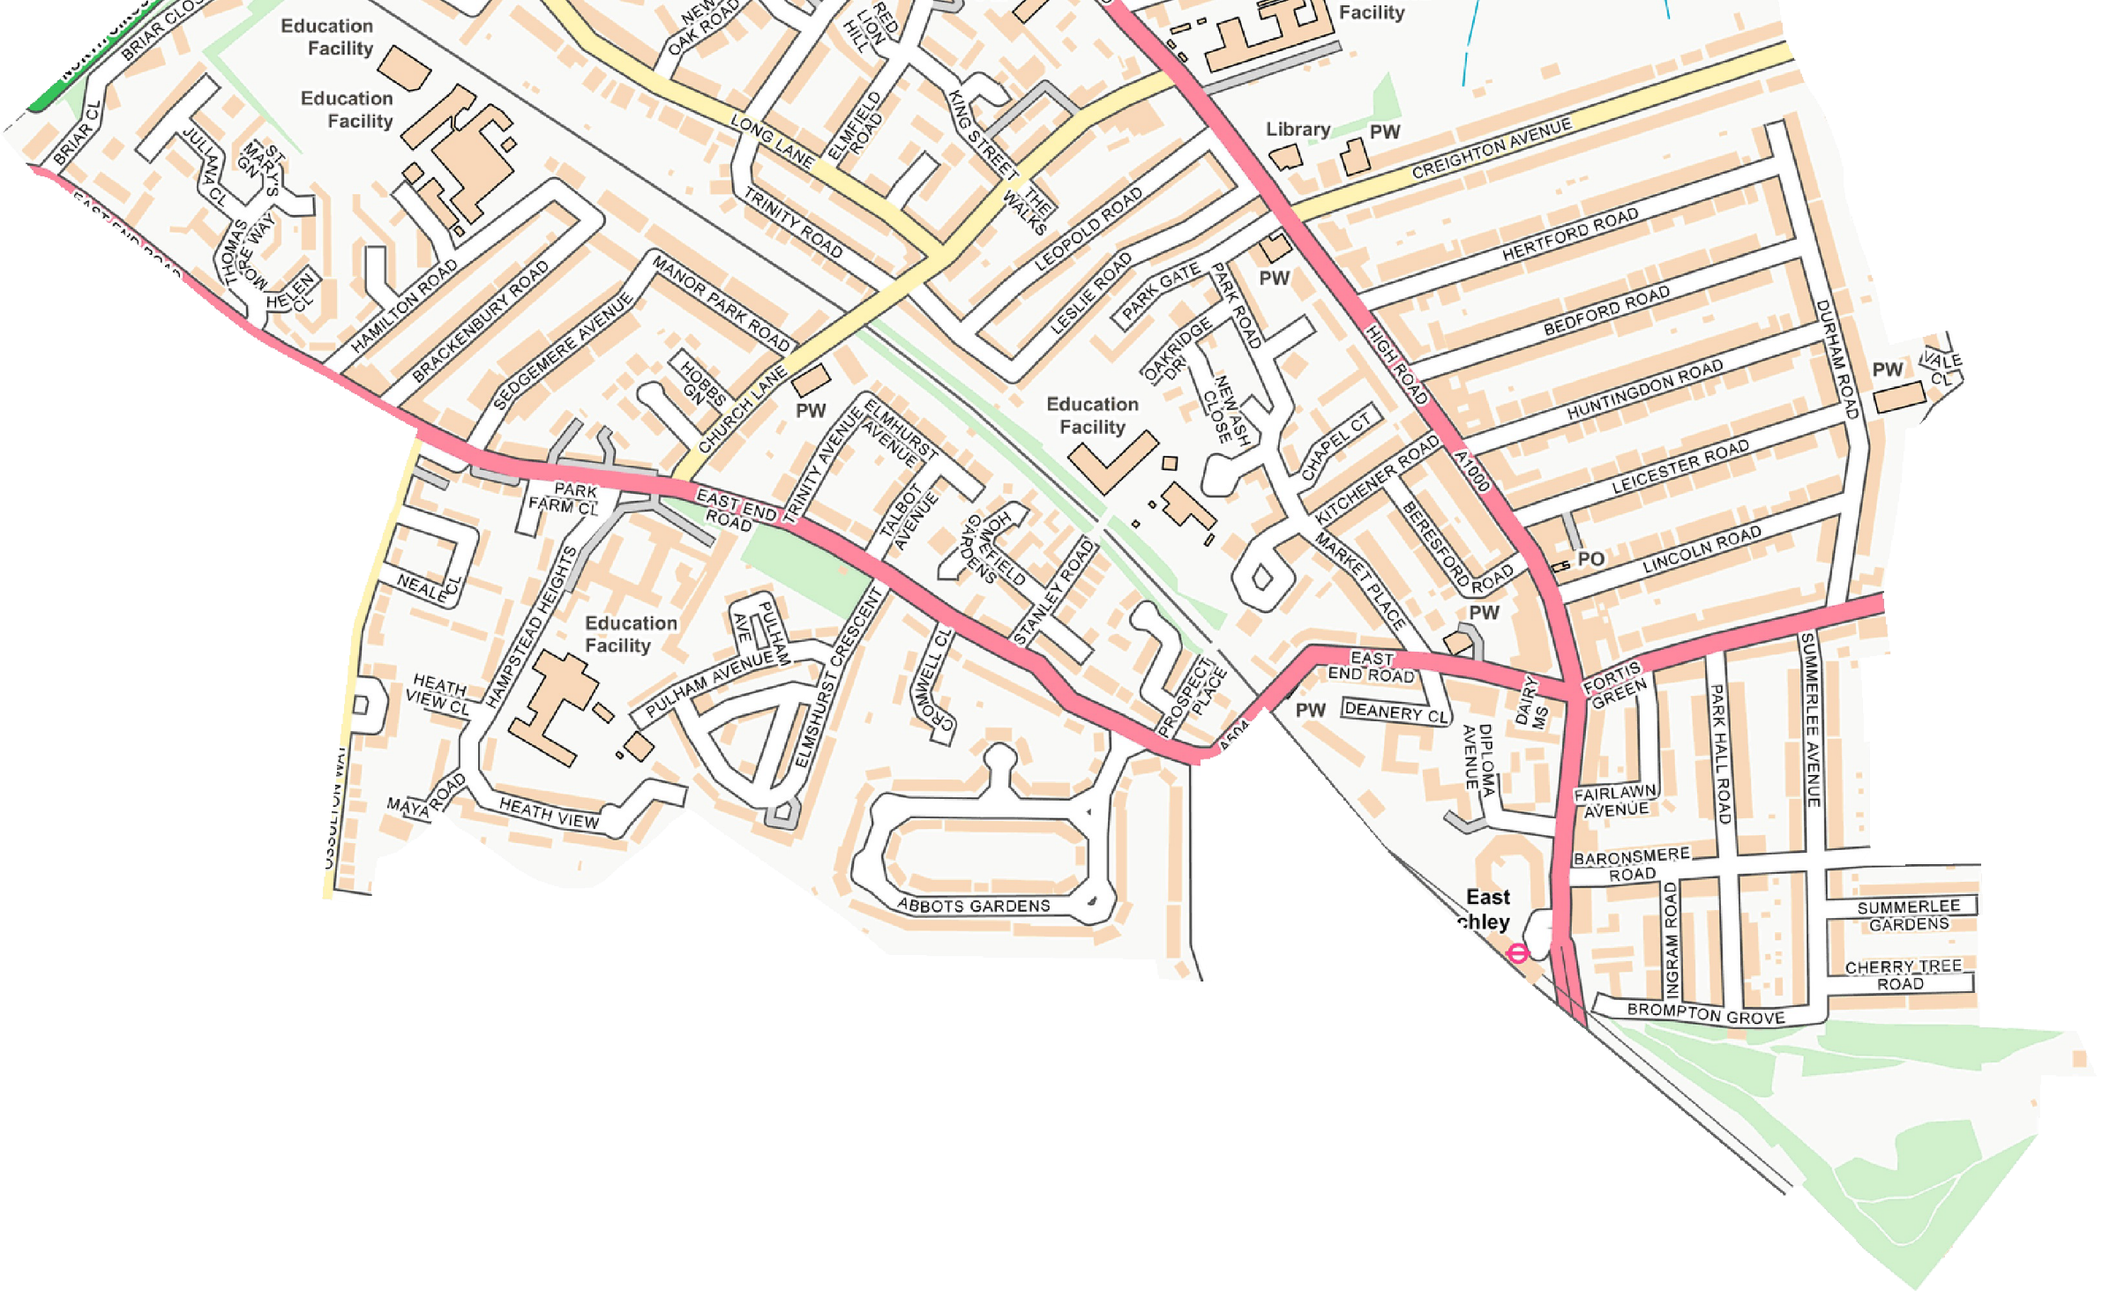
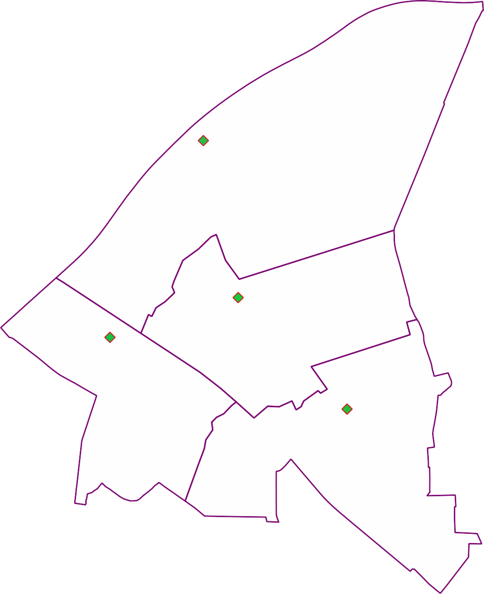

© Crown copyright and database rights 2021 OS 100071674. You are permitted to use this data solely to enable you to respond to, or interact with, the organisation that provided you with the data. You are not permitted to copy, sub-licence, distribute or sell any of this data to third parties in any form.

