London Borough of Barnet
Edgware Ward
from 5 May 2022

Polling Districts and Polling Places
EGA: One Stonegrove Community Centre EGB: Edgware Parish Hall
EGC: Baden Powell Hall at John Keble Church

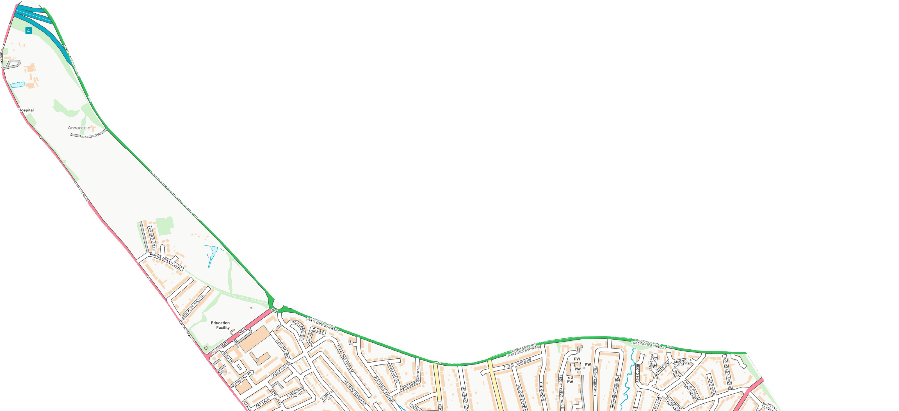
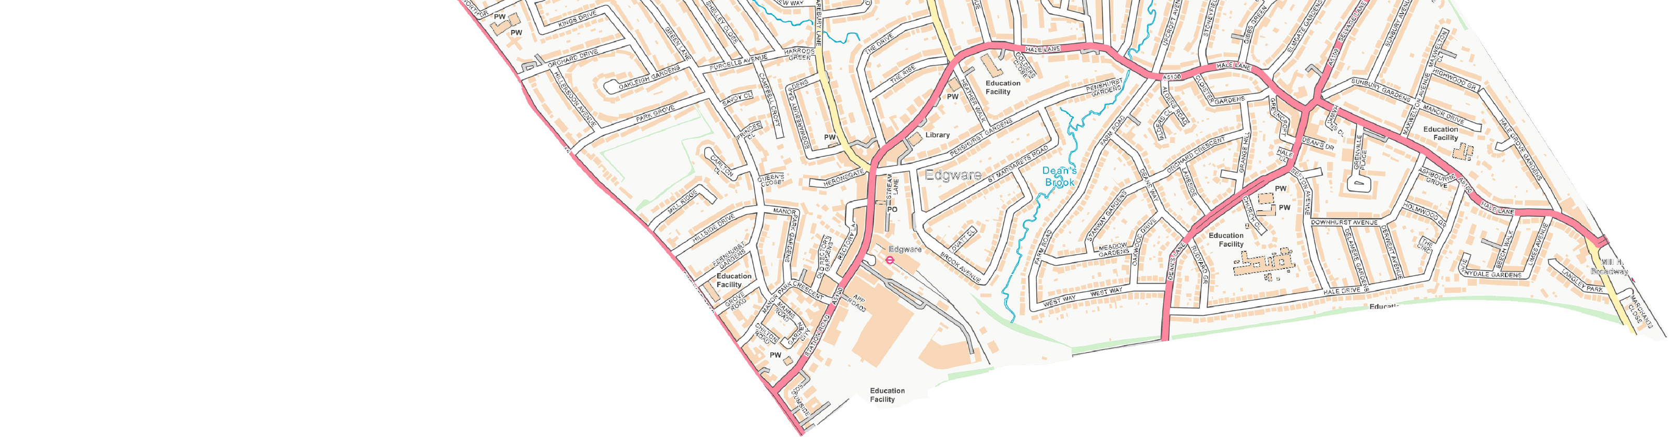
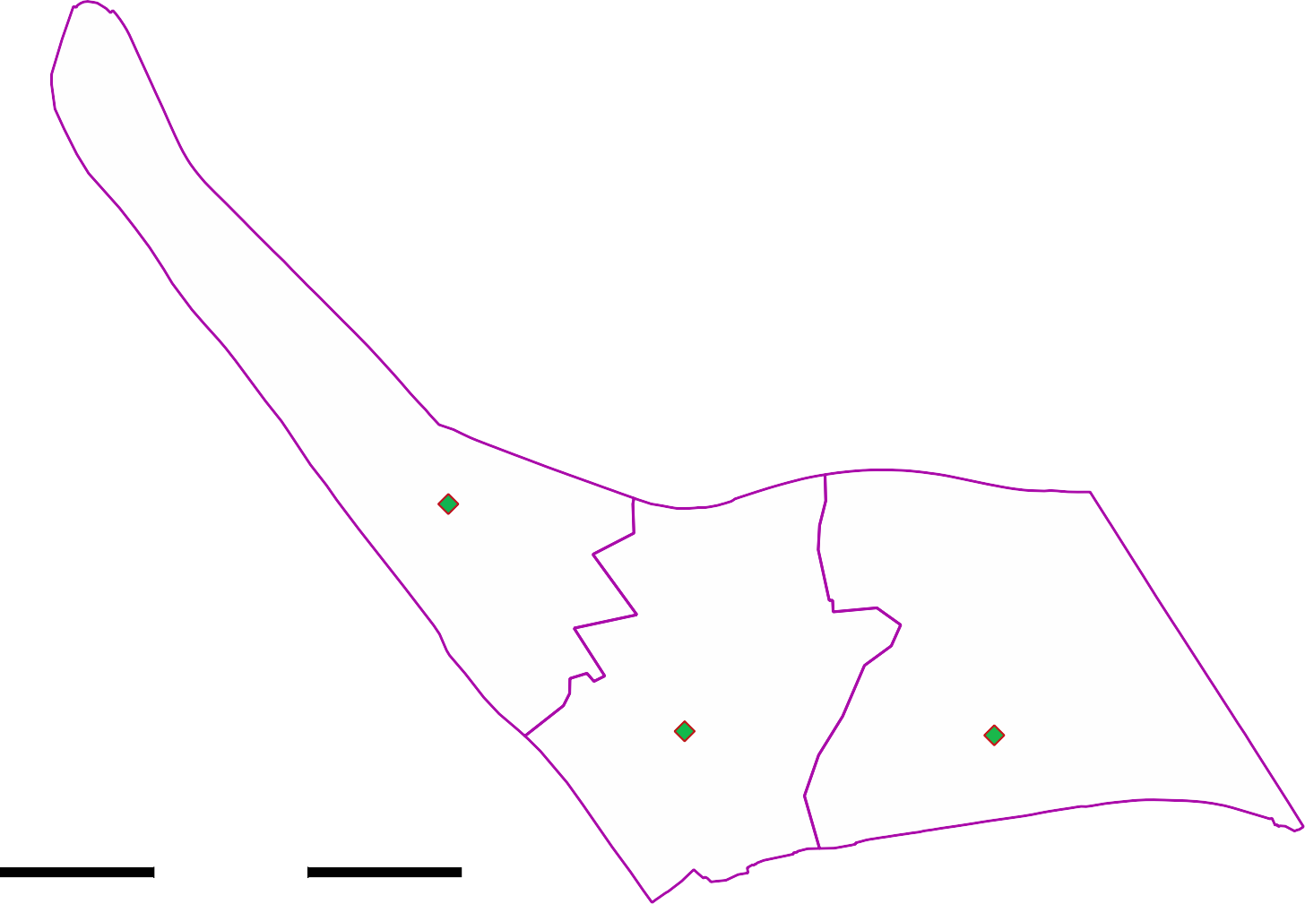

CGP Cttee Jan 2022

© Crown copyright and database rights 2021 OS 100071674. You are permitted to use this data solely to enable you to respond to, or interact with, the organisation that provided you with the data. You are not permitted to copy, sub- licence, distribute or sell any of this data to third parties in any form.
One Stonegrove Community Centre

EGA

EGC
Edgware Parish Hall

EGB
Baden Powell Hall John Keble Church

