London Borough of Barnet
Finchley Church End Ward
from 5 May 2022

Polling Districts and Polling Places
FCA: Function Room at Hendon Crematorium FCB: St Margaret's United Reformed Church FCC: St Phillip the Apostle Parish Centre FCD: Avenue House
FCE: Finchley Baptist Church Hall FCF: Finchley Synagogue

Function Room
at Hendon Crematorium

FCC
FCB

St Margaret's United Reformed Church
CGP Cttee Jan 2022

FCA

St Philip the Apostle
Parish Centre
FCD
Avenue House
Stephen House & Gardens

Finchley Baptist Church Hall

FCE
FCF

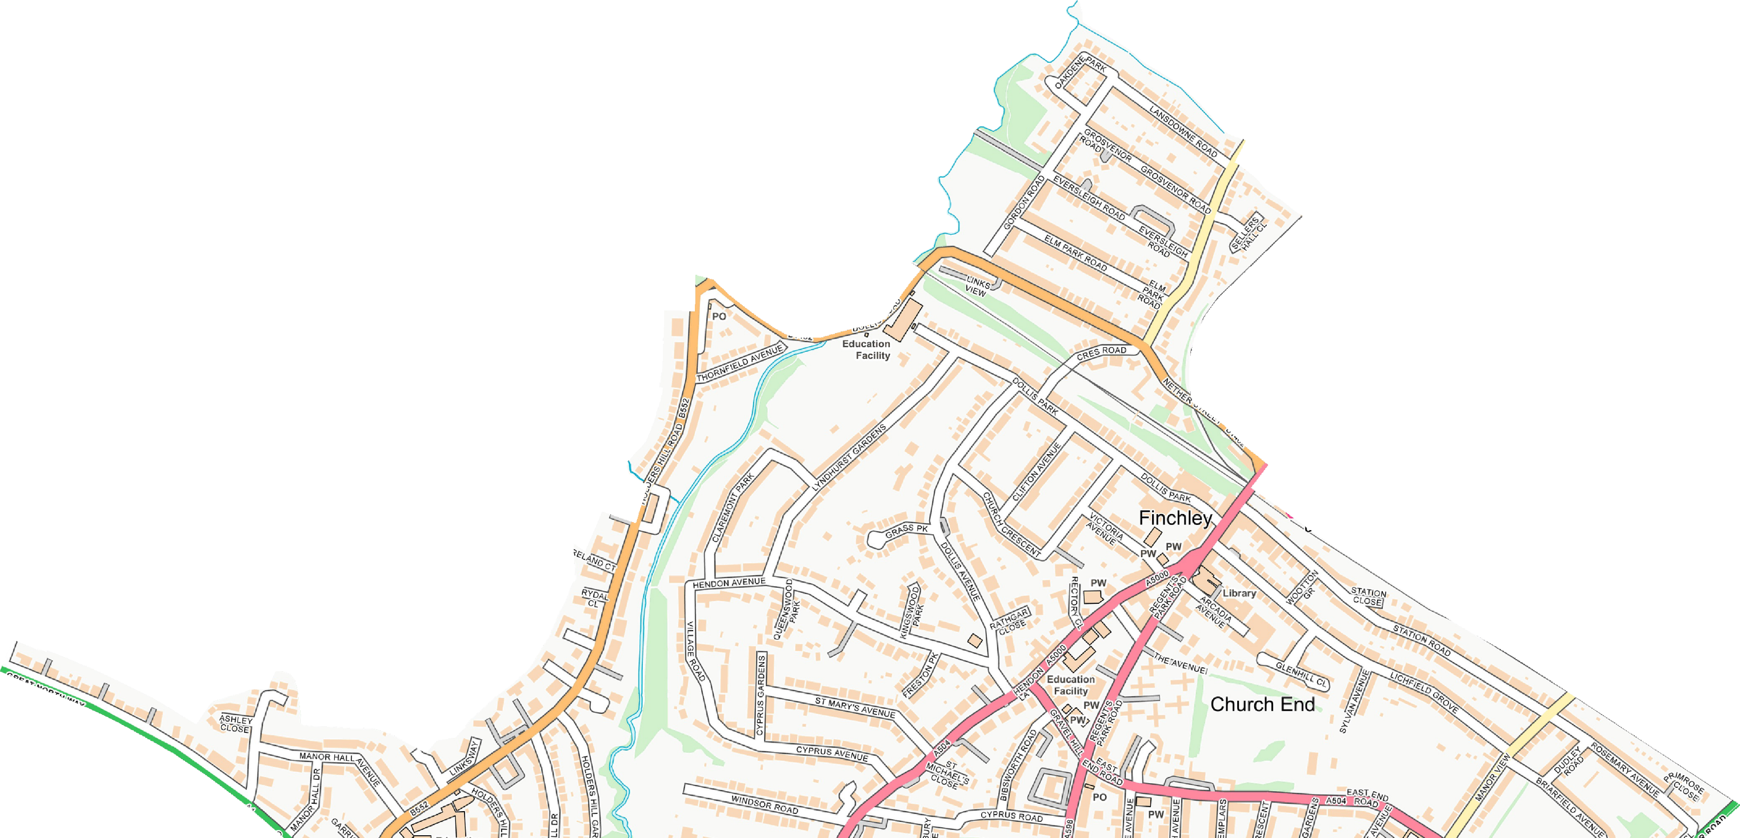
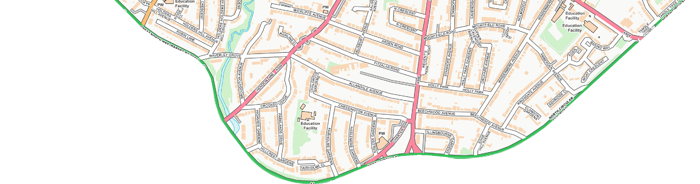
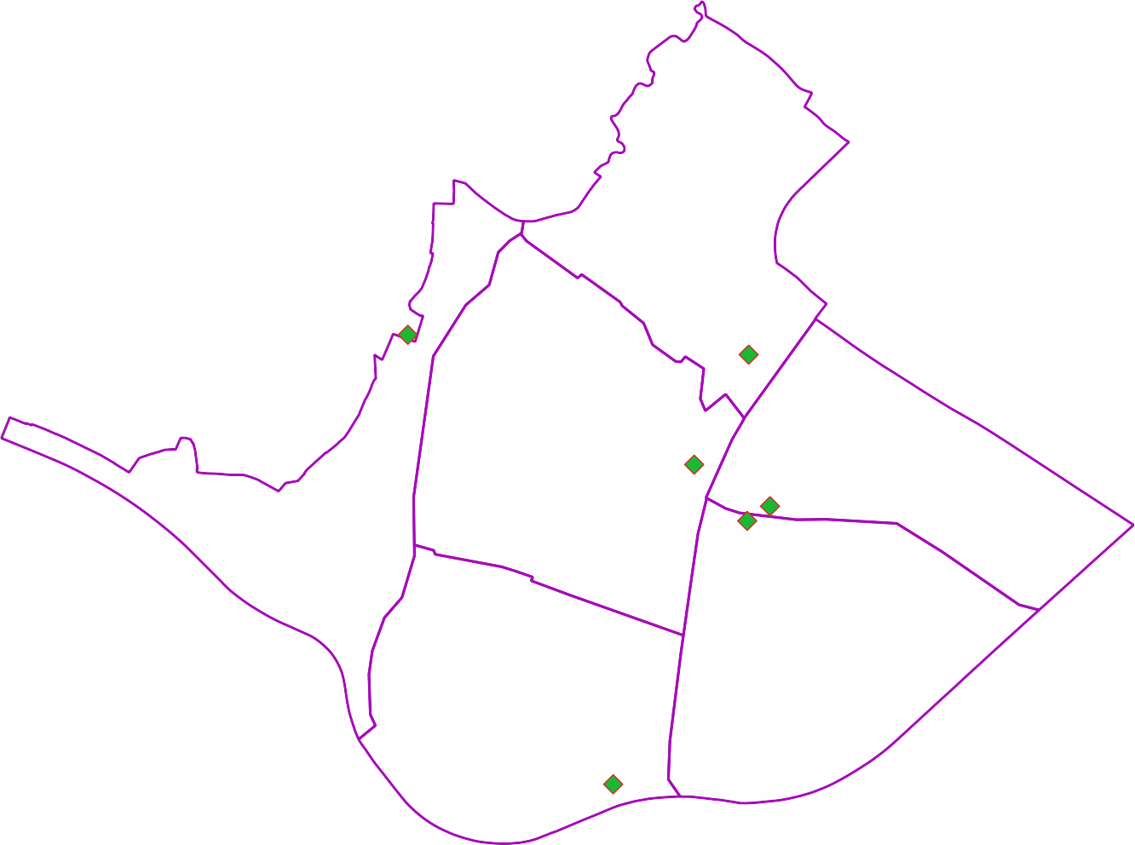
© Crown copyright and database rights 2021 OS 100071674. You are permitted to use this data solely to enable you to respond to, or interact with, the organisation that provided you with the data. You are not permitted to copy, sub-licence, distribute or sell any of this data to third parties in any form.
Finchley Synagogue Kinloss Gardens

