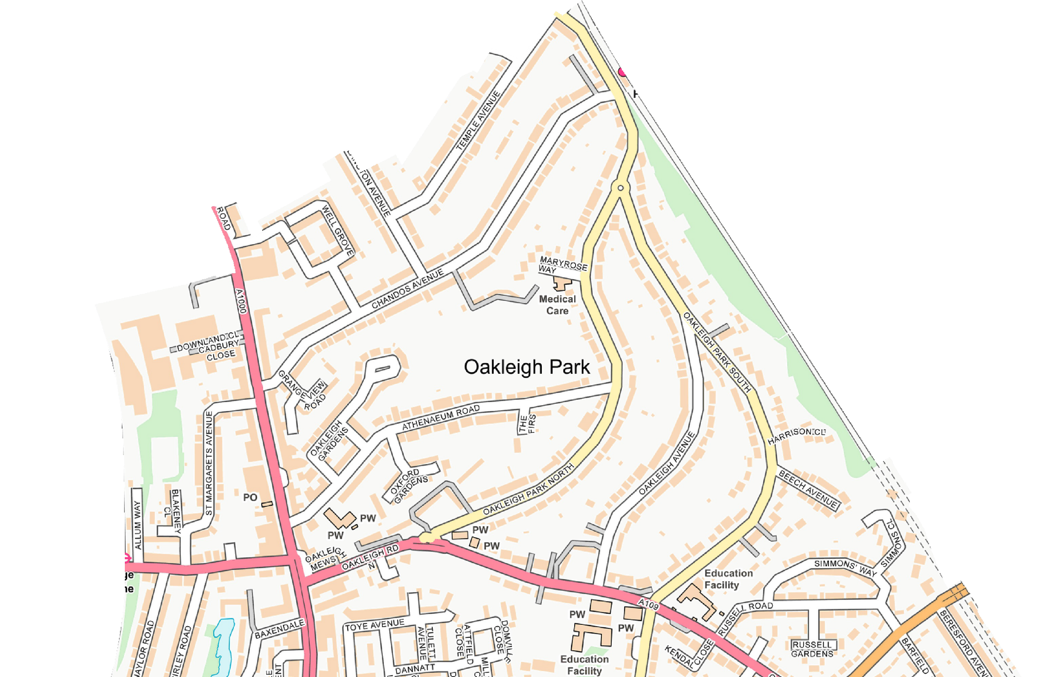
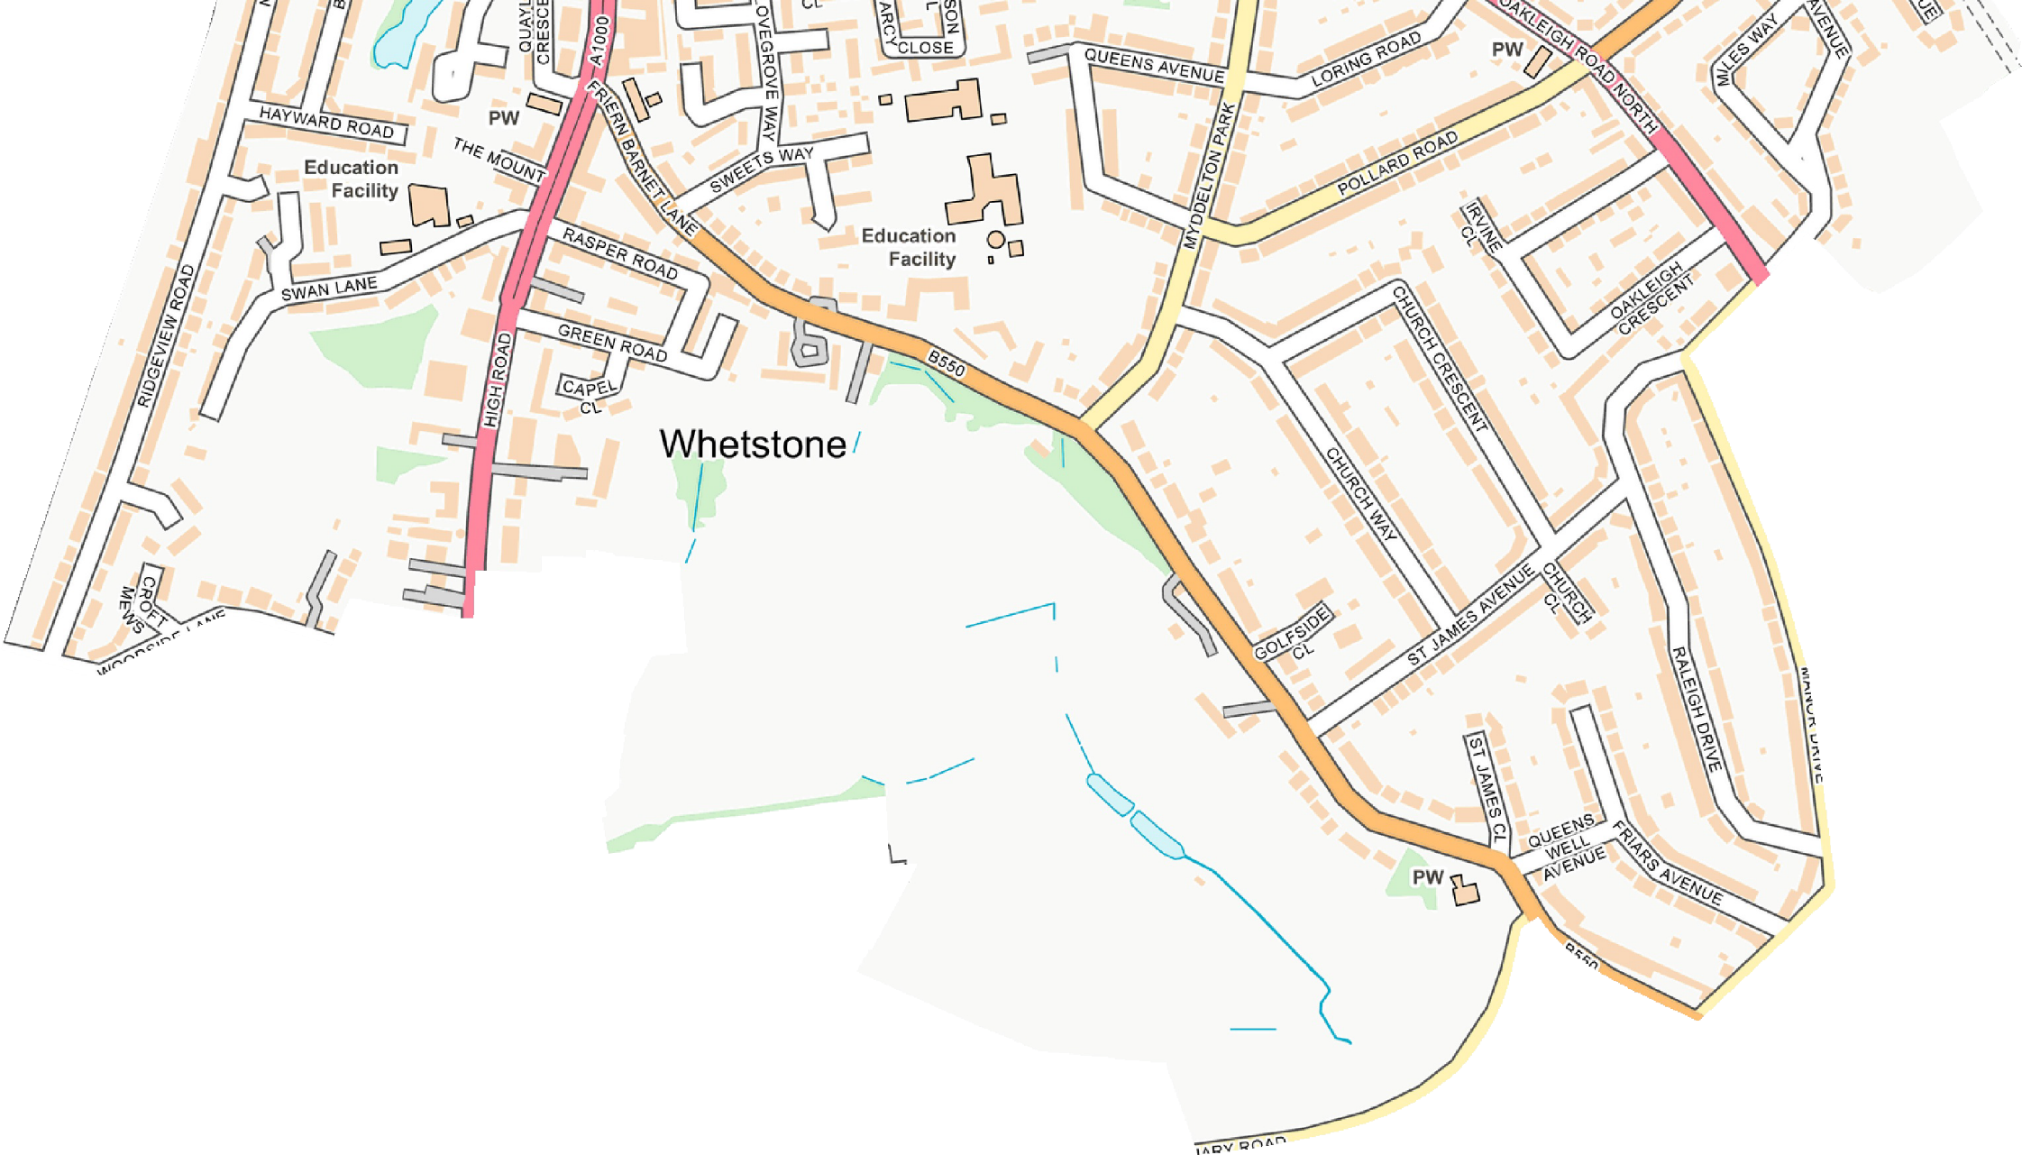
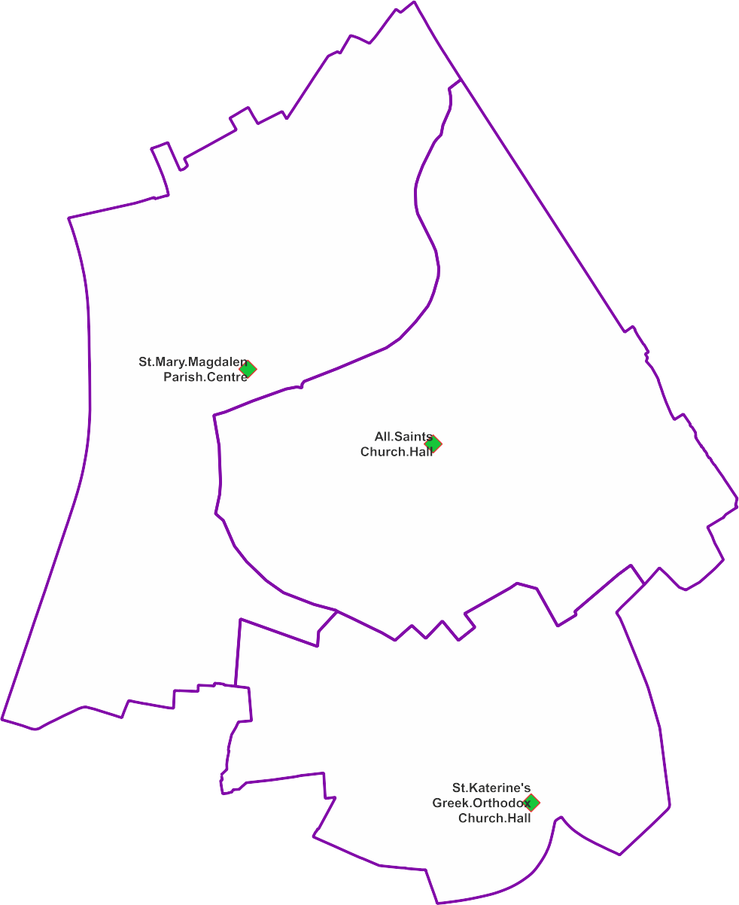
London Borough of Barnet
Whetstone Ward
from 5 May 2022

Polling Districts and Polling Places
WSA: St Mary Magdalen Parish Centre WSB: All Saints Church Hall
WSC: St Katerine's Greek Orthodox Church Hall

WSA

WSB

WSC
FC Jan 2022

© Crown copyright and database rights 2021 OS 100071674. You are permitted to use this data solely to enable you to respond to, or interact with, the organisation that provided you with the data. You are not permitted to copy, sub-licence, distribute or sell any of this data to third parties in any form.

