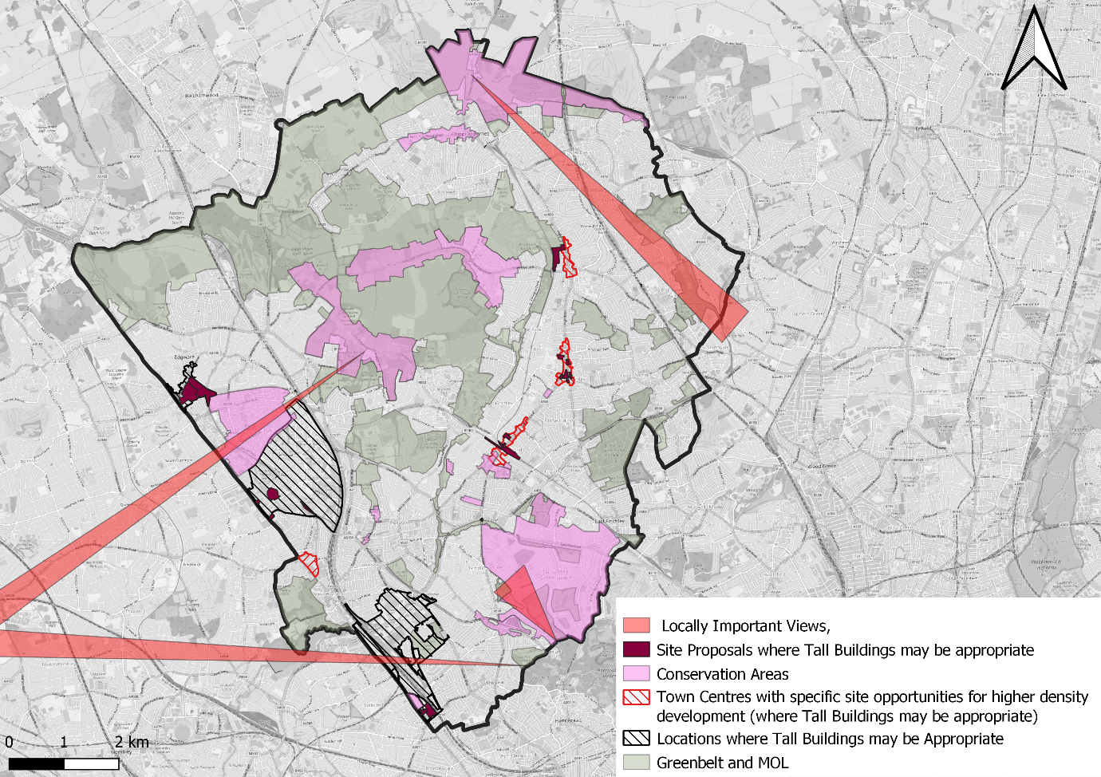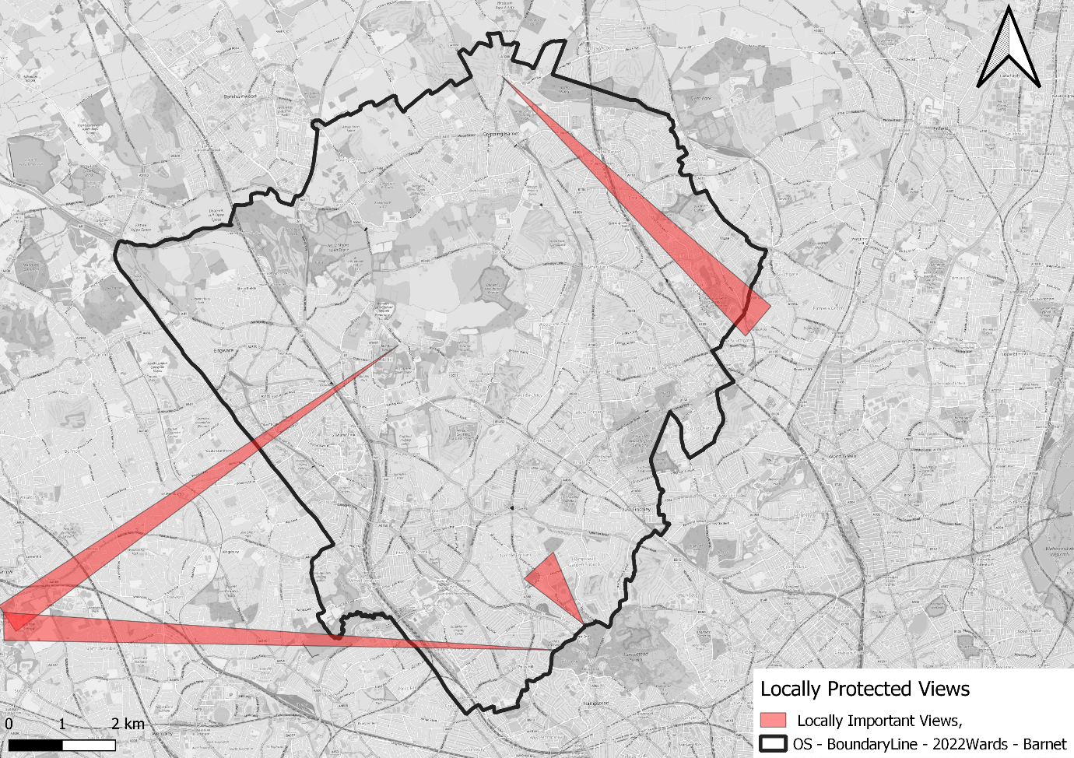
Changes to the (Reg 19) Policies Map arising from Proposed Main Modifications to the Local Plan

April 2024

Contents
1 Introduction 1
2 Changes to the Policies Map 2
3 Mapping Additions 7
3.1 Public Open Spaces 7
3.2 Site Proposals 8
3.3 Local Centres 8
3.4 Safeguarding Crossrail 2 9
3.5 Growth Areas and Mill Hill East Area 11
3.6 Flood RiskMap 12
3.7 Locally Important Views 13
4 Mapping Amendments 14
4.1 Green Belt 14
Map 8- Watling Street, 1km south of Elstree 15
Map 9 – Land Northeast of Brockley Crescent, Edgwarebury 16
Map 10 - Land to Rear of 14-28 Brockley Crescent, Edgwarebury 17
Map 11 – Watling Street and Spur Road, Edgwarebury 18
Map 12– M1 Near Moat Mount 19
Map 13– Highwood Hill and Marsh Lane, Mill Hill 20
Map 14 – Lawrence Street, Mill Hill 21
Map 15 – Milespit Hill, Mill Hill 22
Map 16 – Firth Lane, Mill Hill 23
Map 17– Brett Road, Chipping Barnet 24
Map 18 – Rowley Green Road, Arkley 25
Map 19 - M1 at Junction 4 (Edgware Way), Elstree 26
Map 20 – Edgware Way at Watling Street, Elstree 27
Map 21 – Jewish Community Secondary School, Westbrook Crescent, New Barnet 28
4.2 Metropolitan Open Land (MOL) 29
Map 22 – Jewish Community Secondary School (1) 30
Map 23 – Jewish Community Secondary School (2) 31
Map 24 – New Southgate Cemetery and Recreation Ground 32
Map 25 – Whetstone Stray 33
Map 26 – Finchley Catholic School Sportsfields 34
Map 27 – Friern Barnet Retail Park Open Space (1) 35
Map 28 - Friern Barnet Retail Park Open Space (2) 36
Map 29 - Friern Barnet Retail Park Open Space (3) 37
Map 30 - Friern Barnet Retail Park Open Space (4) 38
Map 31 - Friern Barnet Retail Park Open Space (5) 39
Map 32 – Colney Hatch MOL East 40
Map 33 – Colney Hatch MOL West 41
Map 34 – Glebelands and Coppetts Woods (1) 42
Map 35 - Glebelands and Coppetts Woods (2) 43
Map 36 - Glebelands and Coppetts Woods (3) 44
Map 37 - Mutton Brook 45
Map 38 – Sunny Hill Park 46
Map 39 – Hoop Lane and West London Synagogue Cemeteries 47
Map 40 - Friern Barnet Retail Park Open Space (6) 48
4.3 Locally Significant Industrial Sites (LSIS) 49
Map 41 Connaught Business Centre 50
Map 42 Granard Business Centre 51
Map 43 Lancaster Road Industrial Estate 52
Map 44 Grenville Place – De-designation of LSIS 53
Map 45 Coppetts Centre, Colney Hatch Lane – New LSIS 54
Map 46 Propeller Way – New LSIS 55
Map 47 Hurricane Industrial Park – New LSIS 56
Map 48 Bittacy Hill Business Centre – New LSIS 57
Map 49 Falkland Road (Alston Works) New LSIS 58
4.4 Business Locations 59
Map 50 Colindale Technology Park and sites off Cecil Road - New Business Location 60
Map 51 30-100 Colindeep Lane – New Business Location 61
4.5 'Notifiable Installations' 62
Map 52 Notifiable Installations 62

Introduction

The Inspector has requested identification of any proposed and consequential changes to the Policies Map (as set out at para 1.1.5) arising from the Council’s Proposed Main Modifications to the Local Plan. All changes outlined in this document are necessary to make certain that the Plan and the Policies Map read coherently and as a whole would ensure that the relevant policies are justified and effective.

The National Planning Policy Framework (NPPF) requires land-use designations and allocations to be identified on a policies map. Planning Practice Guidance states that the policies map should illustrate geographically the policies in the plan and be reproduced from, or based on, an Ordnance Survey map. If the adoption of a local plan would result in changes to a previously adopted policies map, when the Plan is submitted for examination, an up to date submission policies map should also be submitted, showing how the adopted policies map would be changed as a result of the new plan.

In accordance with the requirements above, this document sets out the proposed additions, amendments and deletions from the Policies Map produced for the Unitary Development Plan (UDP) (2006) and subsequent changes shown in Barnet’s Local Plan (2012). It also outlines additional changes arising from the Council’s Proposed Modifications to the Local Plan.

The Policies Map produced in 2006 and subsequent changes shown in maps in the 2012 Development Plan will be superseded by a new Policies Map for the new Local Plan which will include the changes identified in this document. The new Policies Map will be available from the date the Local Plan is formally adopted.

The changes arising from the Proposed Modifications of the Plan are :
- the deletion of 7 proposal sites from the Schedule of Site Proposals,
  - Site 6 - Watling Avenue Car Park
  - Site 9 – Colindeep Lane
  - Site 10 – Douglas Bader Estate
  - Site 14 – Sainsburys – The Hyde
  - Site 32 – Manor Road Car Park
  - Site 52 – Kingmaker House
  - Site 54 – Barnet House

- Designation of Locally Important Views as shown in Local Plan Map 4 in support of Policy CDH04 – Tall Buildings.

- Clarification of boundaries of Growth Areas is reflected within the Main Modifications to the Plan. Revisions are replicated on the Policies Map
.

Changes to the Policies Map

The changes listed in the tables below include proposed additions, amendments and deletions from the existing Policies Map (2006) and subsequent changes set out in the Local Plan (2012). Those that are to be taken forward with no change are also shown at the end of this section.

Proposed Additions to the Policies Map

Proposed additions to the Policies Map | Relevant Local Plan policy (as set out in the Local Plan (Reg 19)) | Map reference
Public Open Spaces | ECC04 – Barnet’s Parks and Open Spaces | Map 1
Site Proposals | GSS01 – Delivering Sustainable Growth | Map 2
Local Centres | TOW01 Vibrant Town Centres | Map 3
Safeguarding Crossrail 2 | GSS09 – Existing and Major New Transport Infrastructure  TRC02 – Transport Infrastructure | Map 4
Growth Areas and Opportunity Areas | GSS01 – Delivering Sustainable Growth | Map 5
Flood Risk | ECC02A – Water Management | Map 6
Locally Important Views | CDH04 – Tall Buildings | Map 7

Proposed Amendments to the Policies Map

Current designation (as it appears on the 2012 Policies Map) | Proposed amendments to the designation | Map reference
Green Belt | - Watling Street 1km south of Elstree – addition  - Land northeast of Brockley Crescent, Edgwarebury - addition  - Land to rear of 14-28 Brockley Crescent, Edgwarebury – removal  - Watling Street and Spur Road, Edgwarebury - addition  - M1 near Moat Mount - addition  - Highwood Hill and Marsh Lane, Mill Hill – addition  - Lawrence Sreet, Mill Hill – removal  - Milespit Hill, Mill Hill – removal  - Firth Lane, Mill Hill – addition  - Brett Road, Chipping Barnet – addition  - Rowley Green Road, Arkley – addition  - M1 at Junction 4 (Edgware Way), Elstree – addition  - Edgware Way at Watling Street, Elstree – addition  - Jewish Community Secondary School, Westbrook Crescent New Barnet - addition | - Map 8  - Map 9  - Map 10  - Map 11  - Map 12  - Map 13  - Map 14  - Map 15  - Map 16  - Map 17  - Map 18  - Map 19  - Map 20  - Map 21
Metropolitan Open Land (MOL) | - Jewish Community Secondary School (1) – removal  - Jewish Community Secondary School (2) – removal  - New Southgate Cemetery and Recreation Ground – removal  - Whetstone Stray – addition  - Finchley Catholic School Sportsfield – addition  - Friern Barnet Retail Park Open Space (1) – removal  - Friern Barnet Retail Park Open Space (2) – removal  - Friern Barnet Retail Park Open Space (3) – addition  - Friern Barnet Retail Park Open Space (4) – addition  - Friern Barnet Retail Park Open Space (5) – removal  - Colney Hatch MOL East – removal  - Colney Hatch MOL West – addition  - Glebelands and Coppetts Woods (1) – removal  - Glebelands and Coppetts Woods (2) – addition  - Glebelands and Coppetts Woods (3) – removal  - Mutton Brook – removal  - Sunny Hill Park – removal  - Hoop Lane and West London Synagogue Cemeteries – removal  - Friern Barnet Retail Park Open Space (6) | - Map 22  - Map 23  - Map 24  - Map 25  - Map 26  - Map 27  - Map 28  - Map 29  - Map 30  - Map 31  - Map 32  - Map 33  - Map 34  - Map 35  - Map 36  - Map 37  - Map 38  - Map 39  - Map 40
LSIS | - Connaught Business Centre – amended boundary from 2012  - Granard Business Centre – amended boundary from 2012  - Lancaster Road Industrial Estate – amended boundary from 2012  - Grenville Place – deletion of LSIS  - Coppetts Centre Colney Hatch Lane – additional LSIS  - Propeller Way – additional LSIS  - Hurricane Industrial Park – additional LSIS  - Bittacy Hill Business Centre – additional LSIS  - Falkland Road (Alston Works) – additional LSIS | - Map 41  - Map 42  - Map 43  - Map 44  - Map 45  - Map 46  - Map 47  - Map 48  - Map 49
Business Location | - Colindale Technology Park and sites off Cecil Road – additional Business Location  - 30 – 100 Colindeep Lane – additional Business Location | - Map 50  - Map 51
Notifiable Installations | - Removal of Notifiable Installation at Mill Hill East | - Map 52

Proposed deletions from the Policies Map
- Co-ordinated Character
- Rail Related Employment Land
- Cricklewood Regeneration Area
- Specific UDP Proposal Site
- Rapid Transport Link
- Major Development Sites in Green Belt
- Main Retail Frontage
- Secondary Retail Frontage
- Special Advertisement Control

Layers to be taken forward from the 2012 Policies Map and 2022 North London Waste Plan with no change
- Article 4 Directive 1 and 6 (combined but no changes)
- Conservation Areas
- Archaeological Priority Areas.
- Pipeline Installations
- Metropolitan Walks (Strategic Walking Network)
- Green Chains
- Local Nature Reserve
- Sites of Borough Importance for Nature Conservation (SINC)
- Sites of Local Importance for Nature Conservation (SINC)
- Sites of Metropolitan Importance for Nature Conservation (SINC)
- Site of Special Scientific Interest (SSSI)
- Major and District Town Centres
- Primary Retail Frontage
- Safeguarded Waste Sites (North London Waste Plan 2022)
- Road Network (M1, GLA, Tier 2 and Tier 3)

Mapping Additions

Public Open Spaces

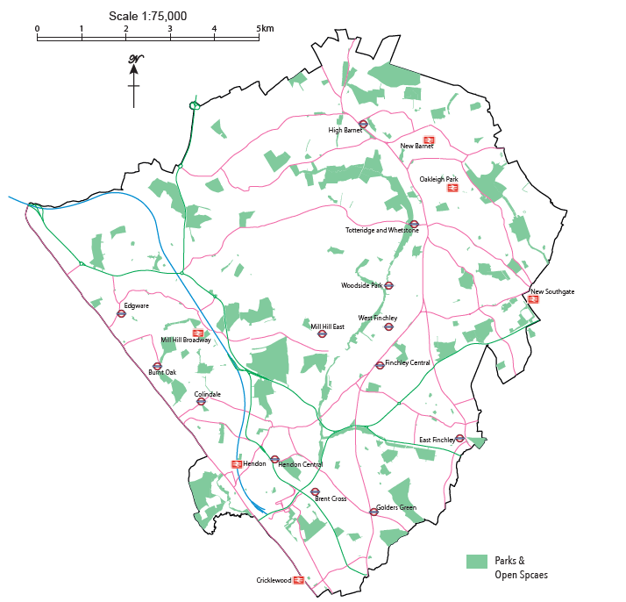
The Public Open Spaces set out in Map 1 are those set out in Barnet’s Parks and Open Spaces Strategy (2016-2026). These have not previously been shown on the Policies Map.
Public Open Spaces Map 1
N

Site Proposals

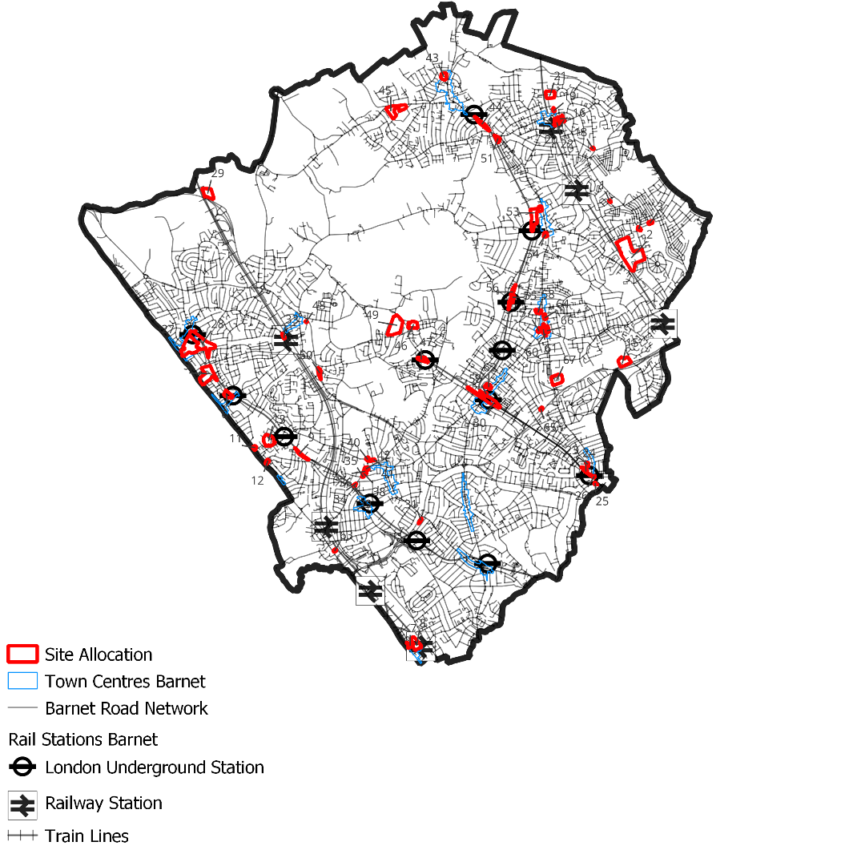
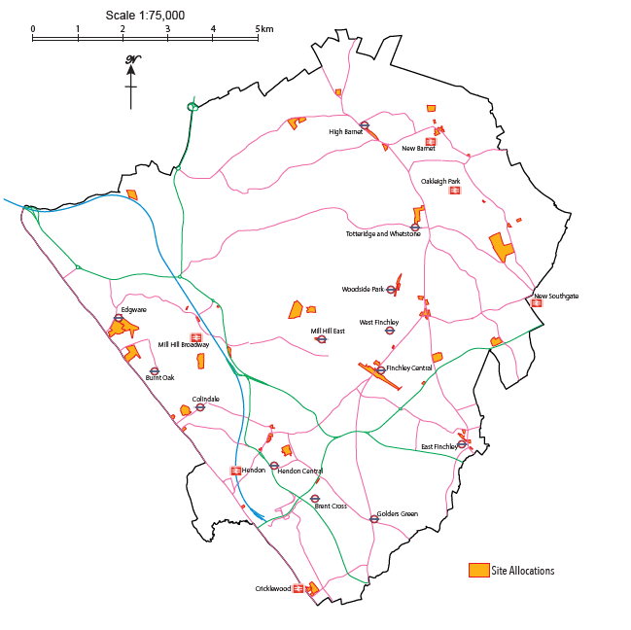
Map 2 shows all 58 sites identified in the Local Plan Schedule of Proposals (Annex 1) as part of the Proposed Modifications to the Plan. The Council proposes to remove 7 proposal sites from the Reg 19 Schedule of Proposals as part of the Proposed Modifications to the Plan. In addition to being depicted on the Policies Map individual site boundaries are shown in Annex 1 of the Plan and the Borough Sites Map (also in Annex 1).
Site Proposals Map 2

Local Centres

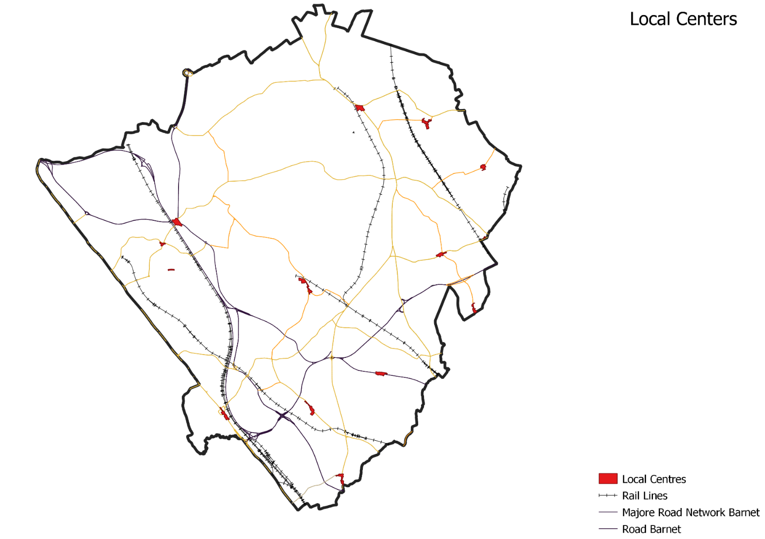
Barnet’s Local Centres are set out in Map 3. These were not previously shown on the Policies Map but rather as a list of addresses in Appendix 6 of the Local Plan Development Management Policies Document (2012).
Local Centres
Map 3

Safeguarding Crossrail 2

The Crossrail 2 Safeguard boundary is set out in Map 4. The Safeguarding Direction issued by the Department for Transport in March 2015 require local planning authorities to consult Transport for London on planning applications within the boundaries shown on the safeguarding plans before granting planning approval.
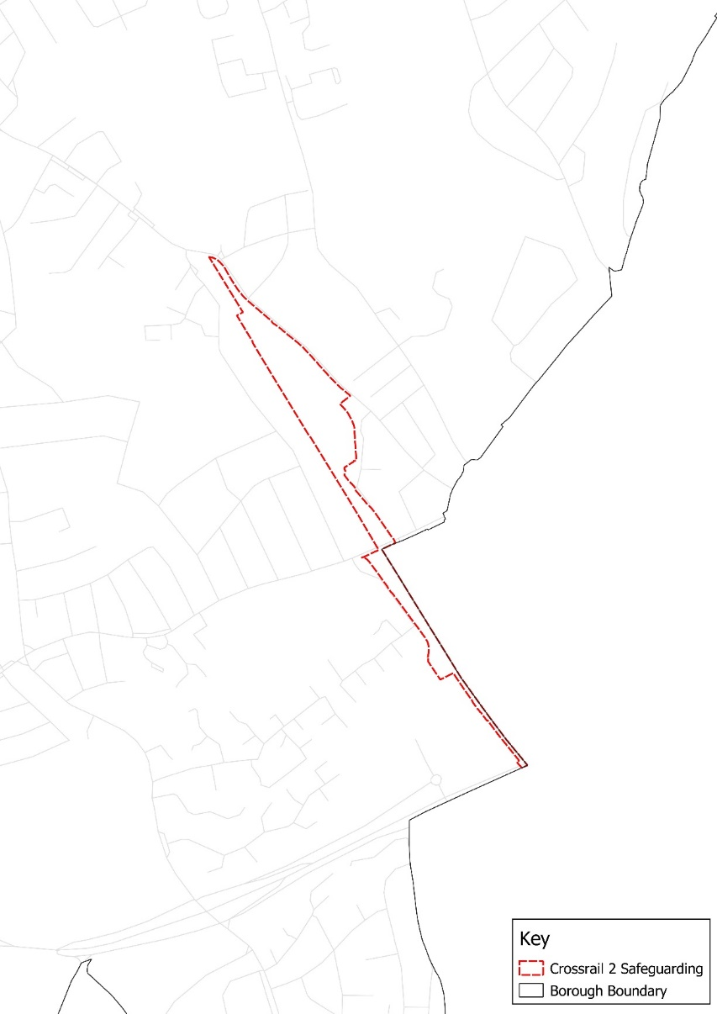
N
Safeguarding Crossrail 2 Map 4
Not to scale

Growth Areas and Mill Hill East Area

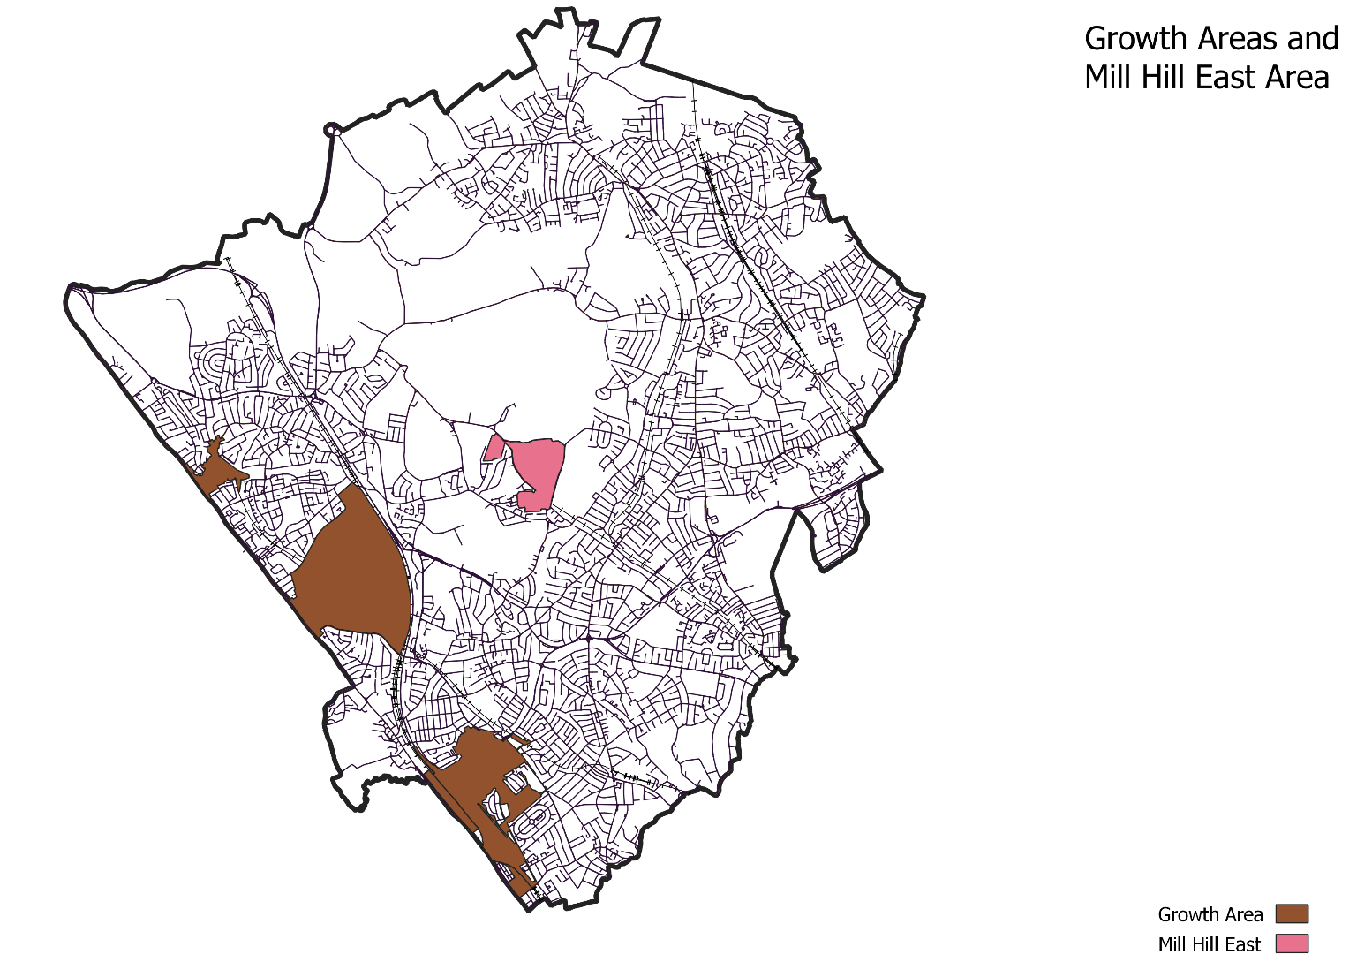
The Policies Map sets out Barnet’s Growth Areas while the Key Diagram outlines the extent of Opportunity Areas for Brent Cross – Cricklewood and Colindale while depicting the New Southgate Opportunity Area with a symbol. The relationship between Opportunity Areas and Growth Areas is explained in the Local Plan. Barnet’s Growth Areas are depicted individually within the Plan and on the Policies Map. The area of Mill Hill East (although not a Growth Area) is shown in the same way. Map 5 shows the Growth Areas and the Mill Hill East Area.
Map 5

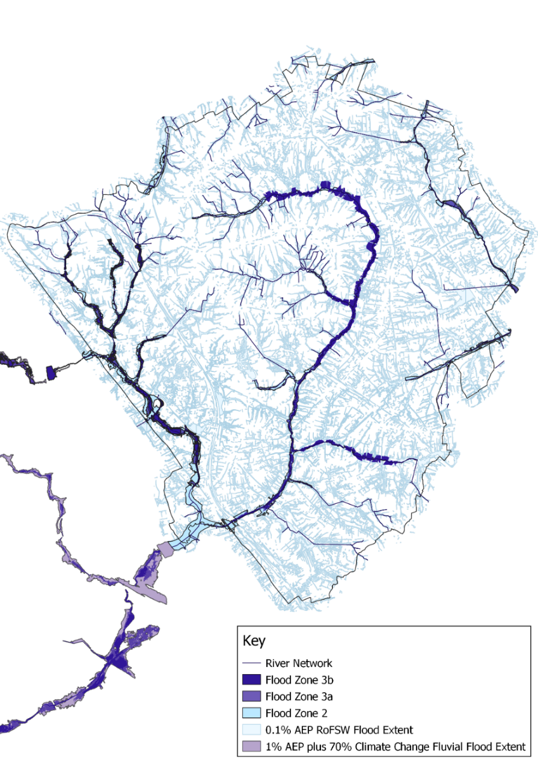
Flood RiskMap

Map 6 sets out the flood risk in Barnet.
N
Flood Risk Map 6
Not to scale

Locally Important Views

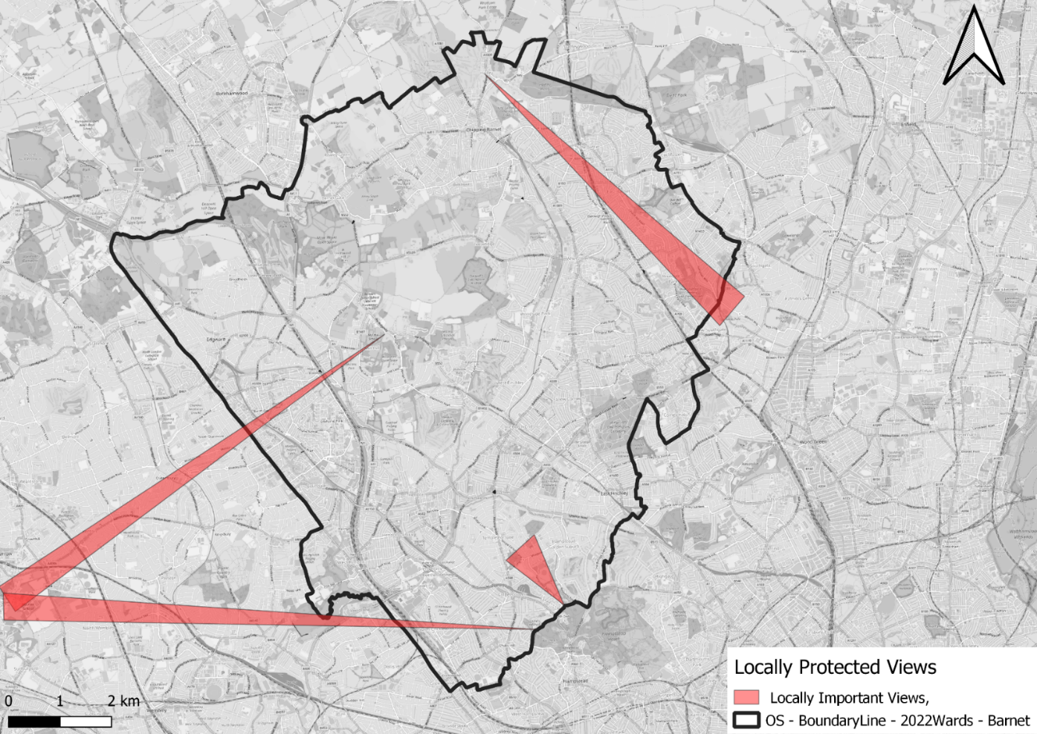
Map 7 sets out the 4 locally important views from points within the Borough. These views are shown in Local Plan Map 4 in support of Policy CDH04 – Tall Buildings and on the Policies Map. T
Locally Important Views
Map 7

Mapping Amendments

Green Belt

Barnet’s Green Belt and Metropolitan Open Land (MOL) Study (2018) considered the accuracy and robustness of Barnet’s existing Green Belt boundaries, with a view to highlight areas for potential realignments along alternative permanent and readily recognisable physical features where necessary. The potential minor Green Belt boundary adjustments set out in the study have been analysed and the following amendments to the Green Belt boundary, set out in Maps 8-21, are to be taken forward on the new Policies Map. This amounts to an additional 5.429ha of Green Belt land.

The following amendment maps set out below are alongside justifications setting out the reasons for addition or removal of Green Belt land which corresponds to the Green Belt and MOL Study (2018).

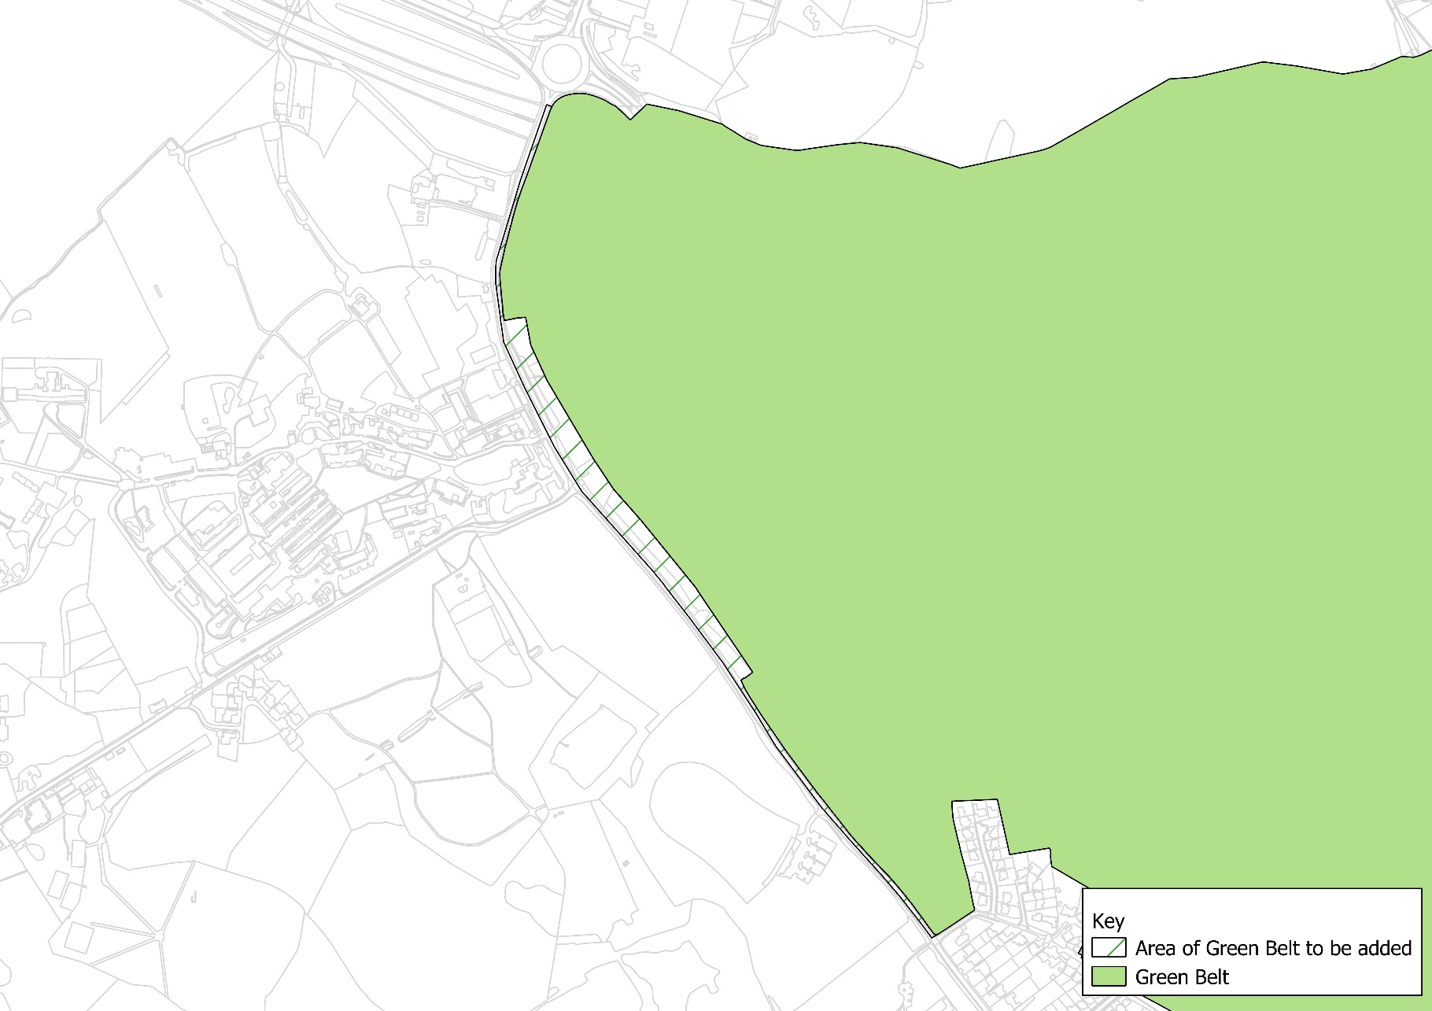
Map 8- Watling Street, 1km south of Elstree
Not to scale
N
Justification for change:
Brings Green Belt boundary to correspond with edge of public highway rather than running through a field, and thus makes the boundary more defensible.

Map 9 – Land Northeast of Brockley Crescent, Edgwarebury
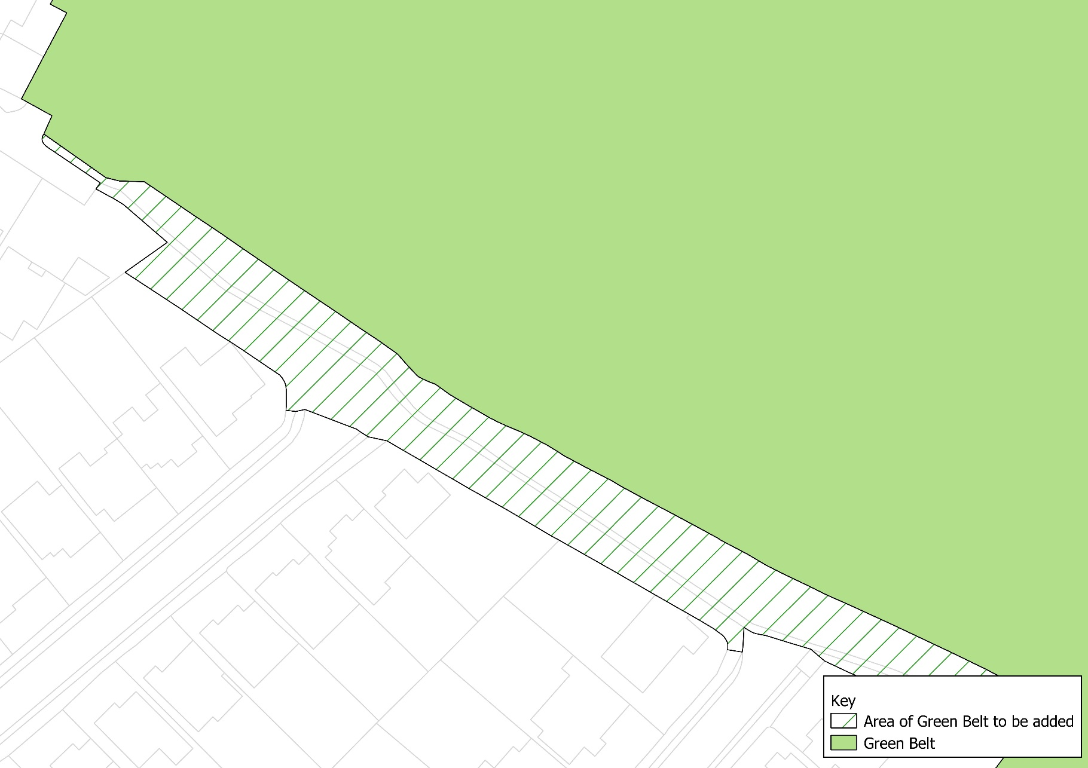
Justification for change:
Brings the Green Belt boundary to correspond with the urban edge (property lines of adjoining dwellings).

N

Not to scale

Map 10 - Land to Rear of 14-28 Brockley Crescent, Edgwarebury
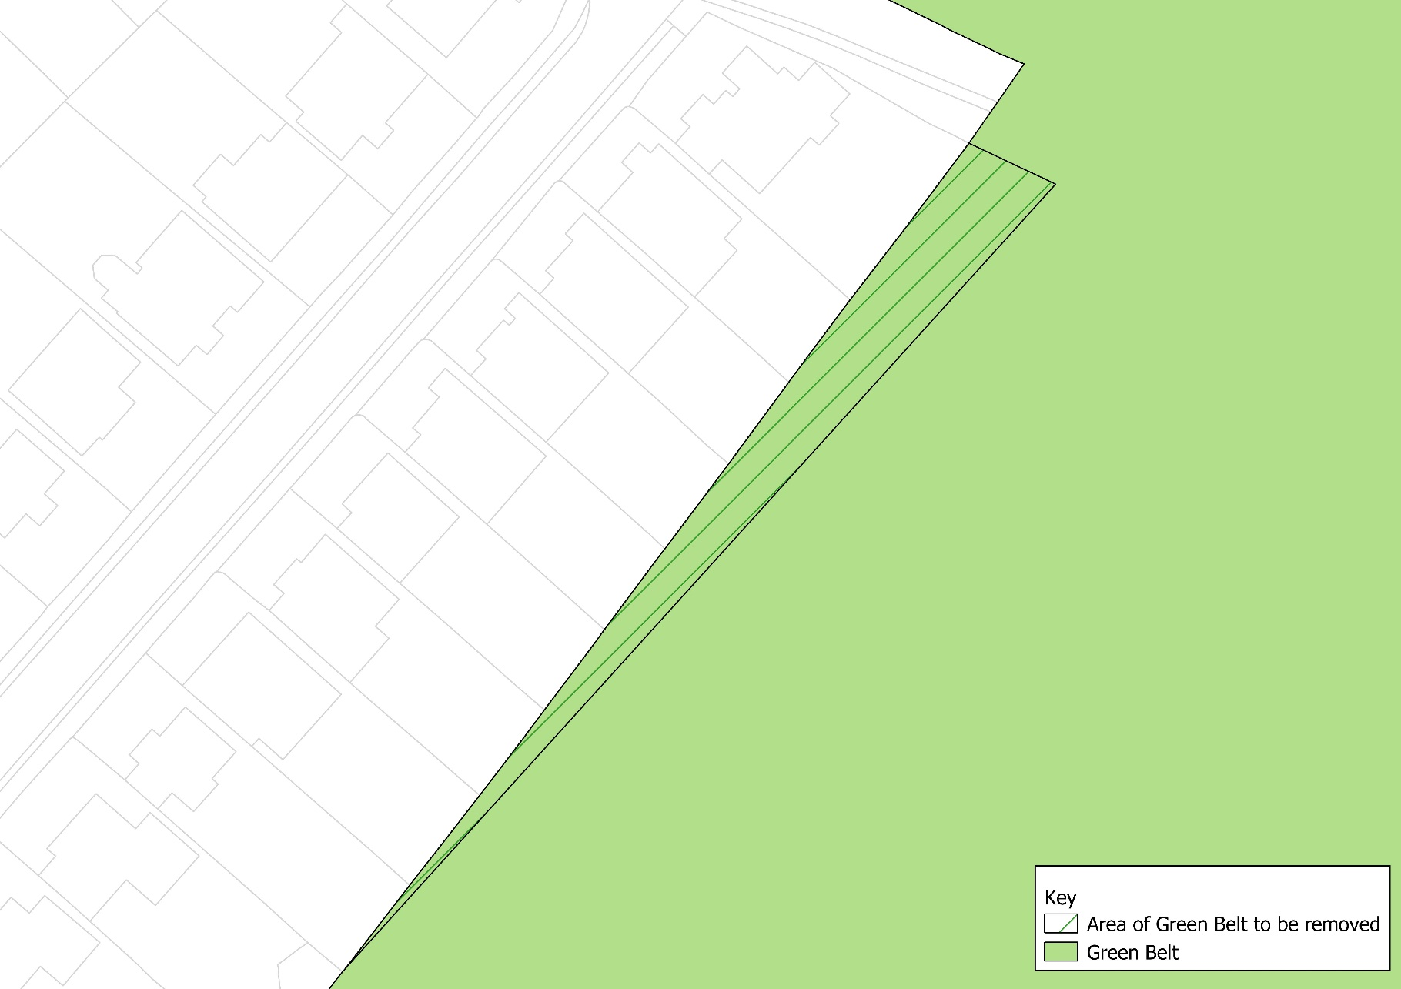
Justification for change:
Removal of southeastern ends of properties at 14-28 Brockley Crescent. Desktop review suggests that when the subdivision was created it did not fit properly with the Greenbelt boundary, which almost certainly would have followed a pre-existing property boundary. It does not appear that the house owners in question have gained possession of land beyond their original boundaries. Removing this area from Greenbelt would be an exercise in regularising a situation that appears to have been caused by previous poor mapping.

N

Not to scale

Map 11 – Watling Street and Spur Road, Edgwarebury
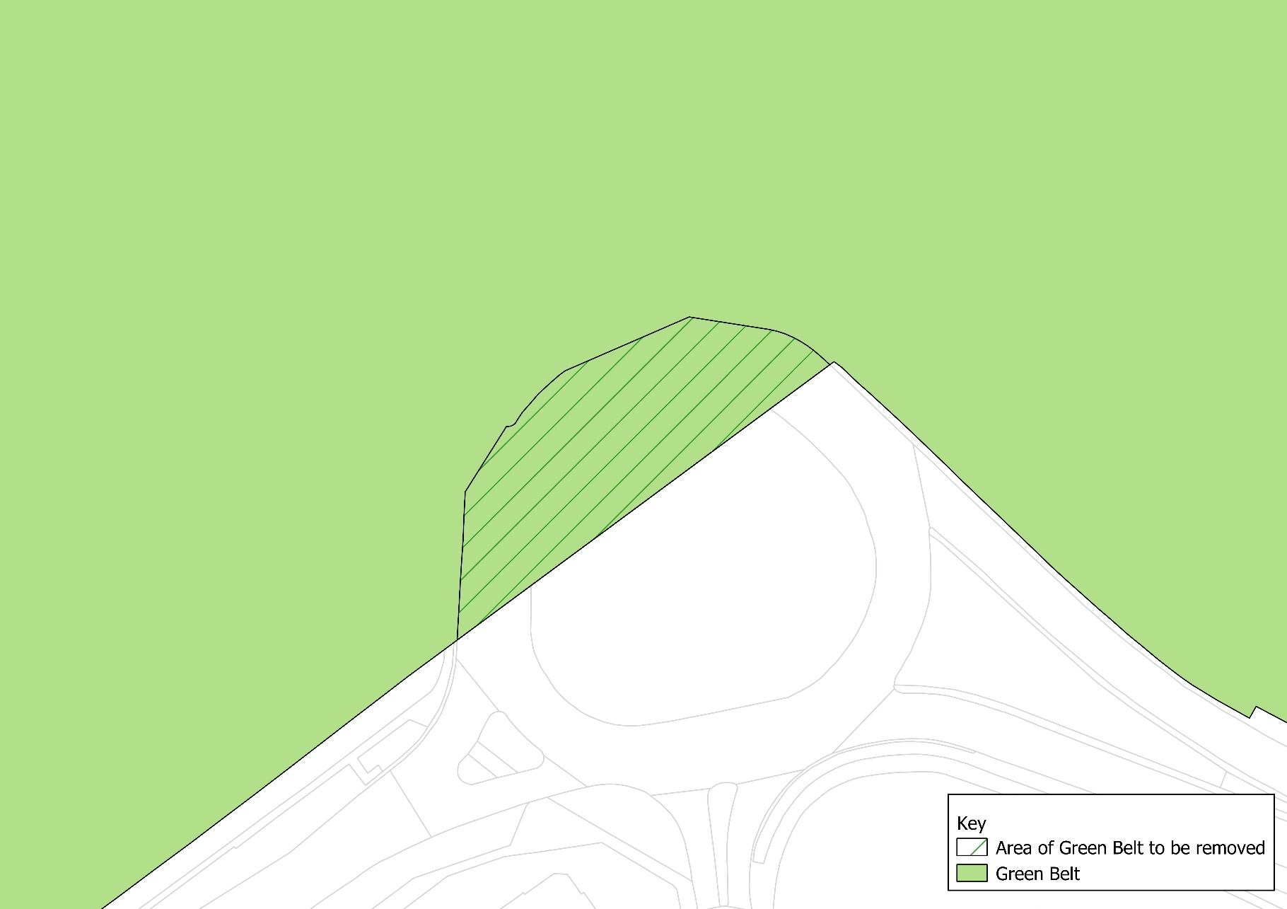
Justification for change:
Will bring Green Belt boundary to align with boundary of public highway, thereby creating a strong boundary along east side of Watling St and north side of Spur Road.

N

Not to scale

Map 12– M1 Near Moat Mount
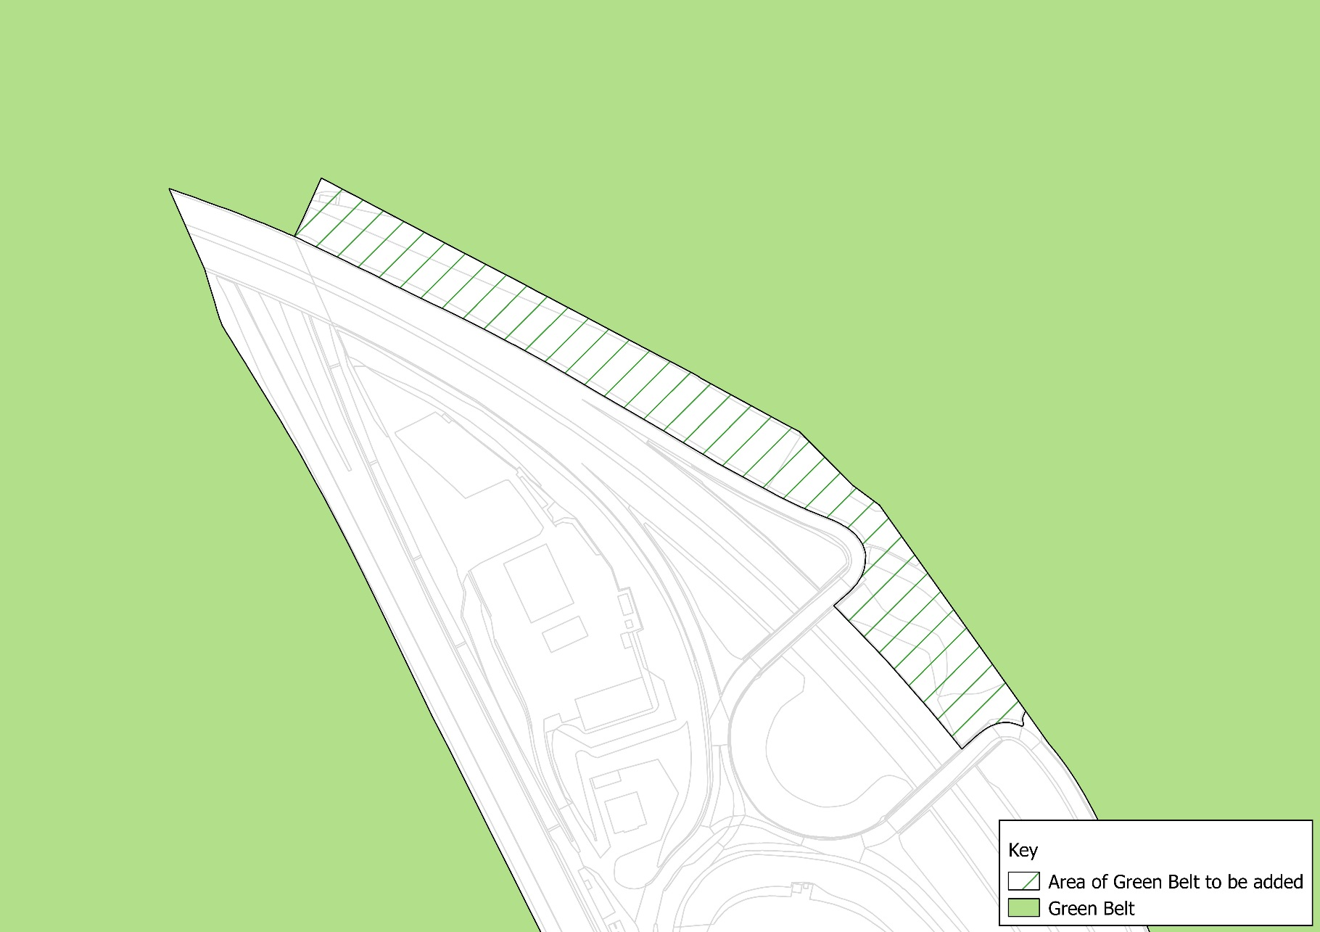
Justification for change:
The proposed adjustment reflects the longterm configuration of the M1 and associated sliproads at this location and regularises the Greenbelt boundary to follow the edge of the M1 corridor.

N

Not to scale

Map 13– Highwood Hill and Marsh Lane, Mill Hill
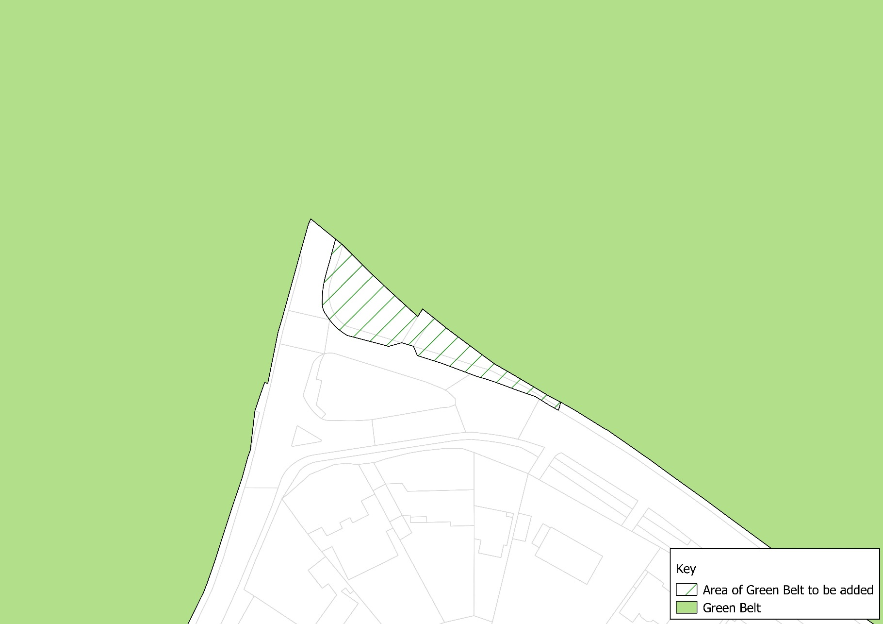
Justification for change:
it will align the Green belt boundary with the edge of the public highway land and have no impact on the developability or protection of land.

N

Not to scale

Map 14 – Lawrence Street, Mill Hill
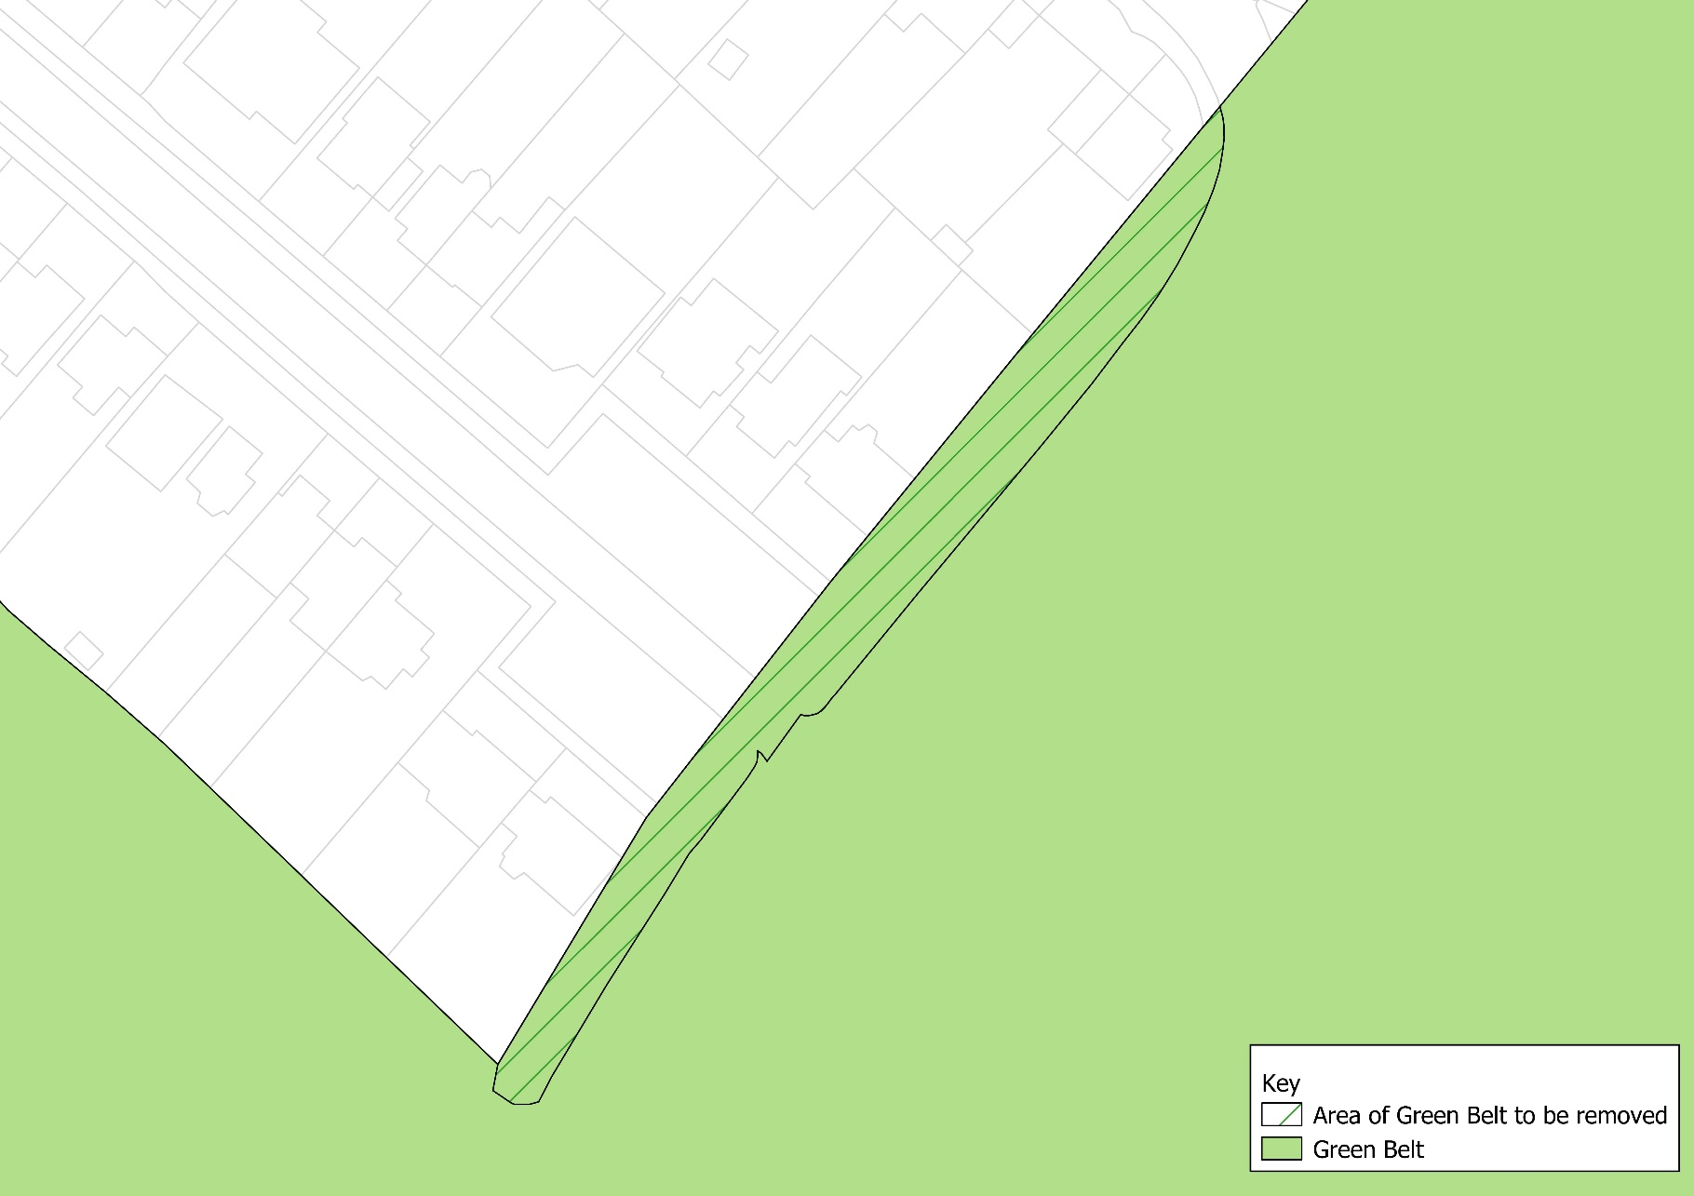
Justification for change:
it will align the Green belt boundary with the edge of the public highway land and have no impact on the developability or protection of land.

N

Not to scale

Map 15 – Milespit Hill, Mill Hill
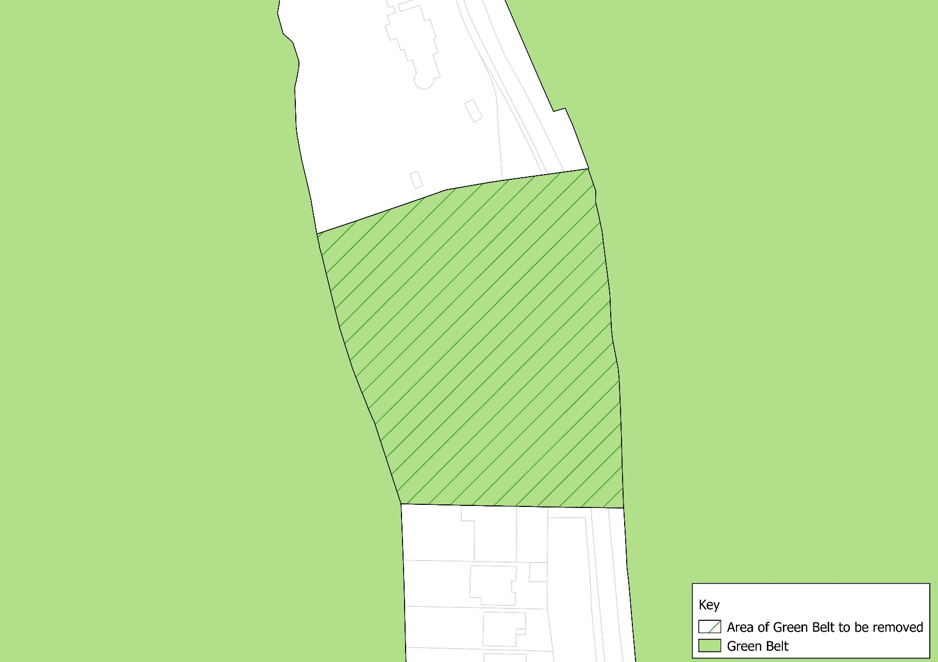
Justification for change:
As discussed in the report, a mapping error resulted in the Greenbelt boundary being drawn to erroneously include these properties and the adjacent road, as evidenced by the associated correspondence

N

Not to scale

Map 16 – Firth Lane, Mill Hill
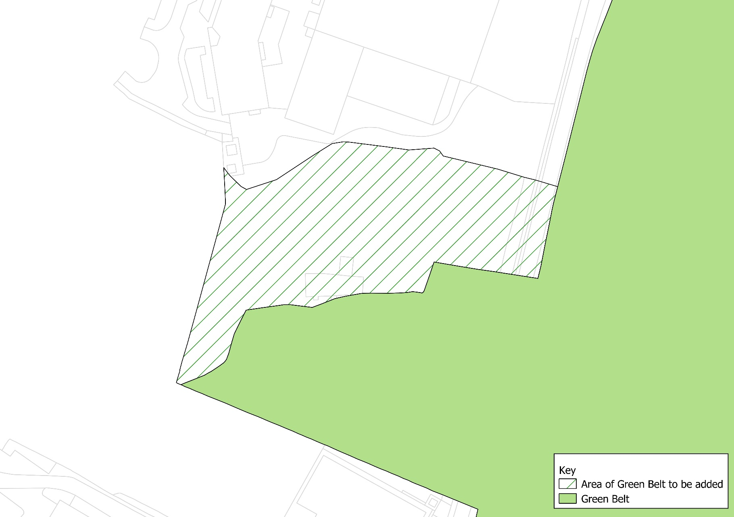
Justification for change:
It is part of the Frith Grange Scout camp (the balance is already in the Greenbelt), and the addition will make the Greenbelt boundary consistent with the ownership boundary, along the edge of the urban area immediately adjoining to the north of the camp.

Map 17– Brett Road, Chipping Barnet
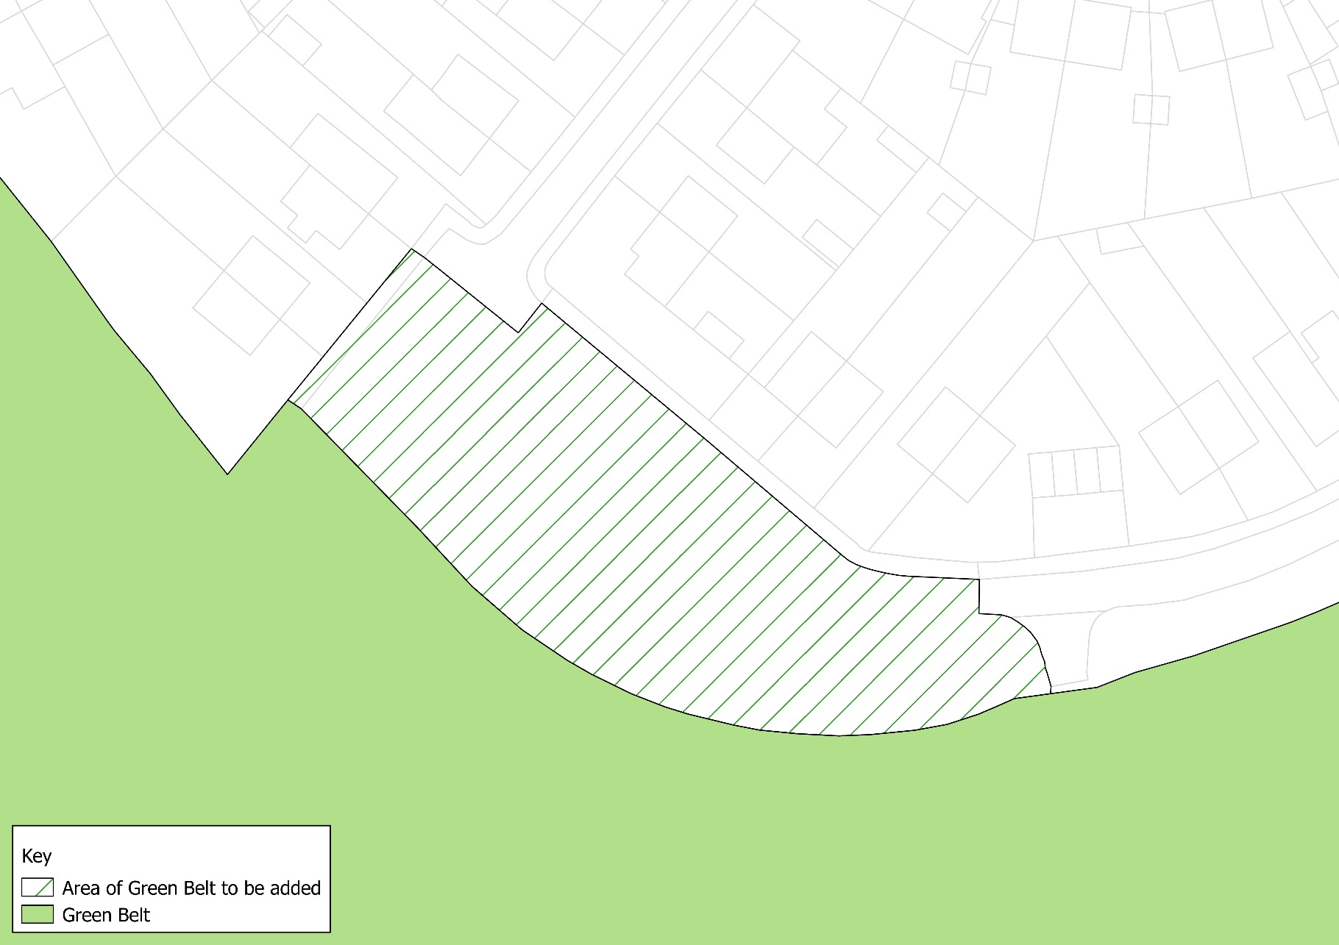
Justification for change:
Current boundary reflects a property line that is older than the estate, but a stronger boundary is achieved by following the built urban edge, along the outer edge of the adjacent street.

N

Map 18 – Rowley Green Road, Arkley
Not to scale
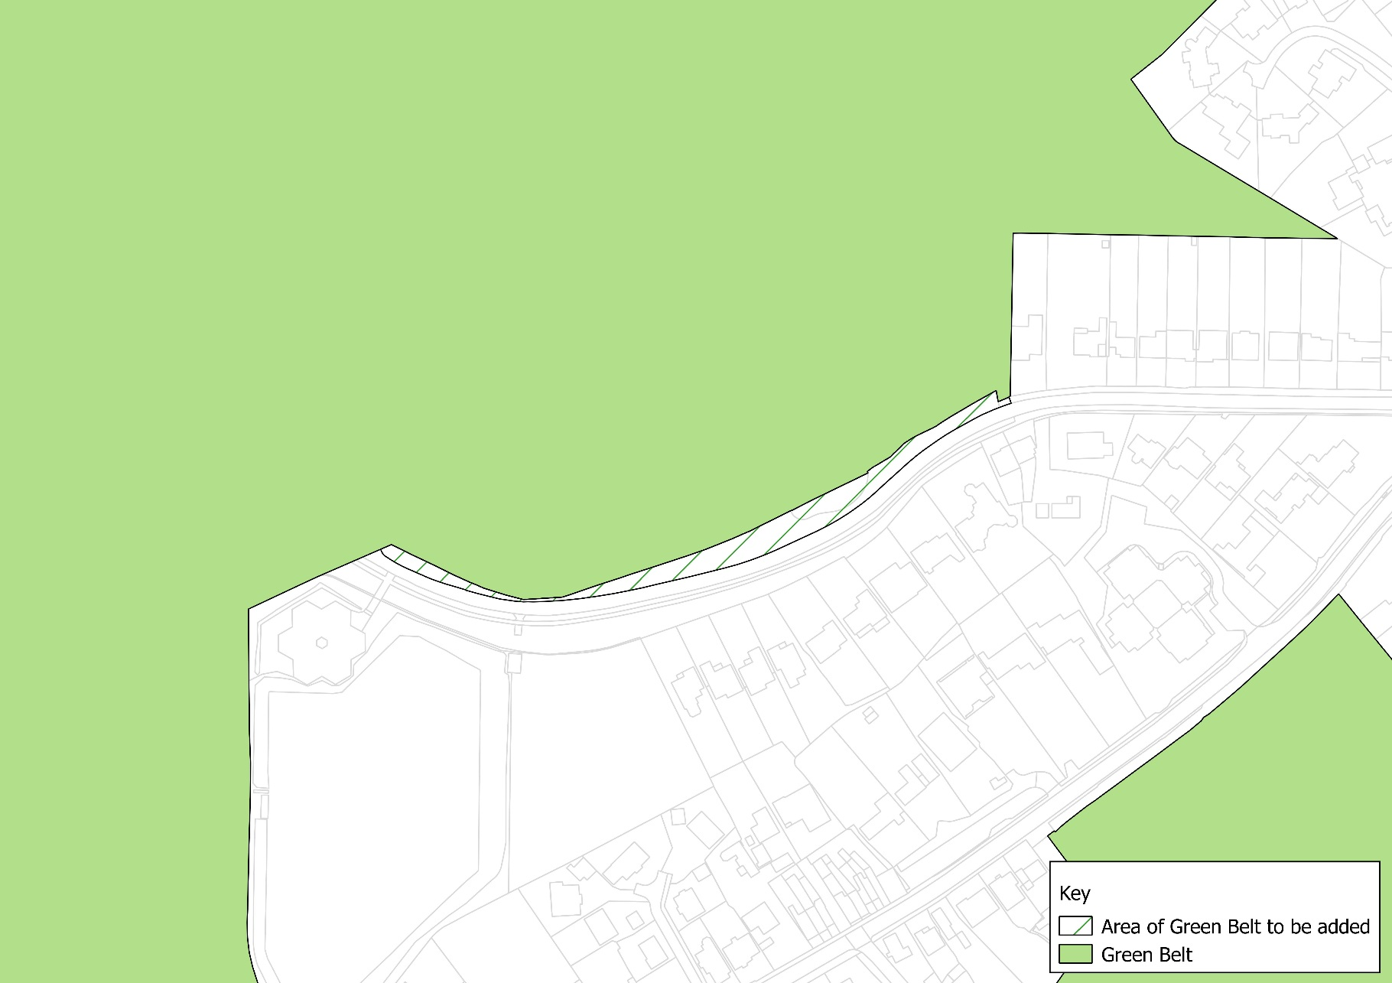
Justification for change:
Brings the Greenbelt boundary to match the edge of the public highway, which creates a strong defensible boundary.

N

Not to scale

Map 19 - M1 at Junction 4 (Edgware Way), Elstree
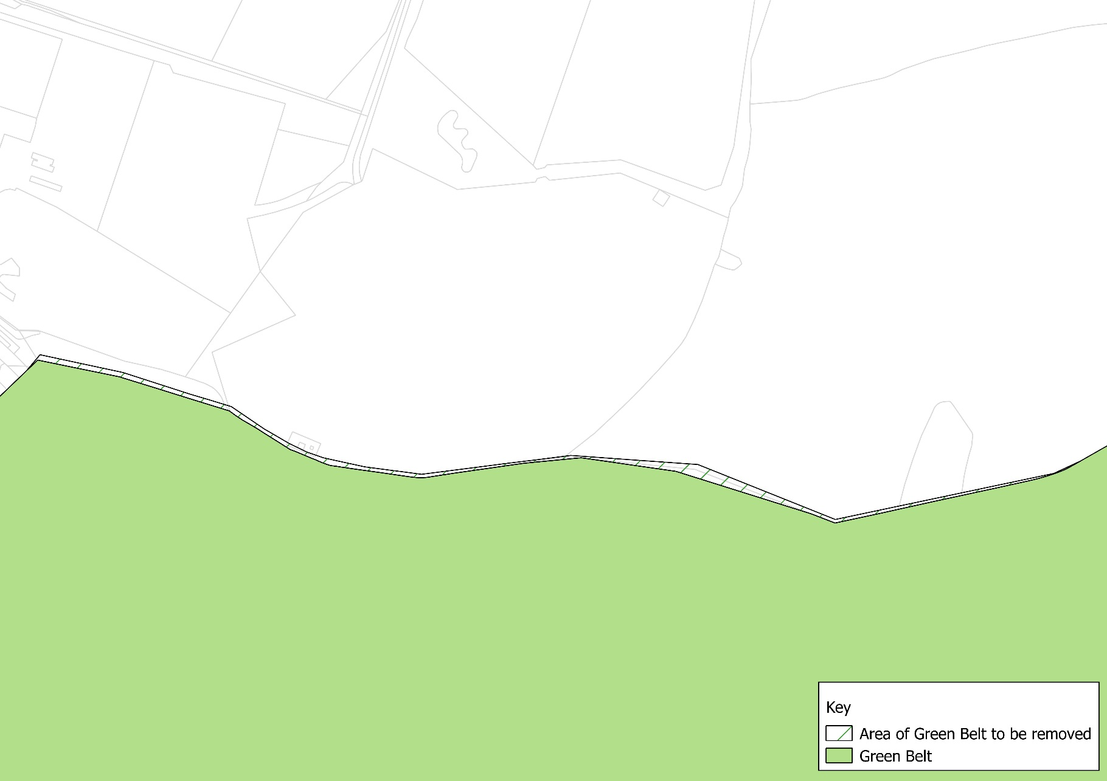
Justification for change:
Brings the Greenbelt boundary to match the borough boundary. This does not in itself create a defensible boundary because the adjacent land in Hertsmere borough is also designated as Greenbelt, but it corrects a mapping discrepancy.

N

Not to scale

Map 20 – Edgware Way at Watling Street, Elstree
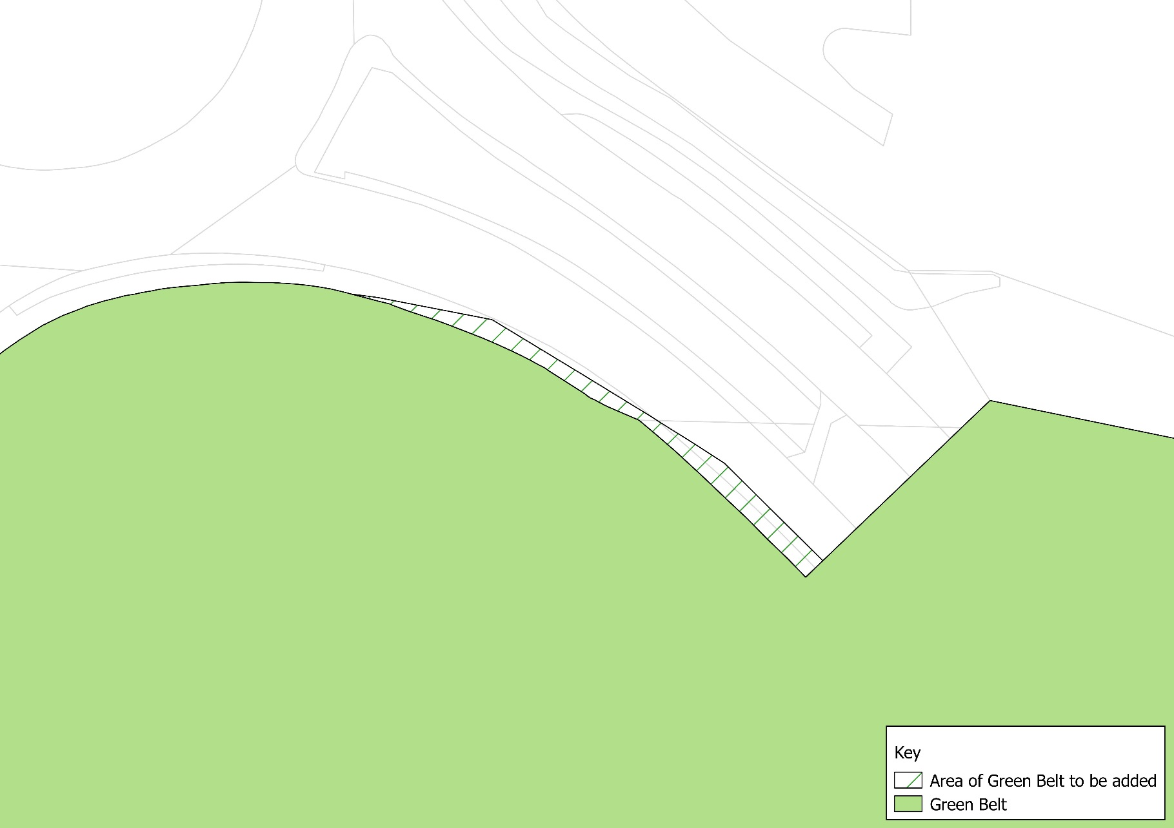
Justification for change:
Brings the Greenbelt boundary to match the borough boundary, which does not follow the edge of the public highway, possibly due to road widening subsequent to the boundary being set, which put the highway boundary out of alignment with the borough boundary (Edgware Way immediately east of Watling St roundabout). This does not in itself create a defensible boundary because the adjacent land in Hertsmere borough is also designated as Greenbelt, but it corrects the discrepancy resulting from adjusting of the highway and its land boundary.

N

Not to scale

Map 21 – Jewish Community Secondary School, Westbrook Crescent, New Barnet
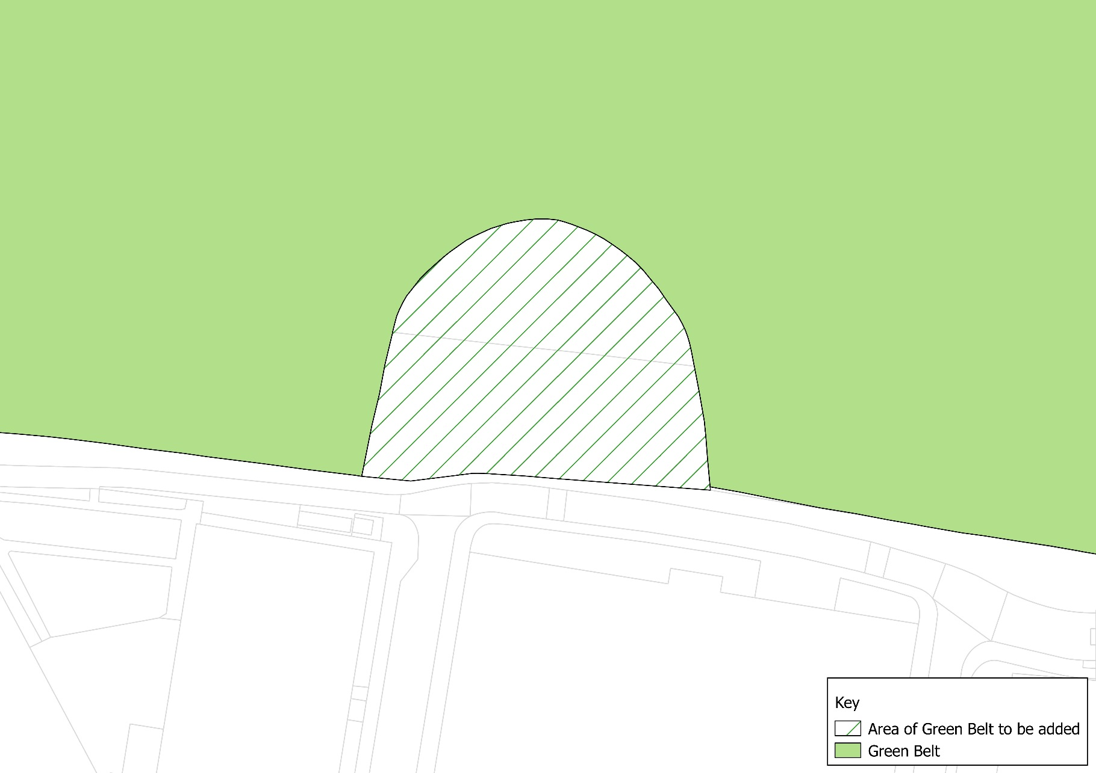
Justification for change:
It reflects new development pattern, but, unlike cases where the proposed change would follow the outline of a building, this boundary reflects a property boundary and is therefore a strong boundary.

N

Not to scale

Metropolitan Open Land (MOL)

As with the Green Belt amendments above, Barnet’s Green Belt and Metropolitan Open Land (MOL) Study (2018) considered the accuracy and robustness of Barnet’s existing MOL boundaries, with a view to highlight areas for potential realignments along alternative permanent and readily recognisable physical features where necessary. The potential minor MOL boundary adjustments set out in the Study have been analysed and the following amendments to the MOL boundary, set out in Maps 22-39, are to be taken forward. This amounts to a reduction of 2.263 ha of MOL.

The following amendment maps set out below are alongside justifications setting out the reasons for addition or removal of MOL land which corresponds to the Green Belt and MOL Study (2018).

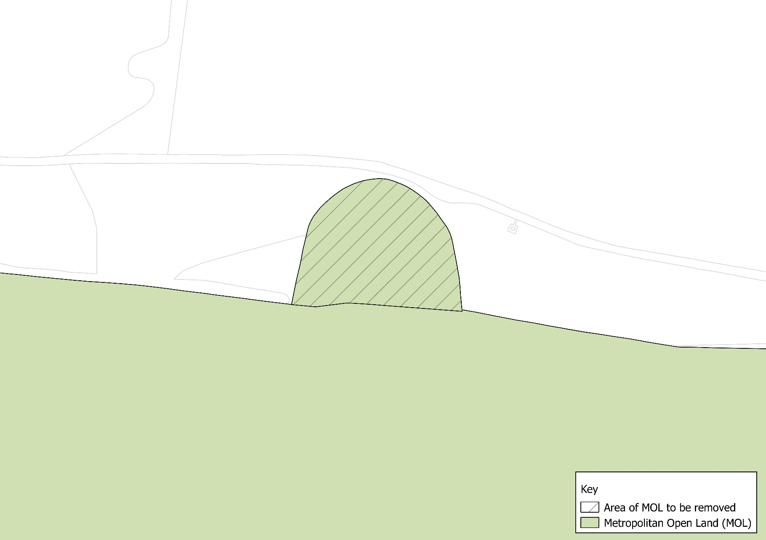
Map 22 – Jewish Community Secondary School (1)
Not to scale
N
Justification for change:
This area will be redesignated as Green Belt as per the adjoining land.

Map 23 – Jewish Community Secondary School (2)
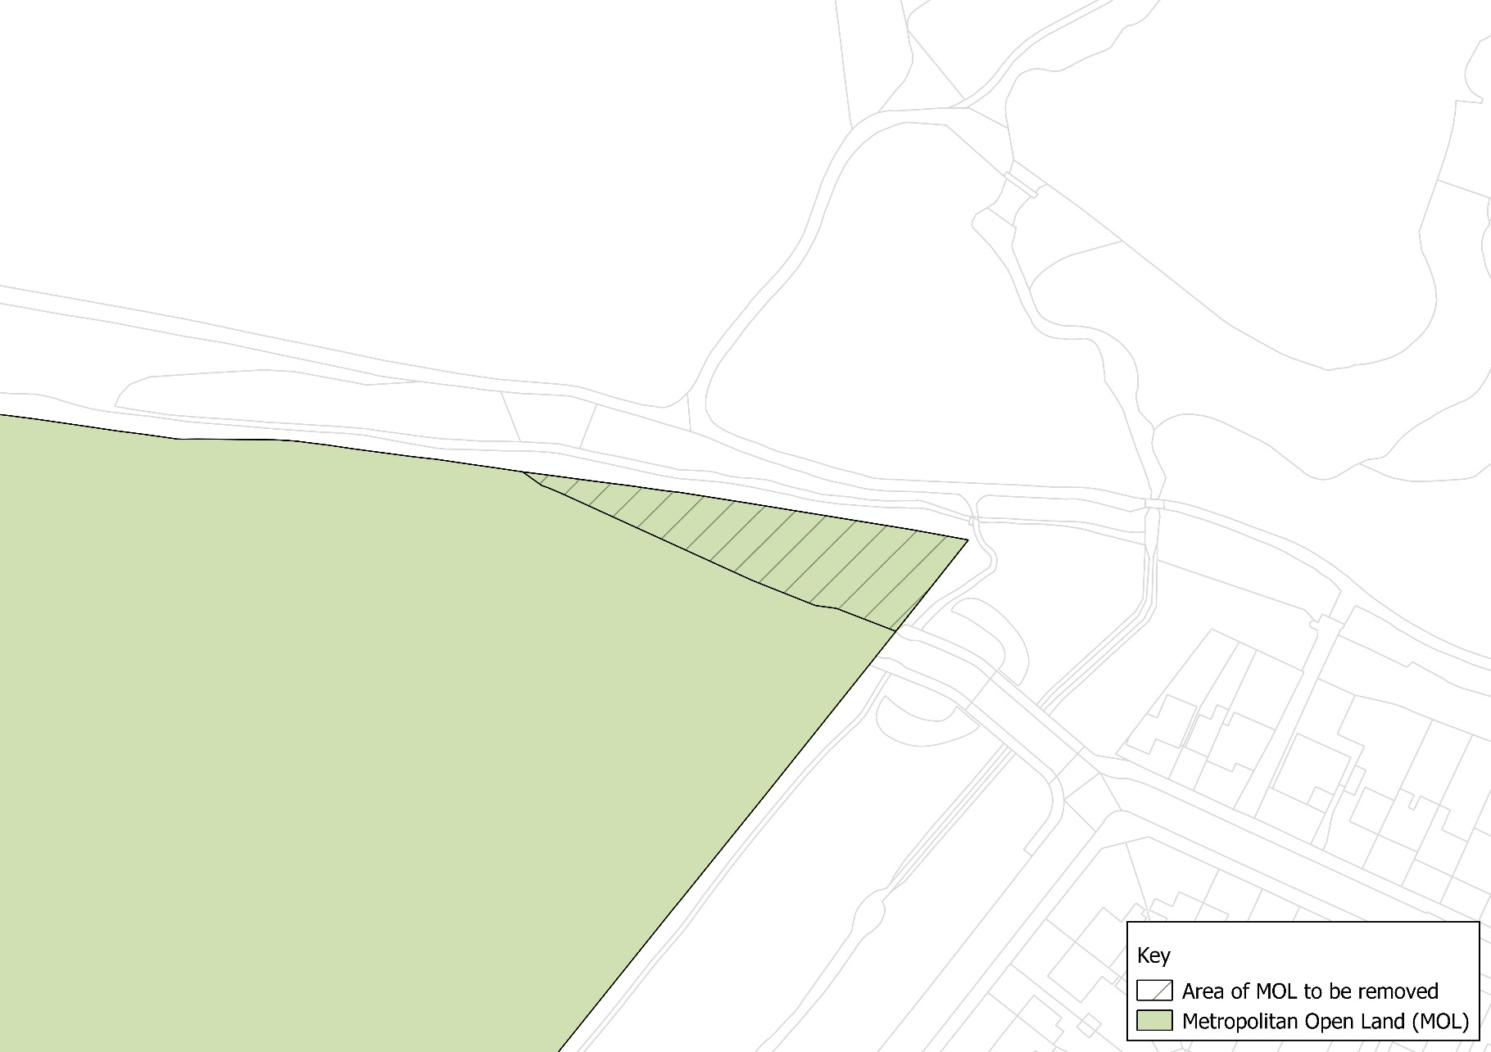
Justification for change:
This area will be redesignated as Green Belt as per the adjoining land.

N

Not to scale

Map 24 – New Southgate Cemetery and Recreation Ground
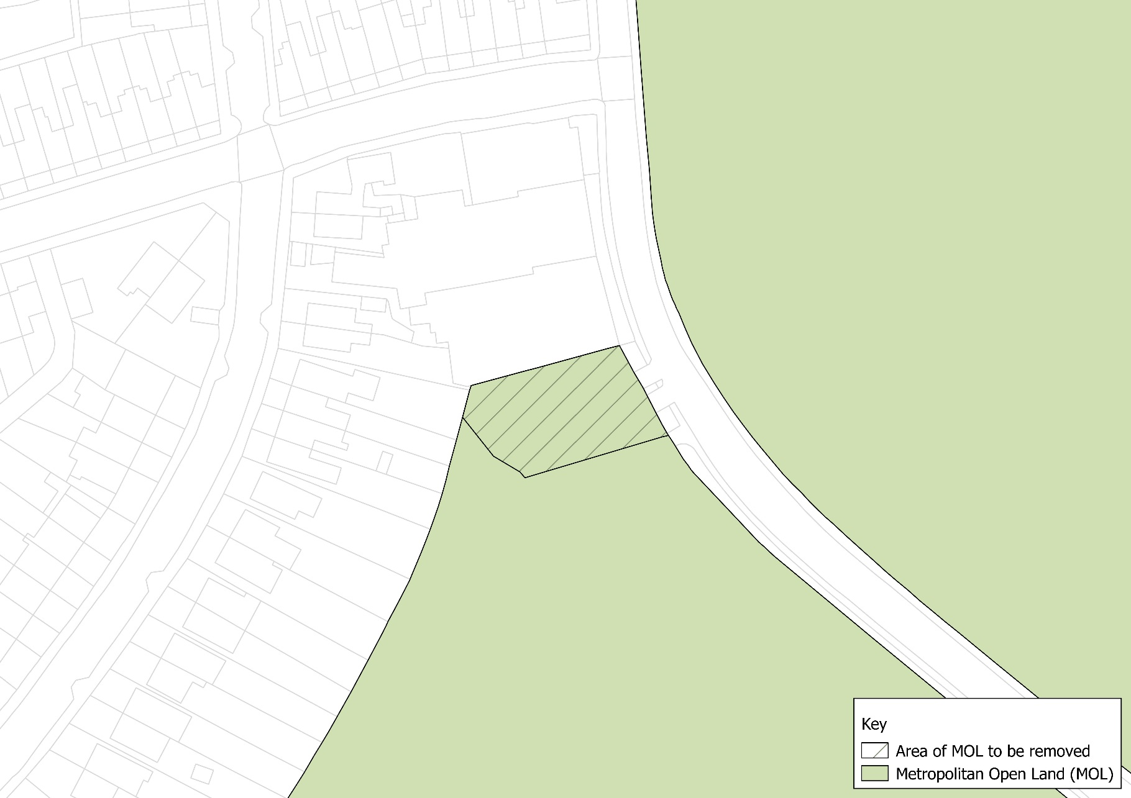
Justification for change:
To be realigned to give a stronger more defensible boundary.

N

Not to scale

Map 25 – Whetstone Stray
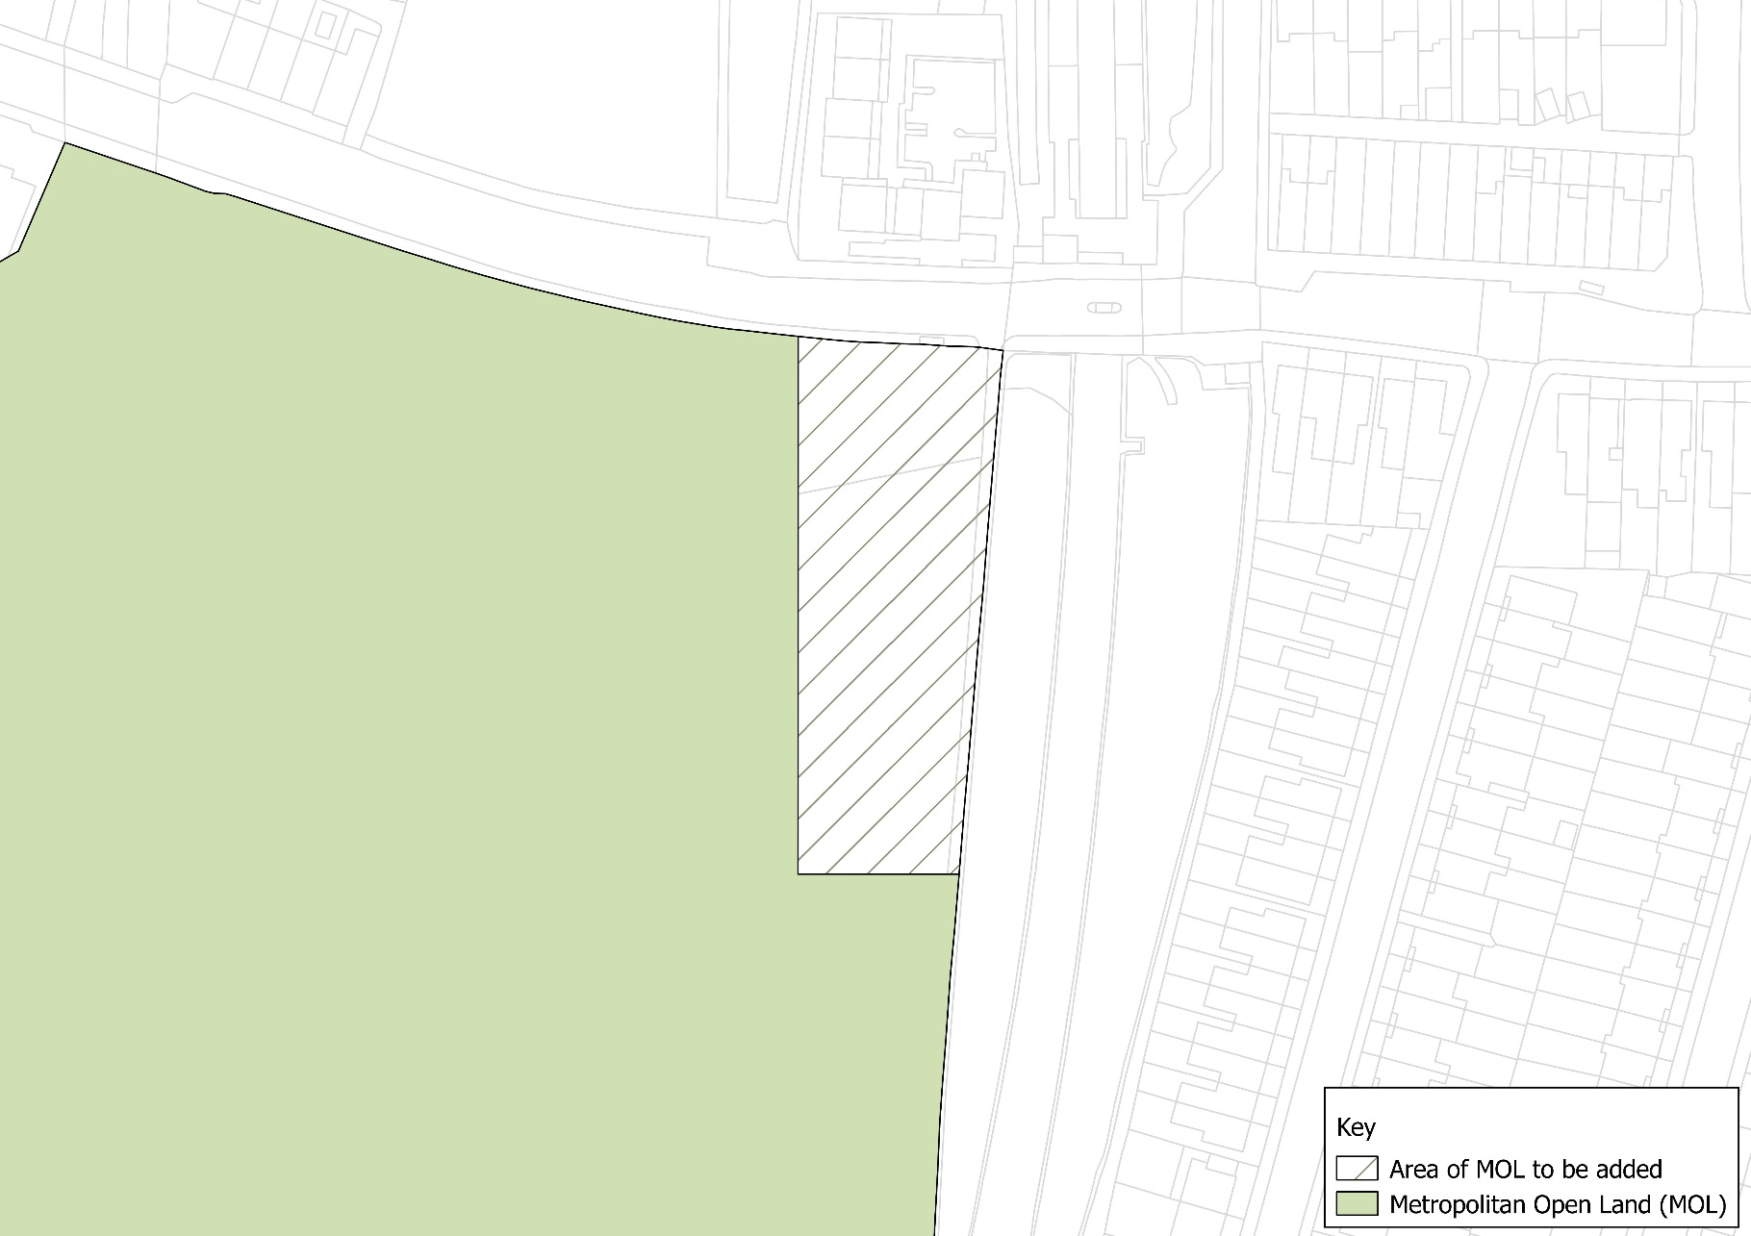
Justification for change:
Forms a stronger more defensible boundary.

N

Not to scale

Map 26 – Finchley Catholic School Sportsfields
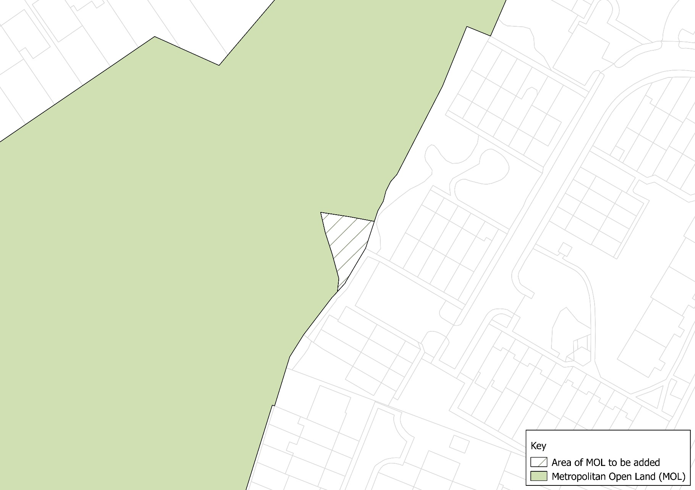
Justification for change:
It realigns it to the edge of the urban area and provides a stronger more defensible boundary.

N

Not to scale

Map 27 – Friern Barnet Retail Park Open Space (1)
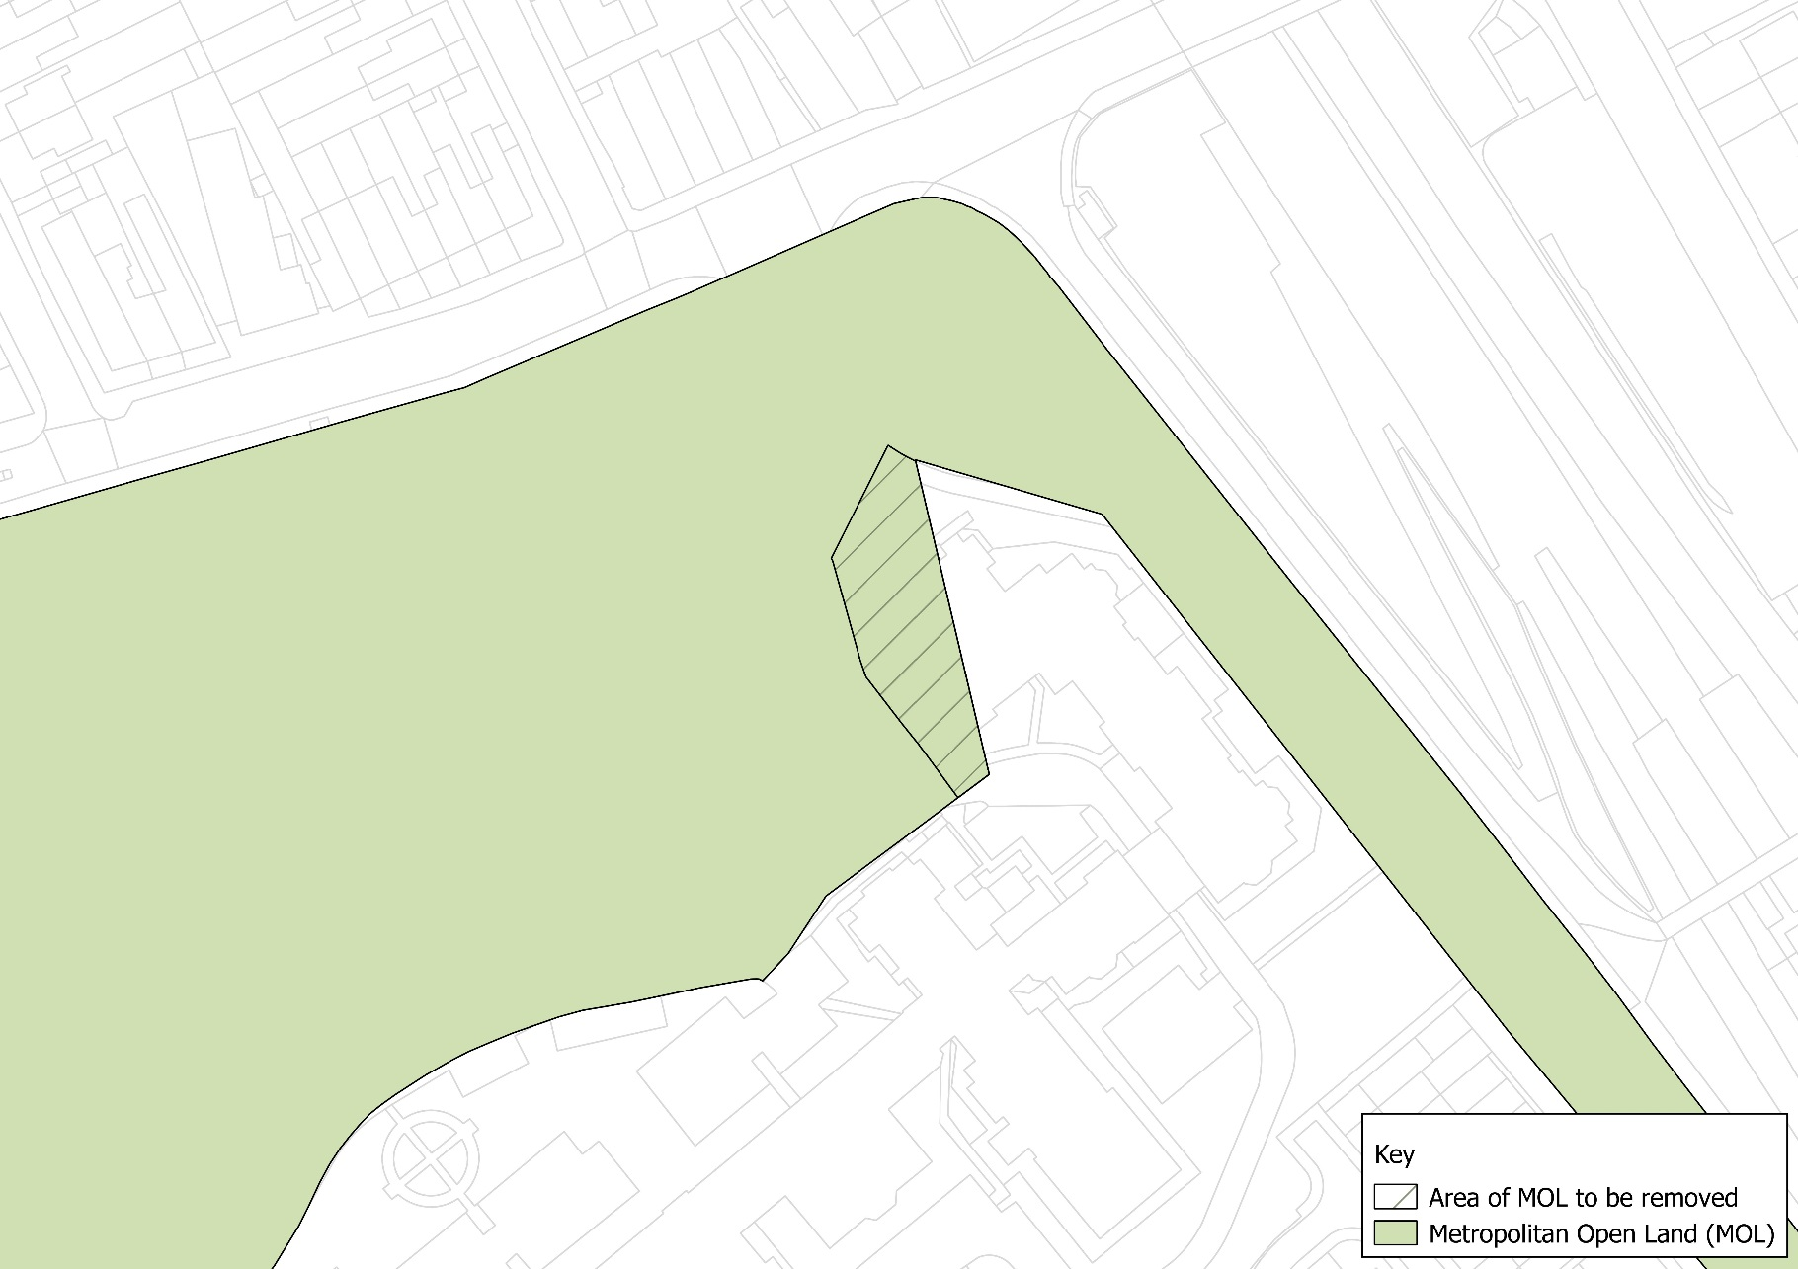
Justification for change:
No practical benefit to having land in MOL if it results in boundary cutting through a building. Remove the full building and its curtilage from MOL.

N

Not to scale

Map 28 - Friern Barnet Retail Park Open Space (2)
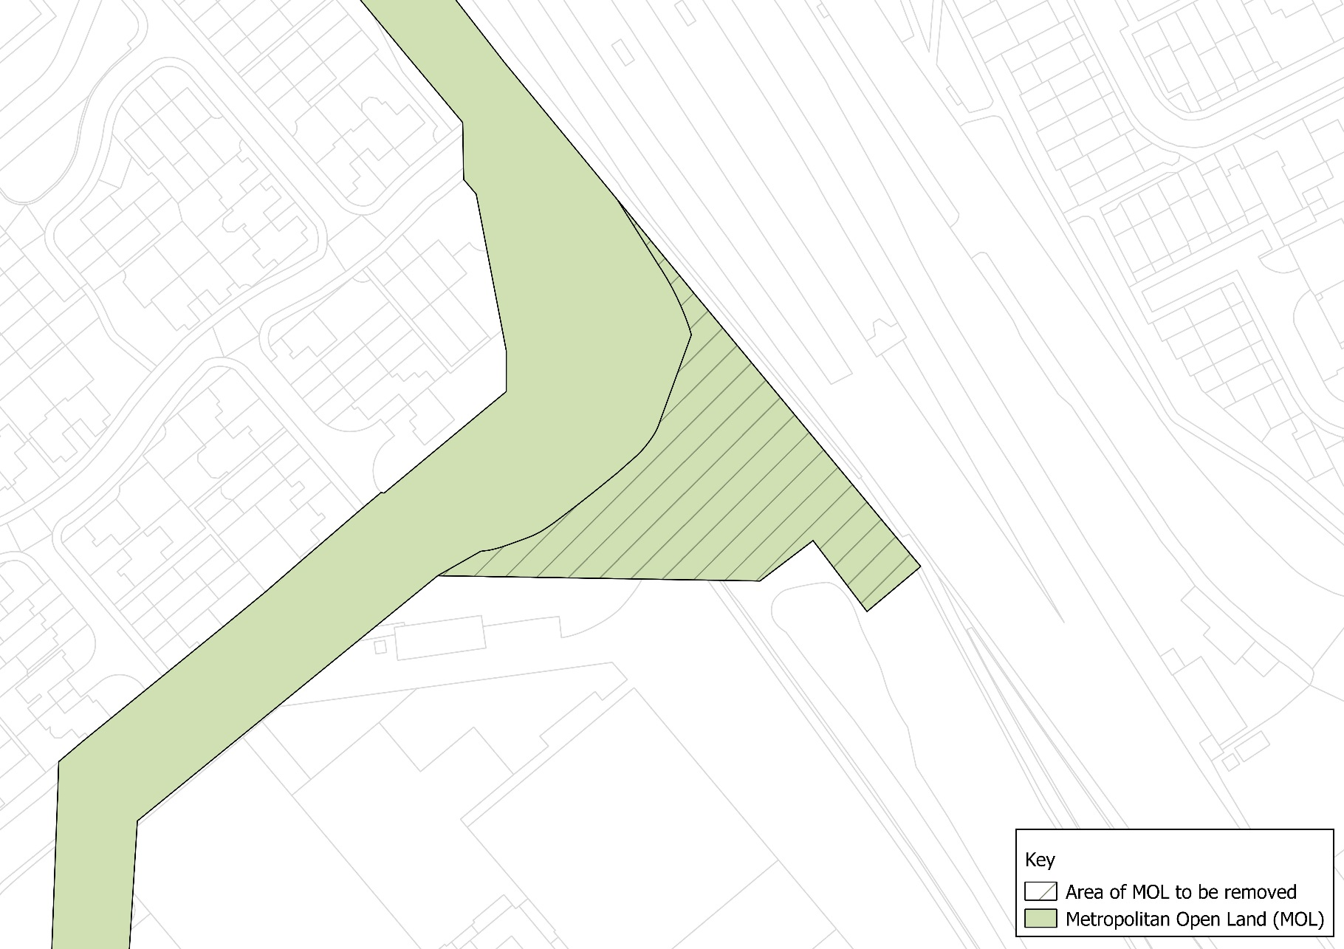
Not to scale
N
Justification for change:
Changing the eastern edge to follow the footpath provides a more consistent and defensible boundary.

Map 29 - Friern Barnet Retail Park Open Space (3)
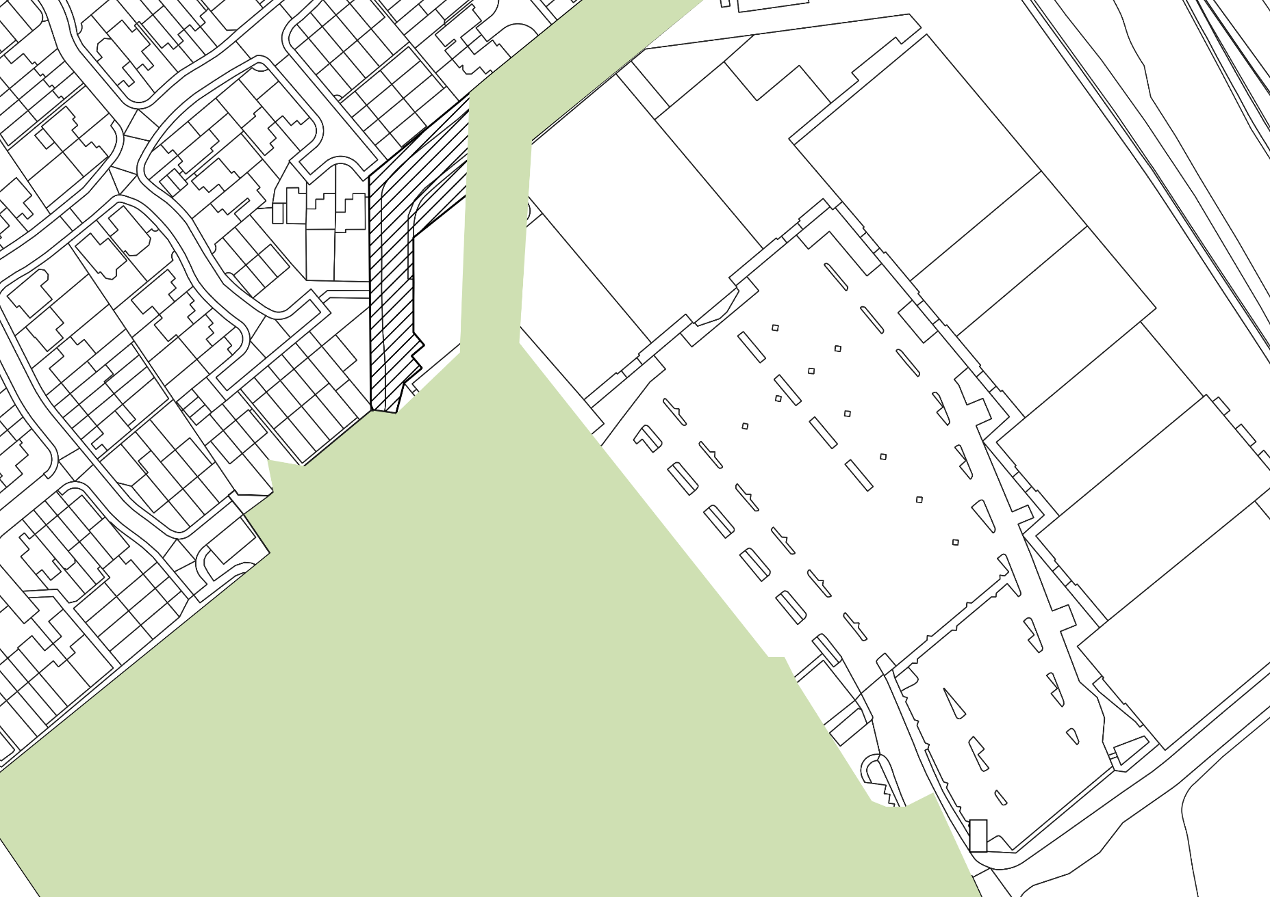
Justification for change:
To follow the footpath and urban boundary and to provide a stronger link to the Friern Bridge Open Space.

N

Not to scale

Map 30 - Friern Barnet Retail Park Open Space (4)
Not to scale
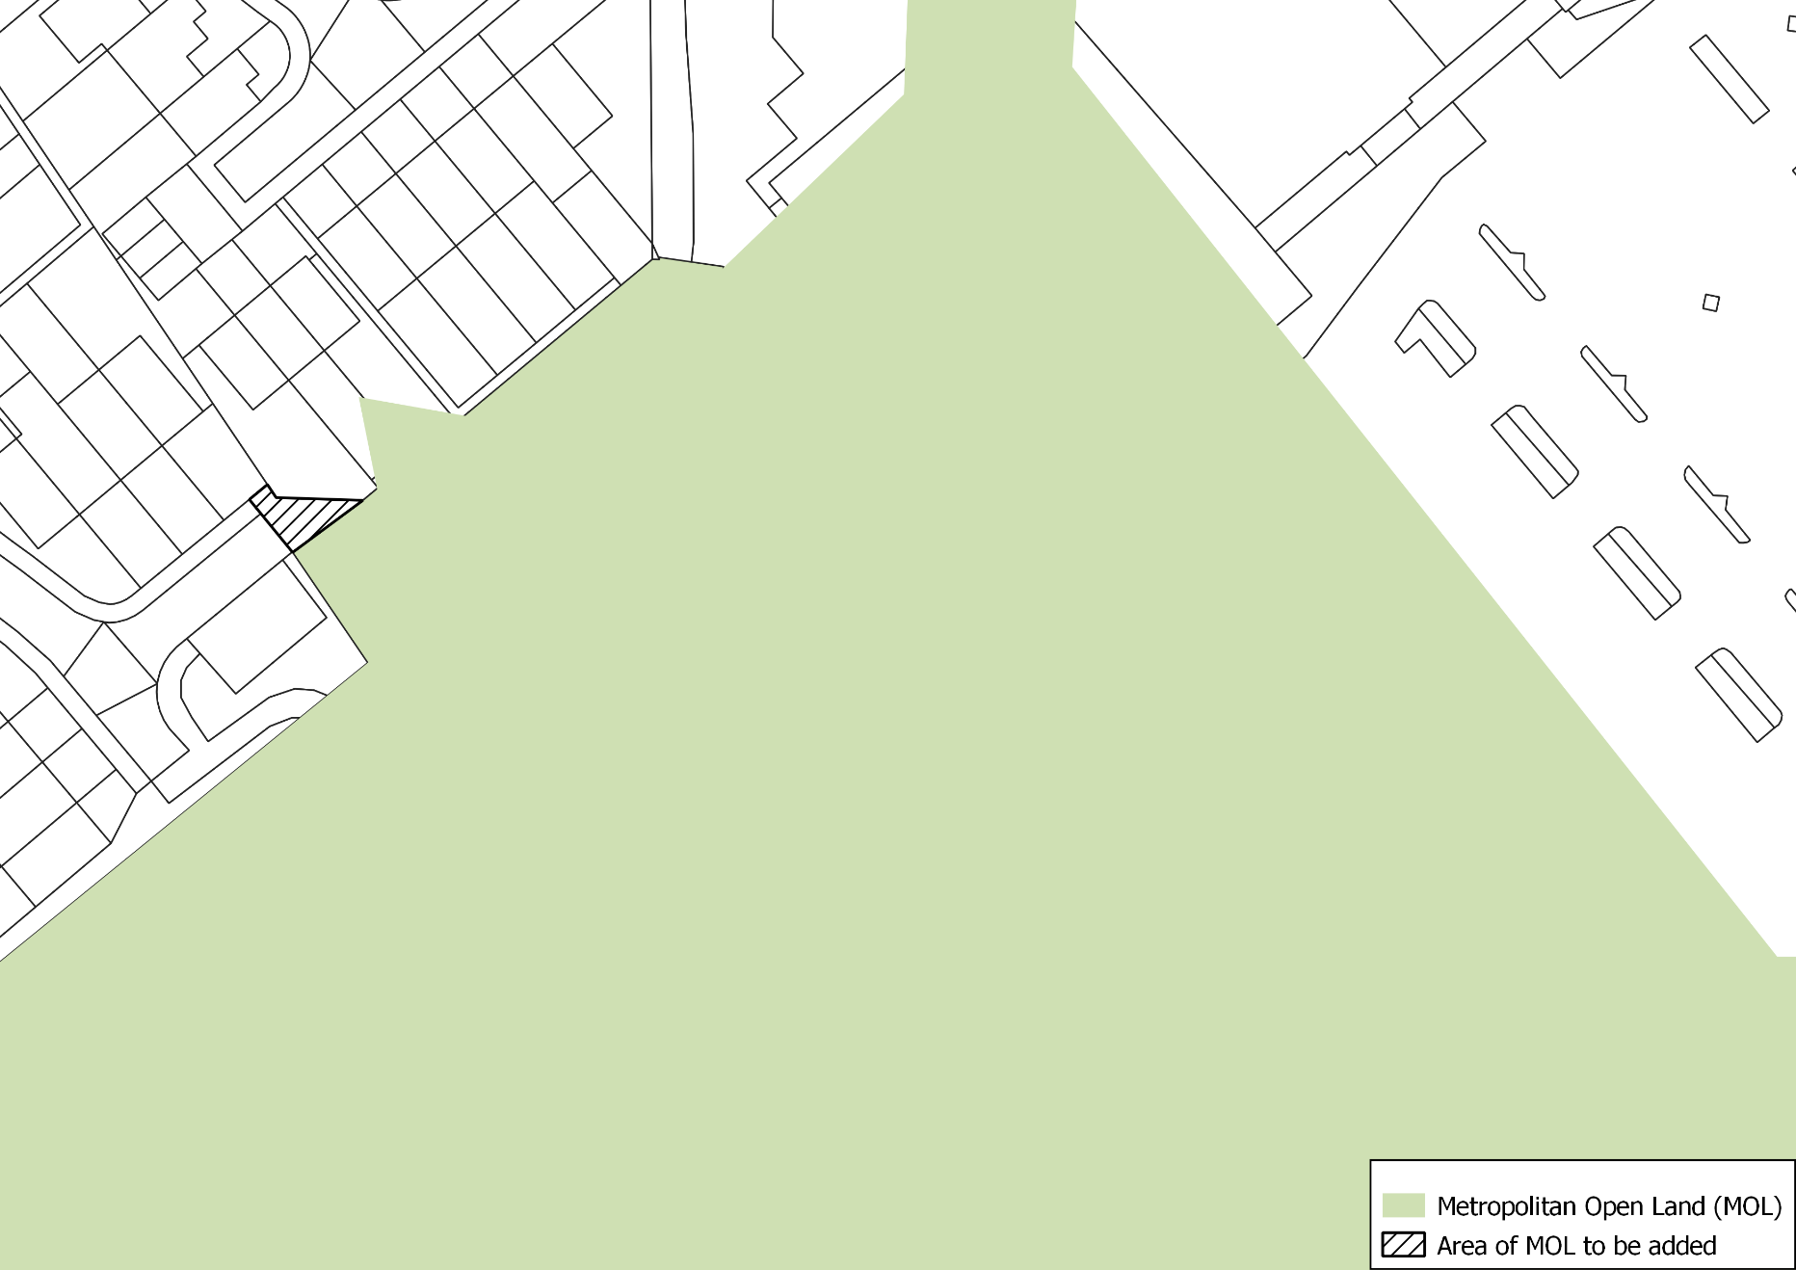
Justification for change:
Make consistent with the edge of the Friern Bridge Open Space and correct a digitisation error.
N

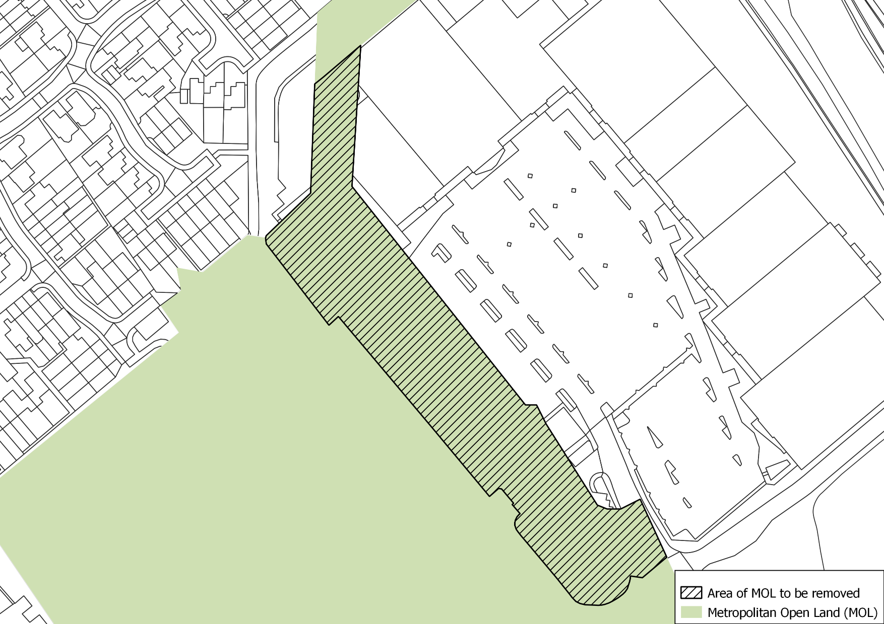
Map 31 - Friern Barnet Retail Park Open Space (5)
Justification for change:
Realigns the boundary to the edge of the open space and provides a more defensible boundary.
Not to scale
N

Map 32 – Colney Hatch MOL East
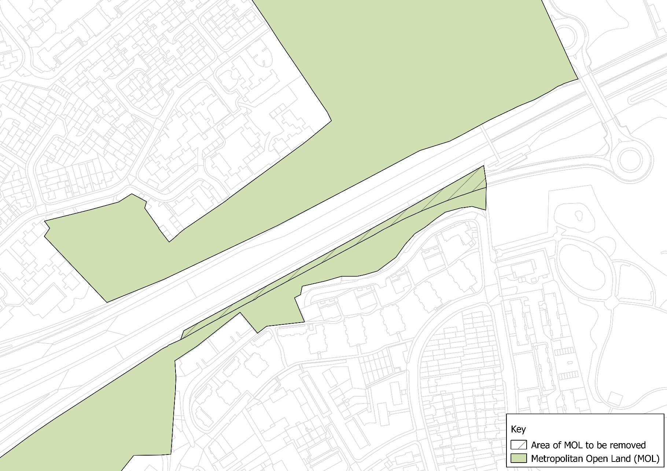
Justification for change:
Realigns to the road boundary and creates a more defensible edge to the MOL.

N

Not to scale

Map 33 – Colney Hatch MOL West
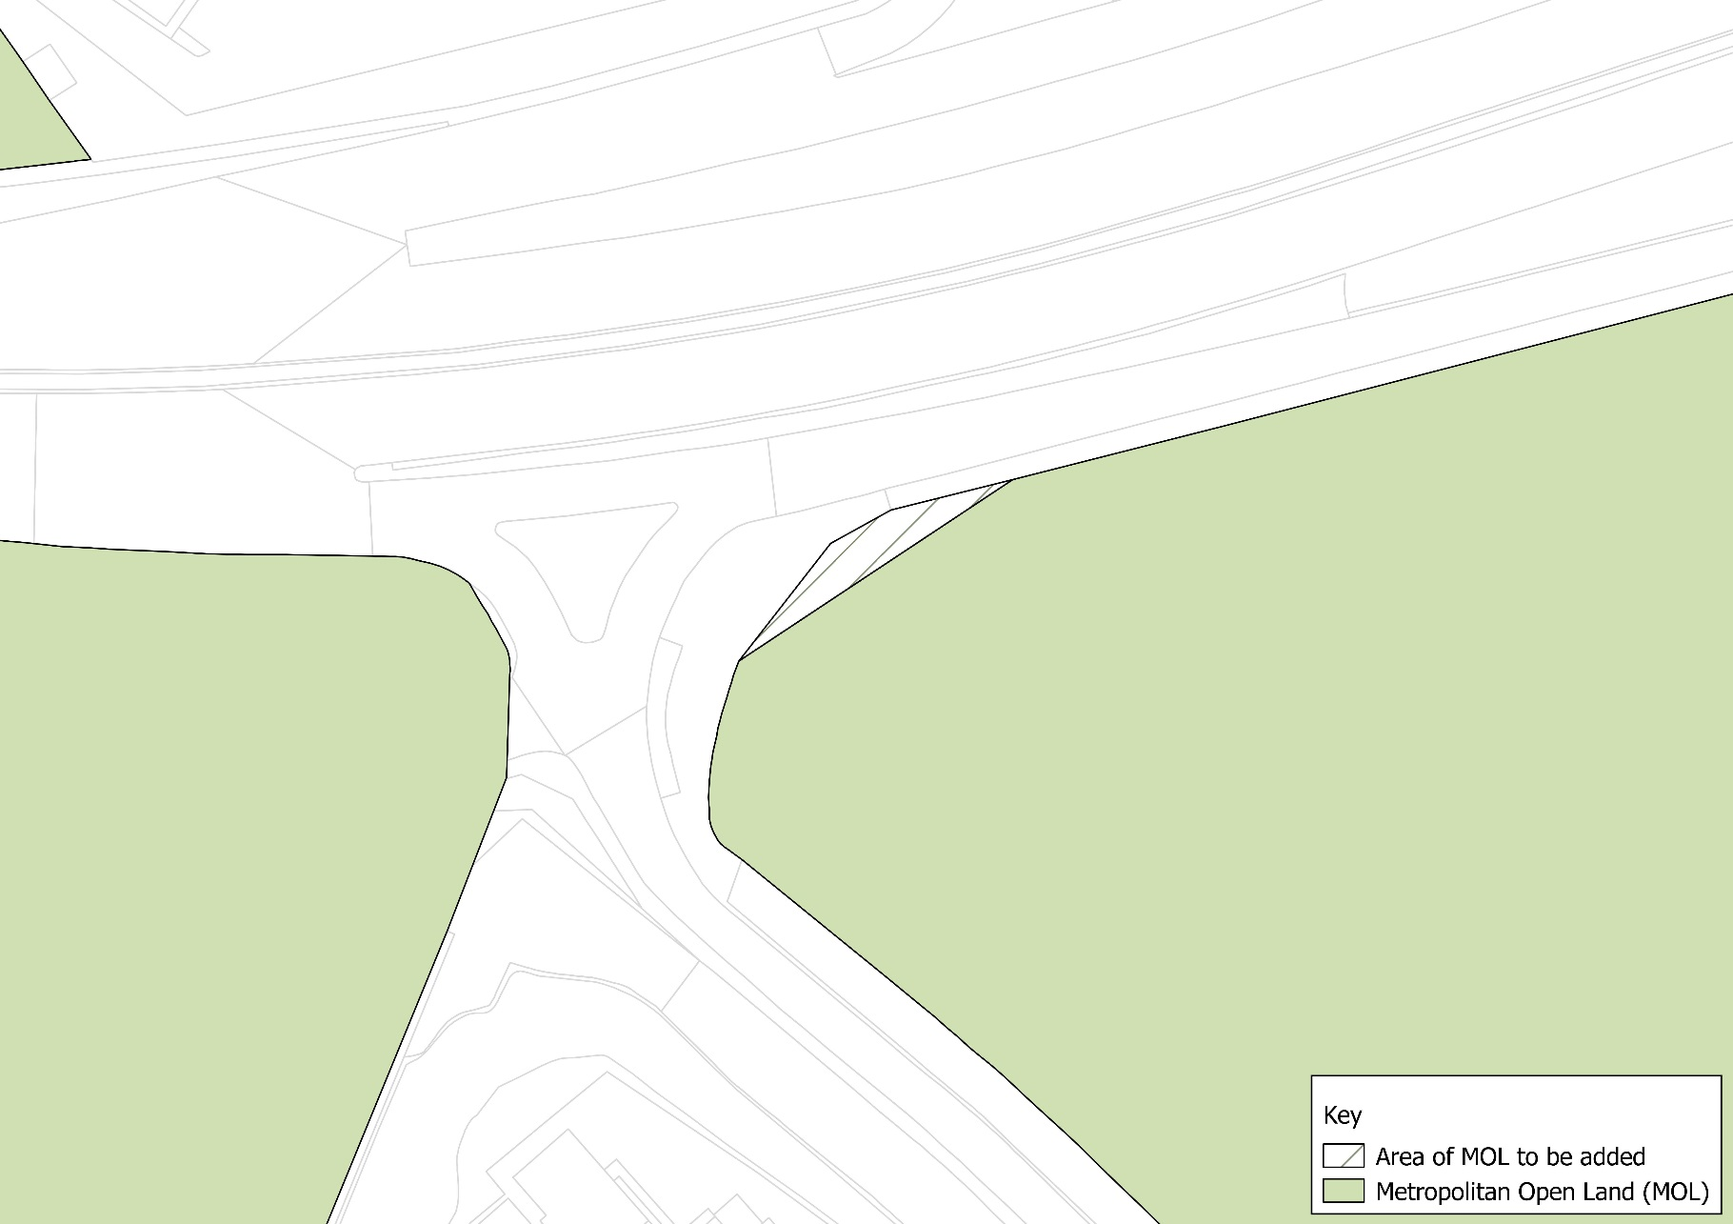
Justification for change:
Realigns to the road boundary and creates a more defensible edge to the MOL.

N

Not to scale

Map 34 – Glebelands and Coppetts Woods (1)
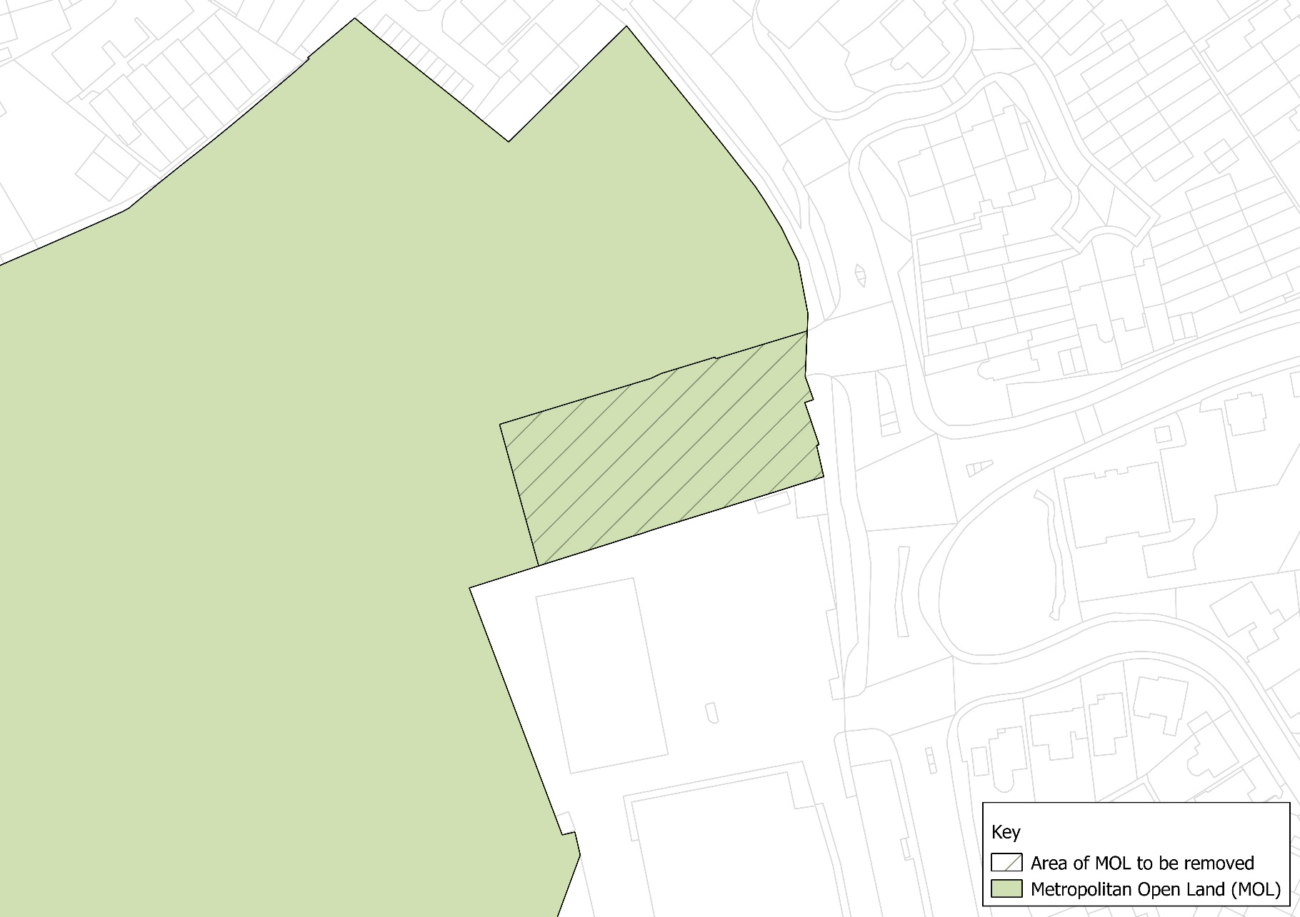
Justification for change:
Aligns to the edge of Coppetts Wood creating a strong defensible boundary.

N

Not to scale

Map 35 - Glebelands and Coppetts Woods (2)
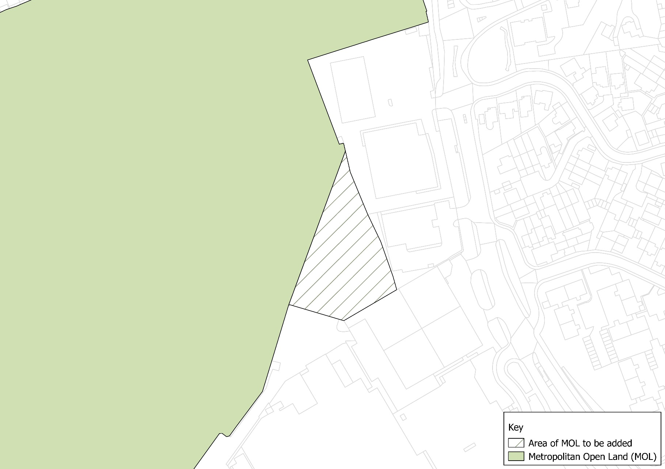
Justification for change:
Aligns to the edge of Coppetts Wood creating a strong defensible boundary.

N

Not to scale

Map 36 - Glebelands and Coppetts Woods (3)
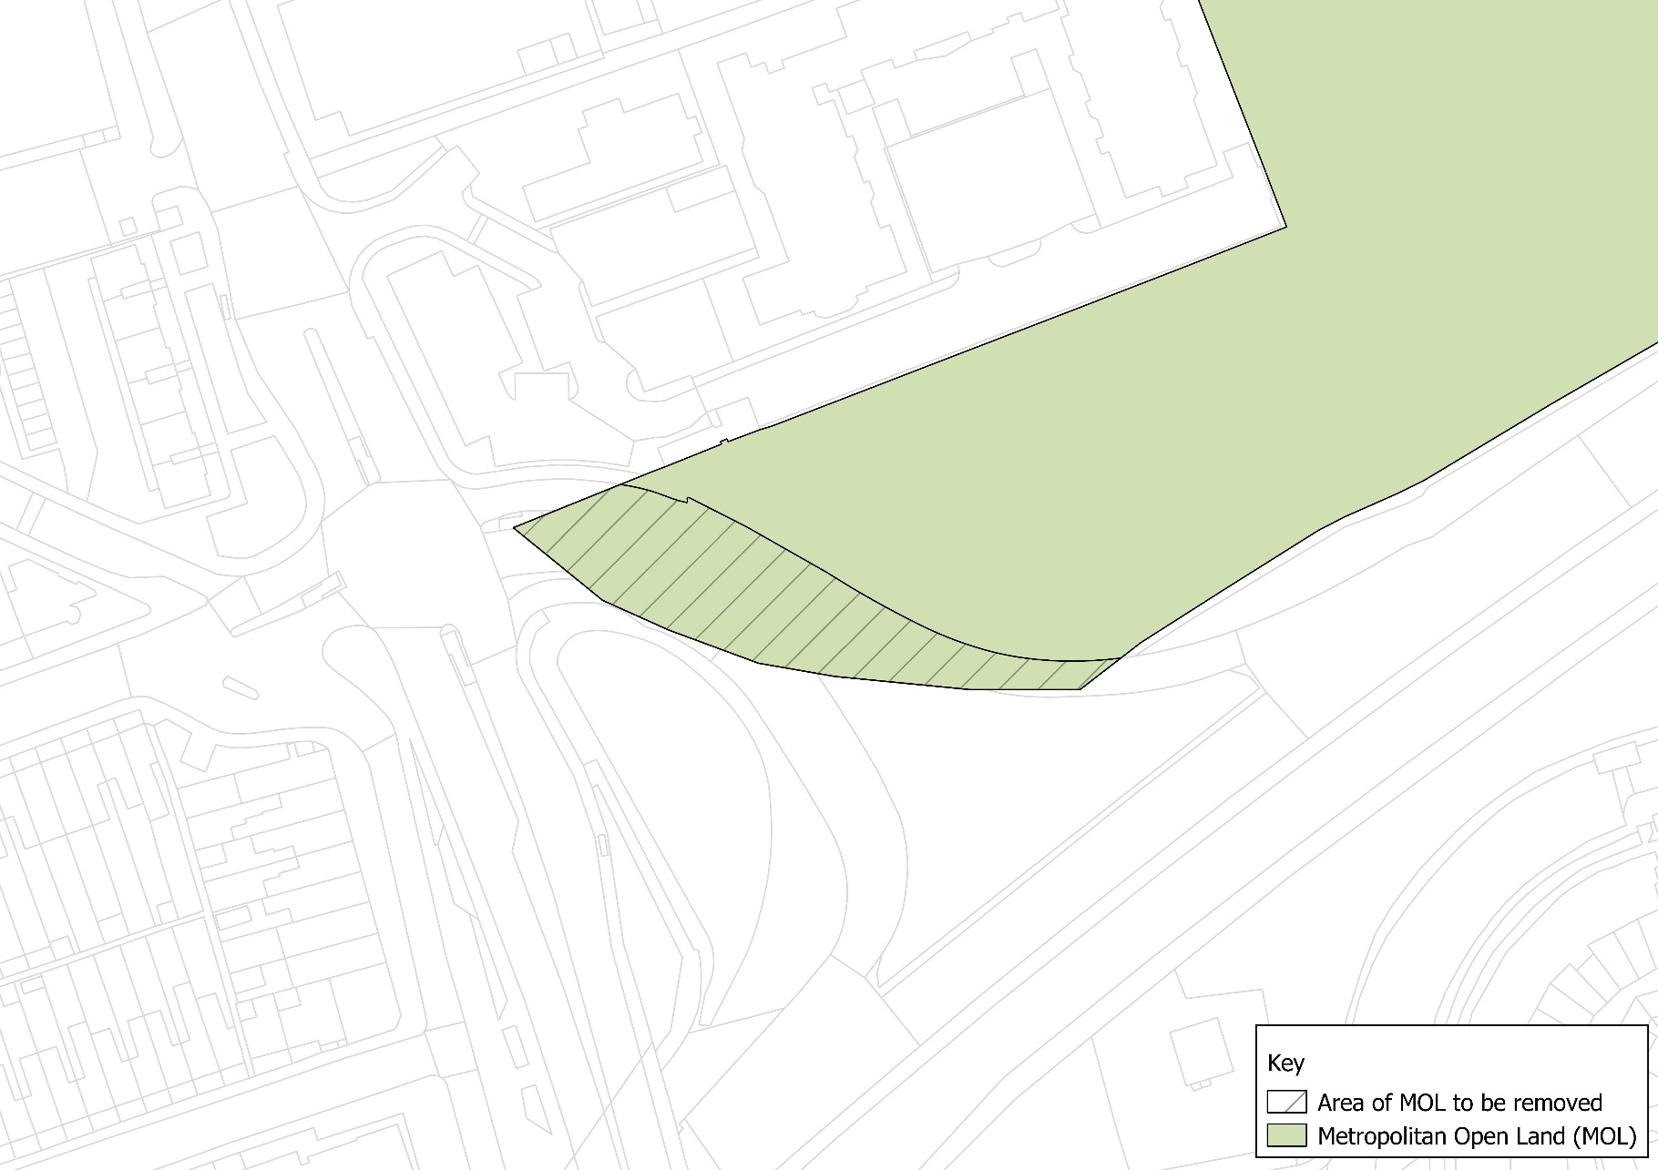
Justification for change:
Realigns to the road boundary of the Glebelands Local Nature Reserve creating a strong defensible boundary.

N

Not to scale

Map 37 - Mutton Brook
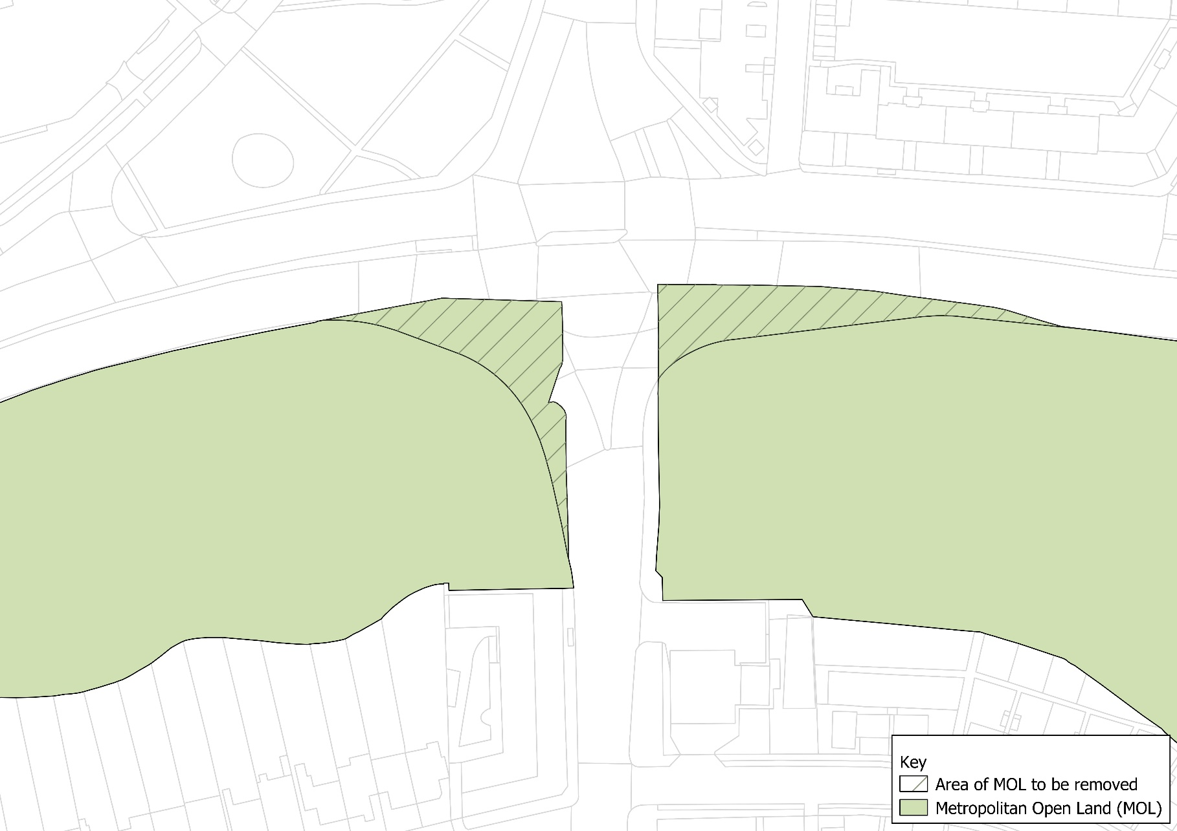
Not to scale
N
Justification for change:
The two areas concerned are part of the widening and improvement of the intersection between the North Circular and Finchley Road. The regularisation of the boundary to follow the amended boundary of the roadway will create a stronger and more defensible boundary.

Map 38 – Sunny Hill Park
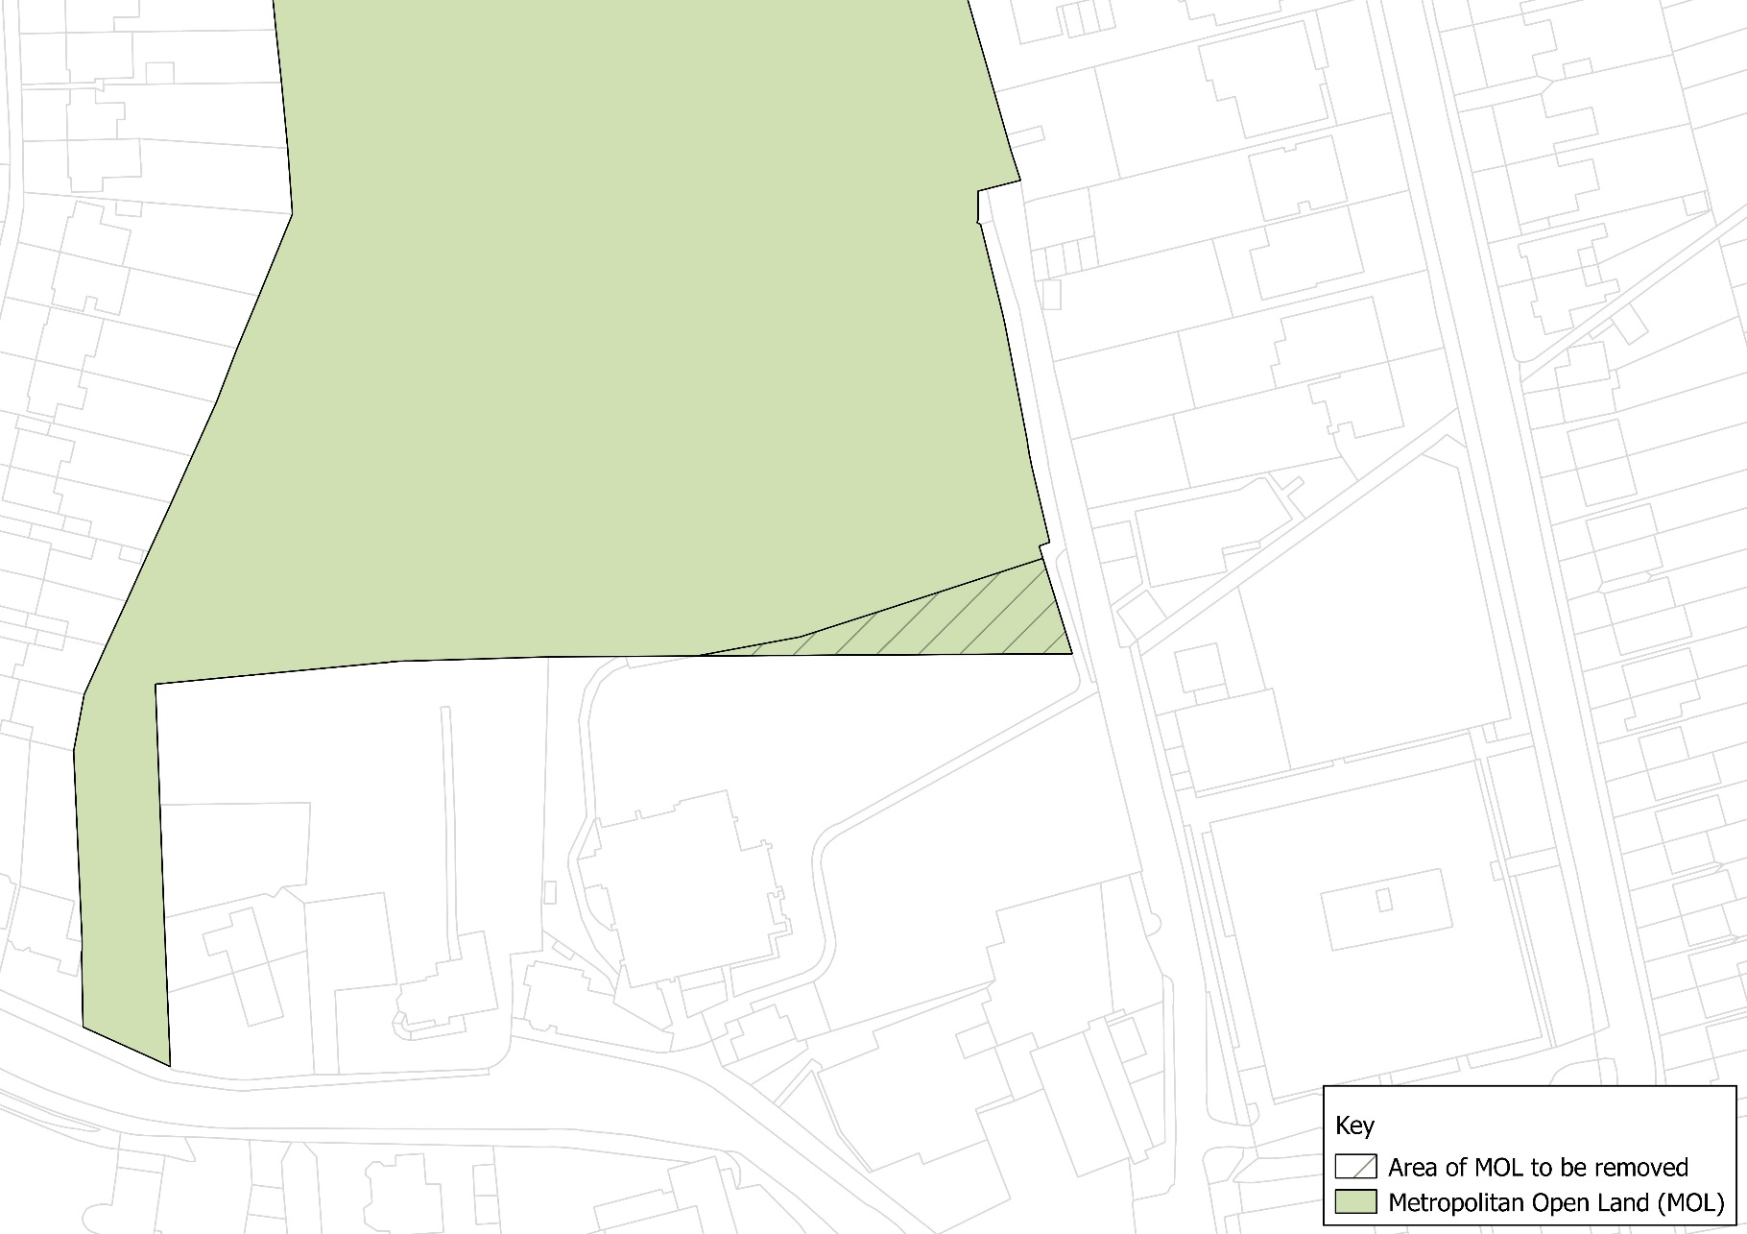
N
Justification for change:
Creates a more rational and therefore stronger boundary.

Not to scale

Map 39 – Hoop Lane and West London Synagogue Cemeteries
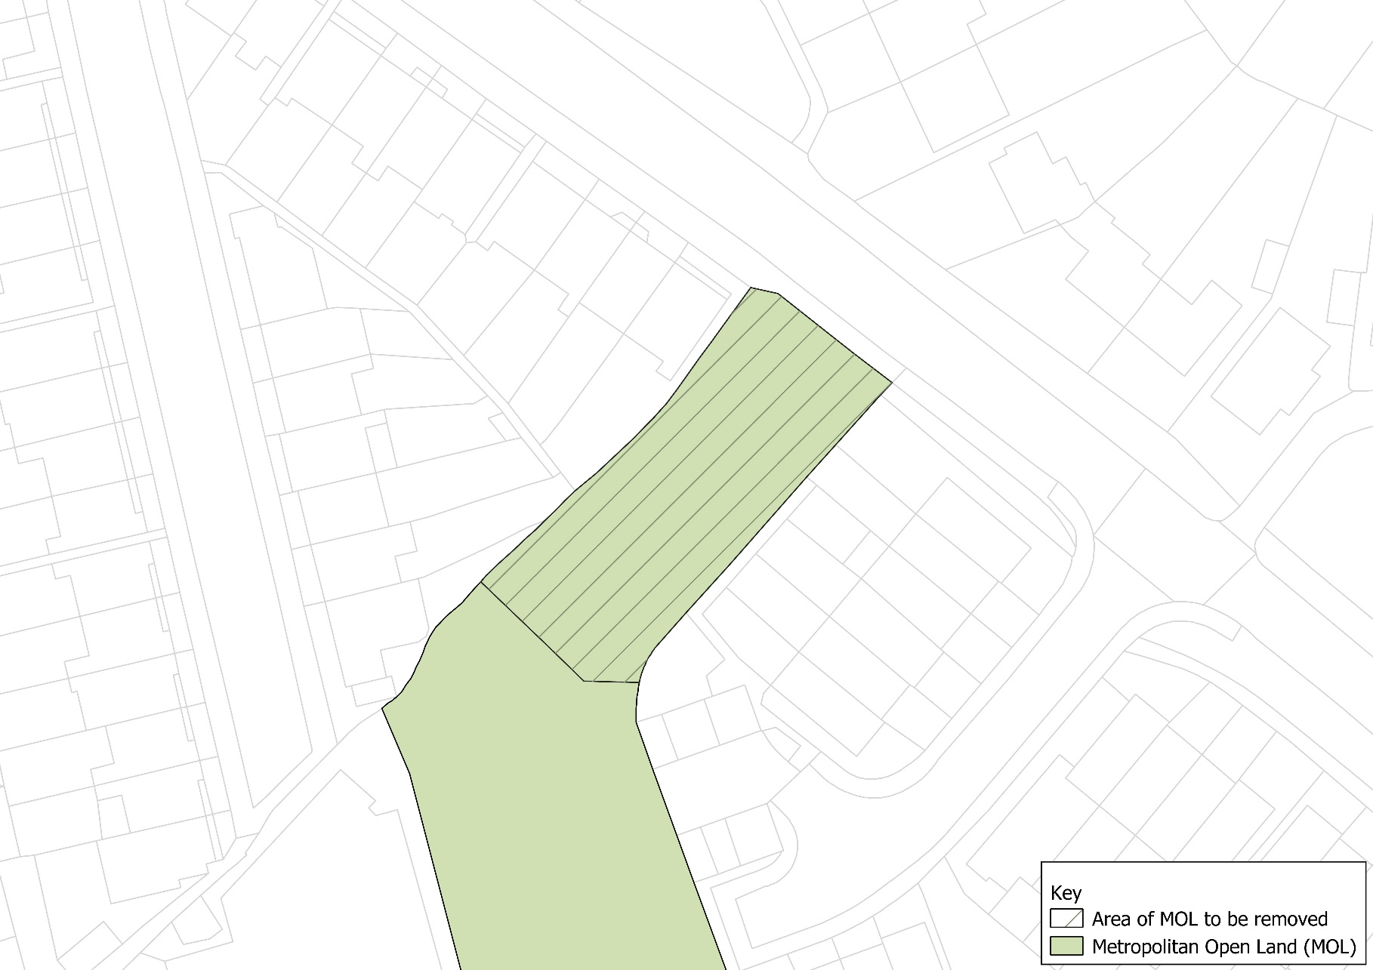
Justification for change:
Removal will result in a strong and more defensible MOL boundary.

N

Not to scale

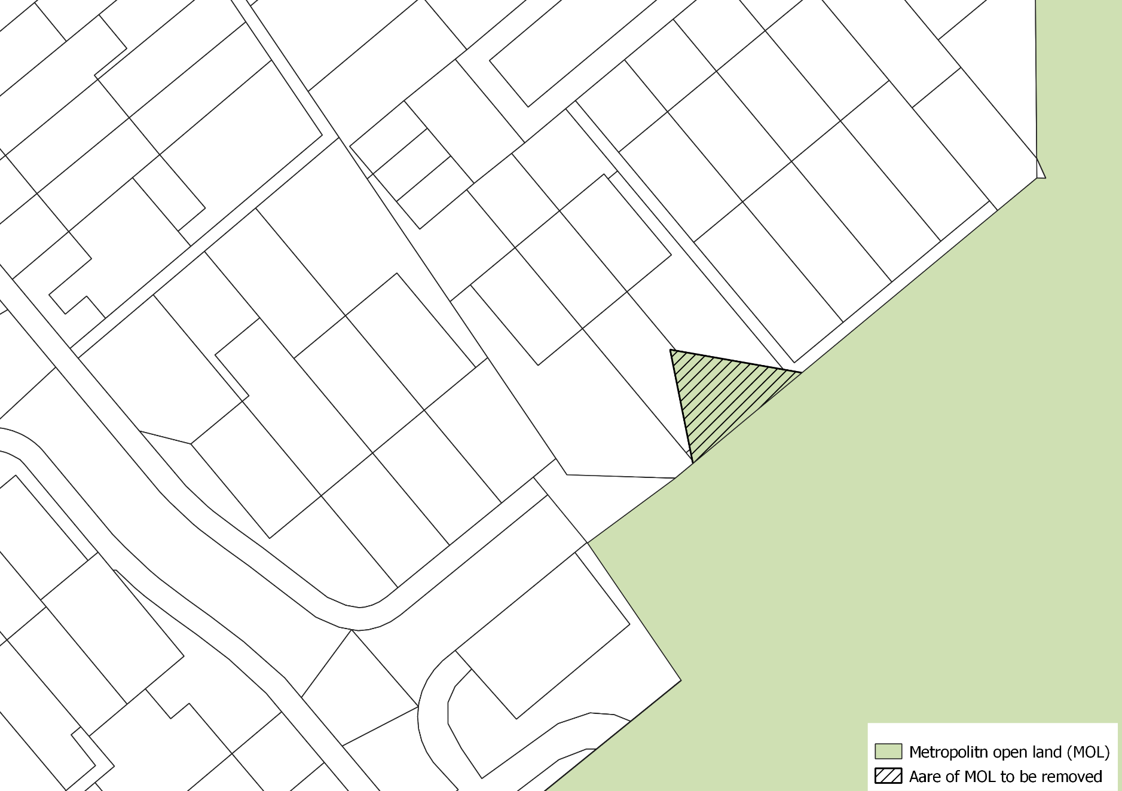
Map 40 - Friern Barnet Retail Park Open Space (6)
Not to scale
N
Justification for change:
Realigns the boundary to the edge of the open space and provides a more defensible boundary.

Locally Significant Industrial Sites (LSIS)

Revisions to existing LSIS boundaries together with new designations at Bittacy Hill, Coppetts Centre, Falkland Road (Alston Works), Hurricane Industrial Park and Propeller Way and de-designation of Grenville Place are set out in Maps 40-49.

Map 41 Connaught Business Centre
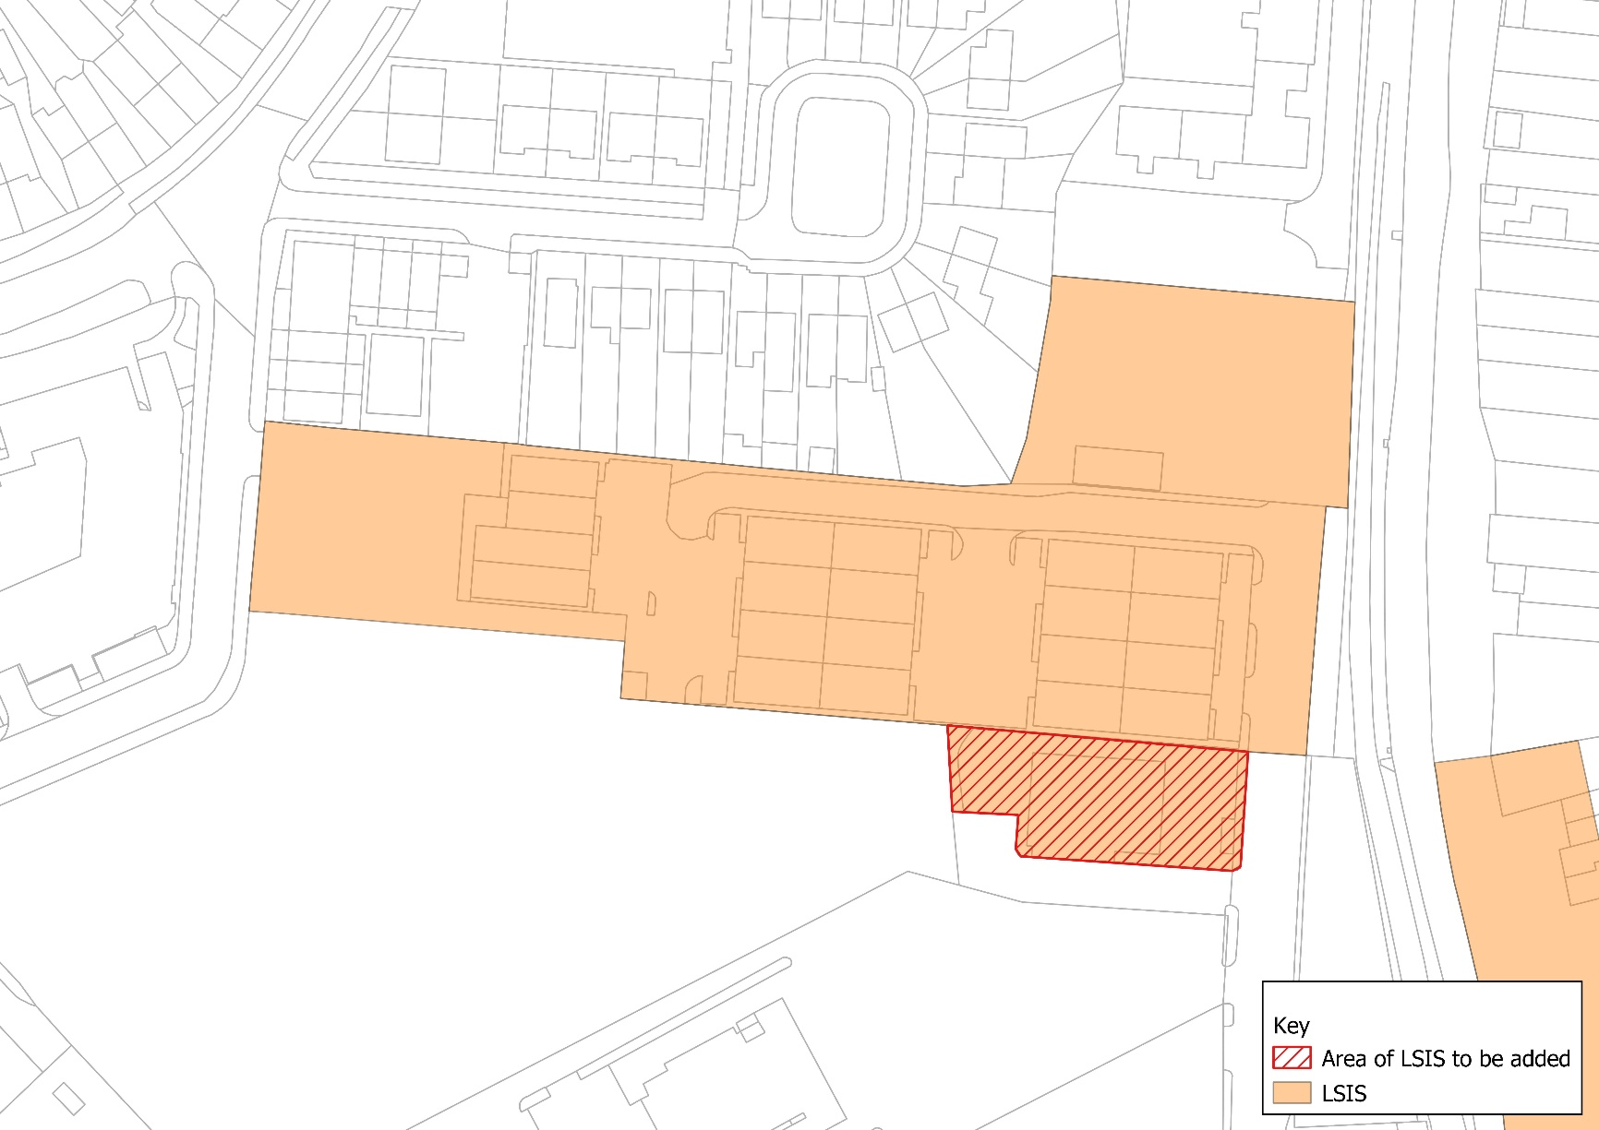
Justification for change:
Well utilised site offering a range of light industrial uses. Expanded to include the small site adjoining the main business centre.

N

Not to scale

Map 42 Granard Business Centre
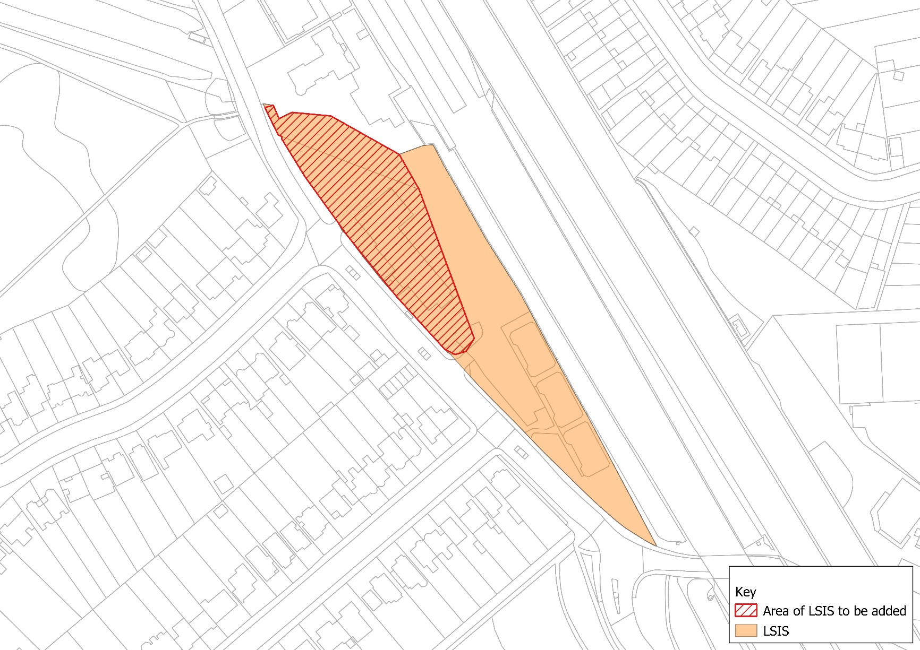
Justification for change:
The site has been expanded to include Churchill House which is a serviced office adjoining the wider Business Centre which is well occupied.

N

Not to scale

Map 43 Lancaster Road Industrial Estate
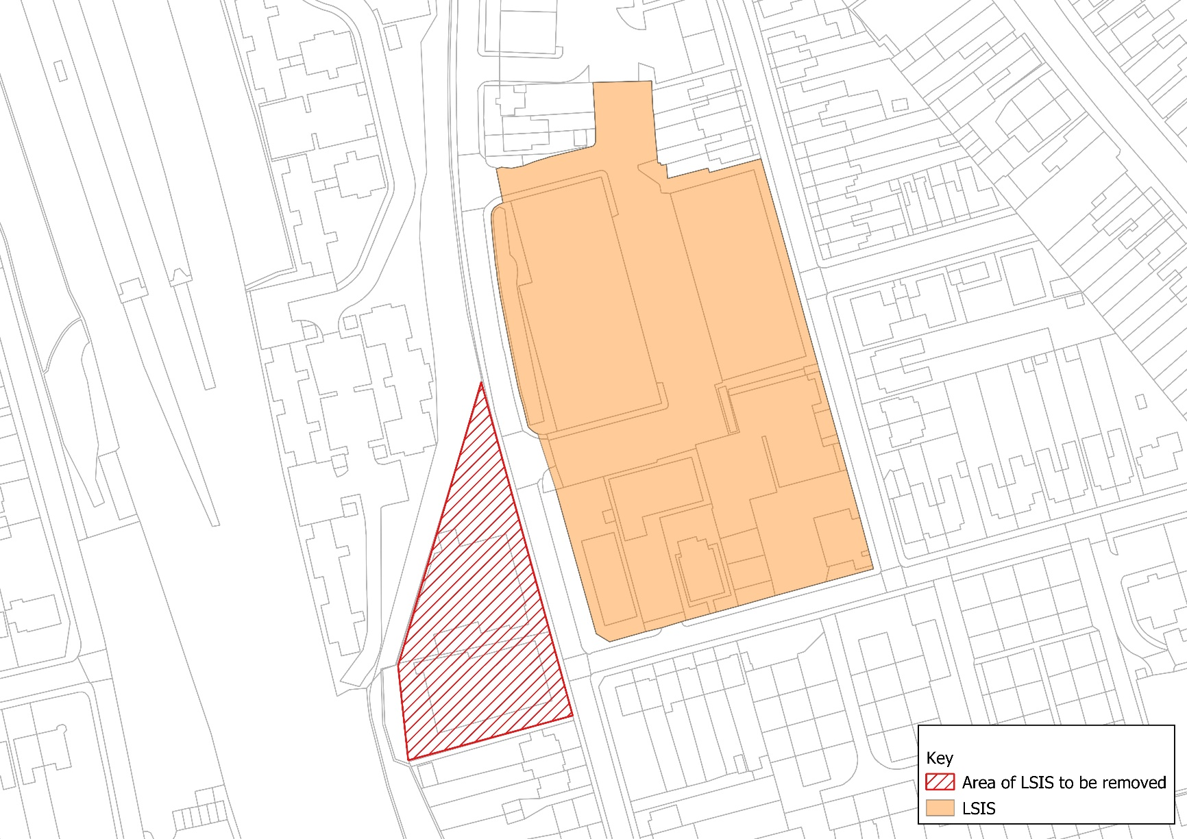
Justification for change:
The site is well occupied and provides needed services to the area. However the area of the site has decreased due to non employment uses becoming predominant on this portion that has been removed.

N

Not to scale

Map 44 Grenville Place – De-designation of LSIS
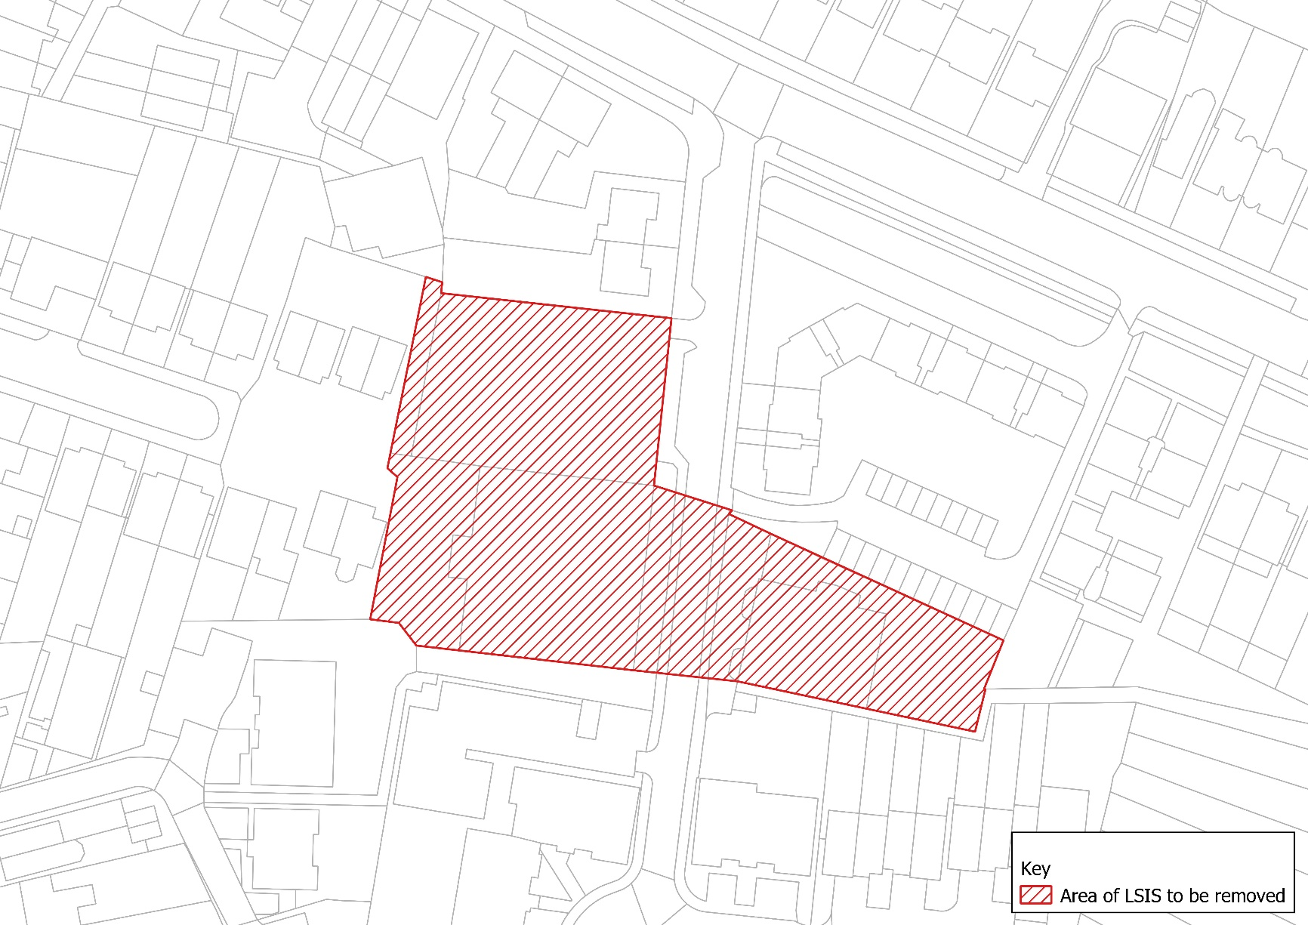
Justification for change:
This site consisted of two small office buildings in a predominately residential area one of which (Trafalgar House) has been converted into residential using PDR and now referred to as the Loft Apartments. The other still spears to be operating as B1a use; however, given the relatively small size of the property and the predominance of residential in the area it does not warrant continued protection

Map 45 Coppetts Centre, Colney Hatch Lane – New LSIS
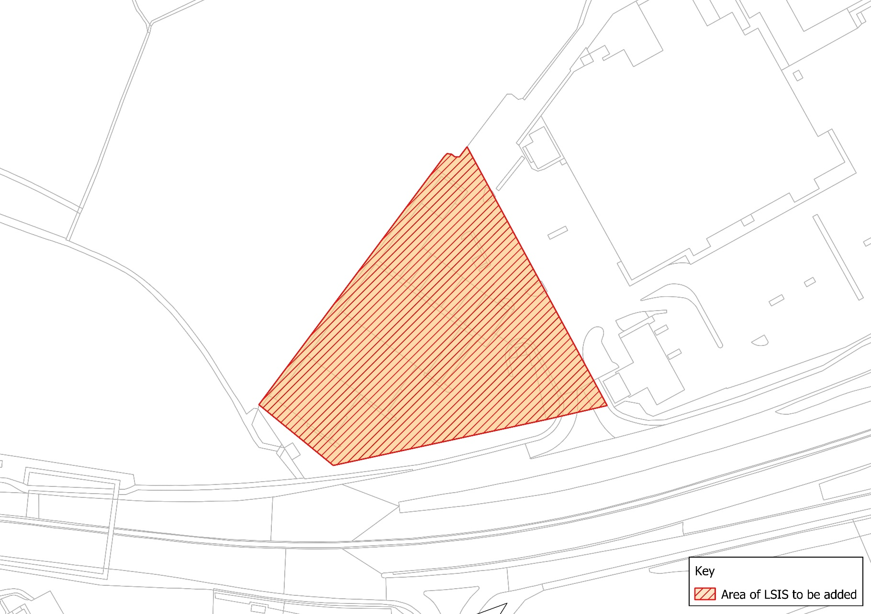
Justification for change:
The site is well functioning and provides a distribution and self storage area.

N

Not to scale

Map 46 Propeller Way – New LSIS
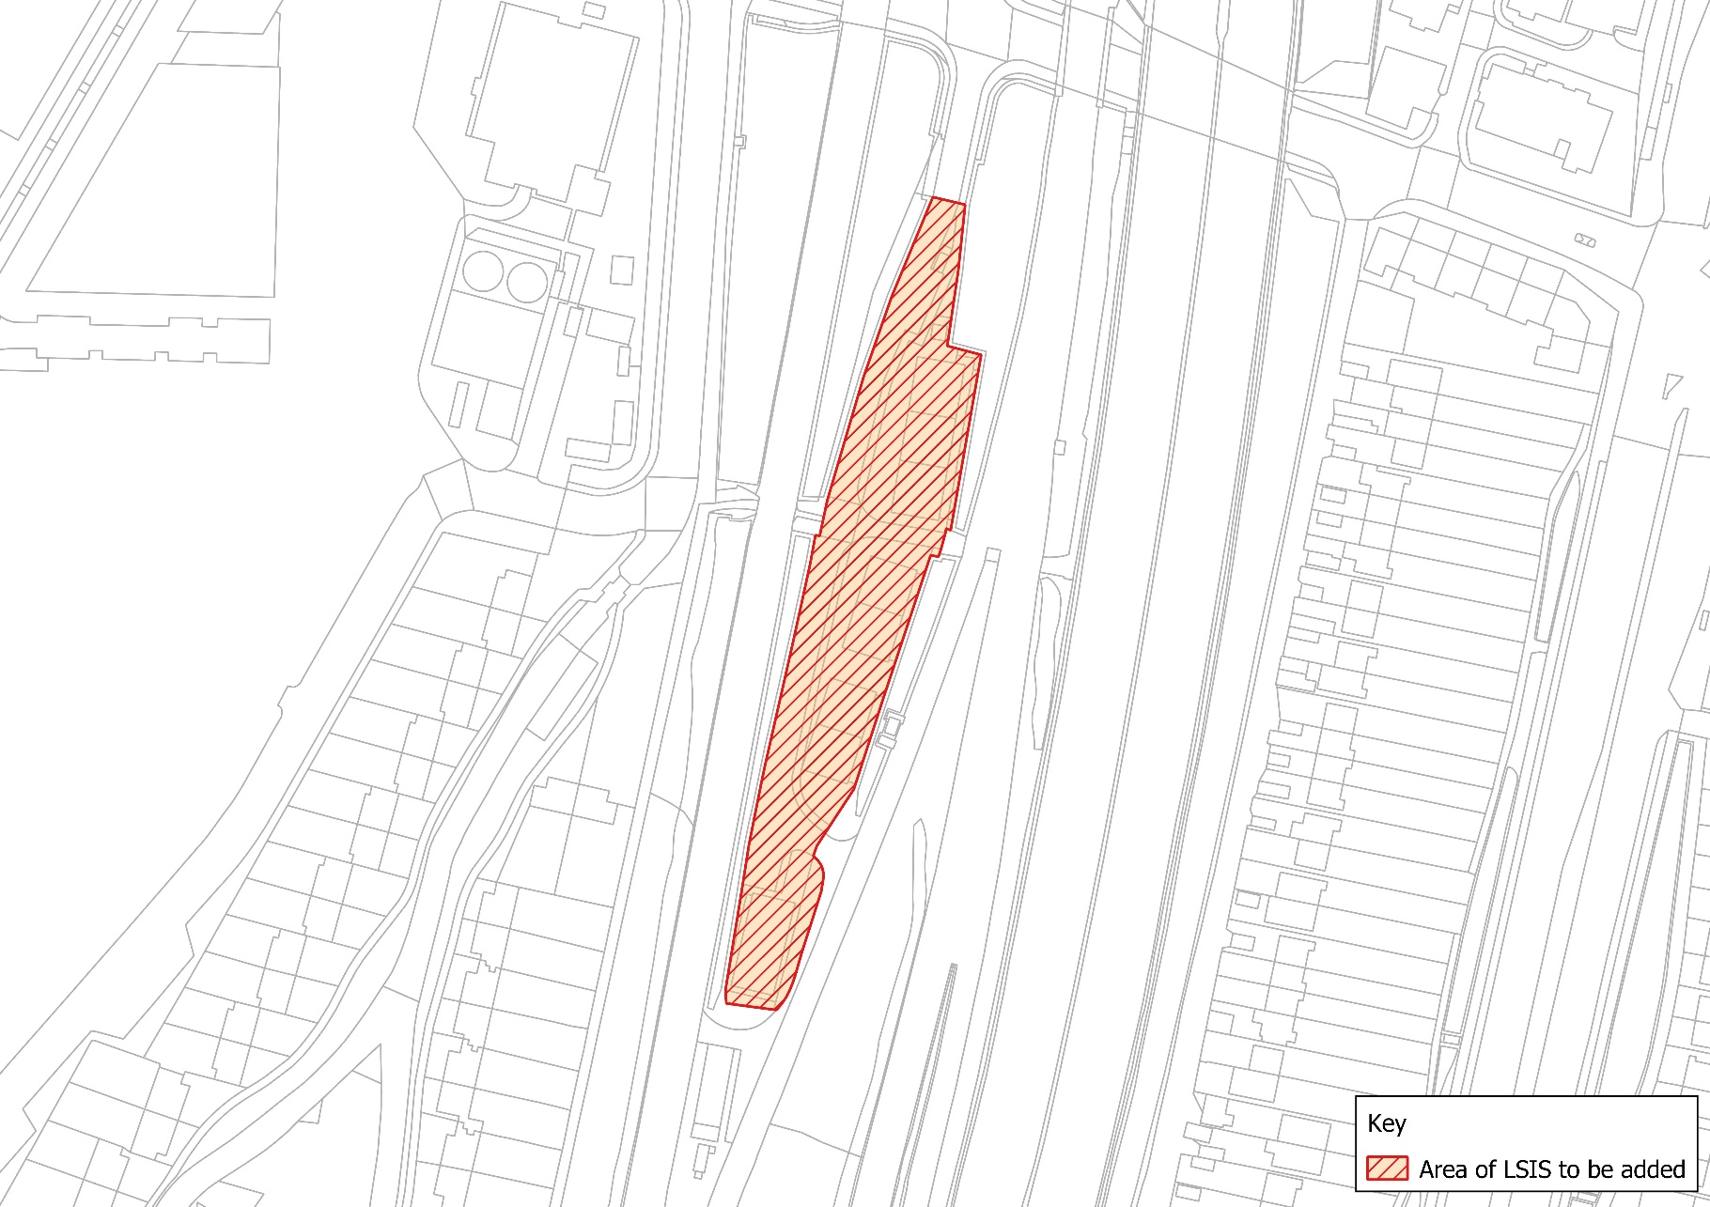
Justification for change:
Identified in the Barnet Employment Land Review as a modern industrial site with a reasonable level of occupancy.

N

Not to scale

Map 47 Hurricane Industrial Park – New LSIS
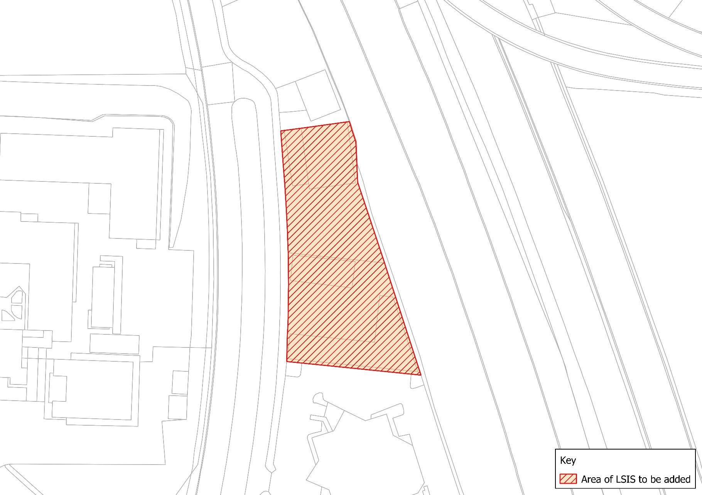
Justification for change:
Identified in the Barnet Employment Land Review as a small but well utilised site.

N

Not to scale

Map 48 Bittacy Hill Business Centre – New LSIS
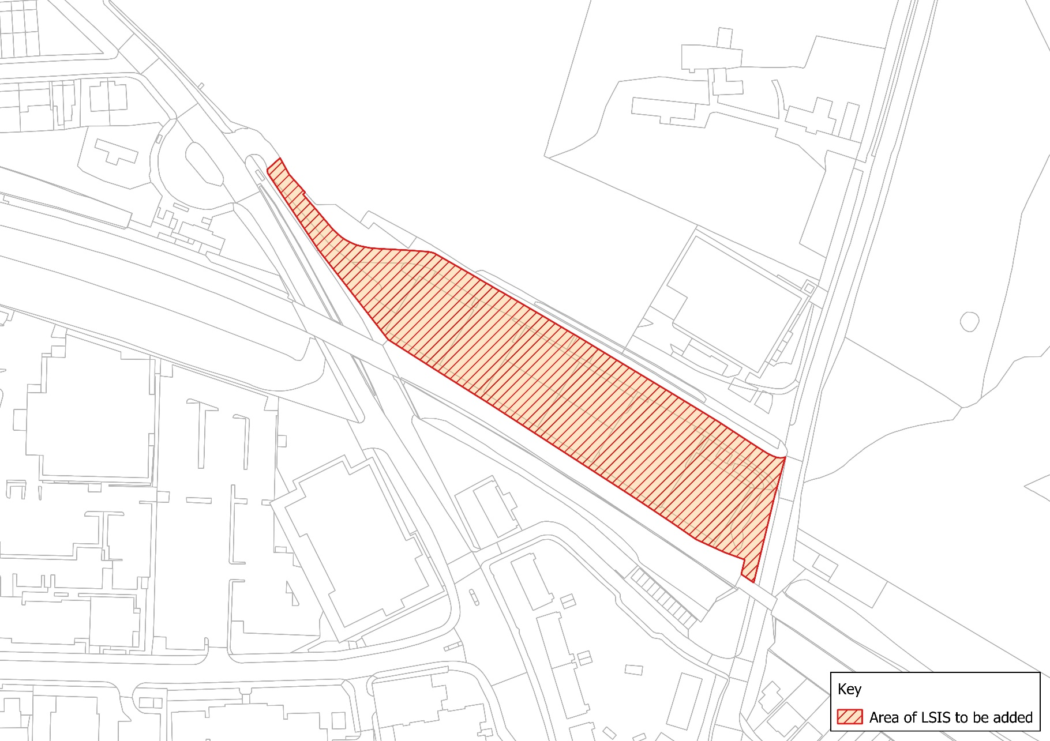
Justification for change:
Identified in the Barnet Employment Land Review as a small but well utilised site.

N

Not to scale

Map 49 Falkland Road (Alston Works) New LSIS
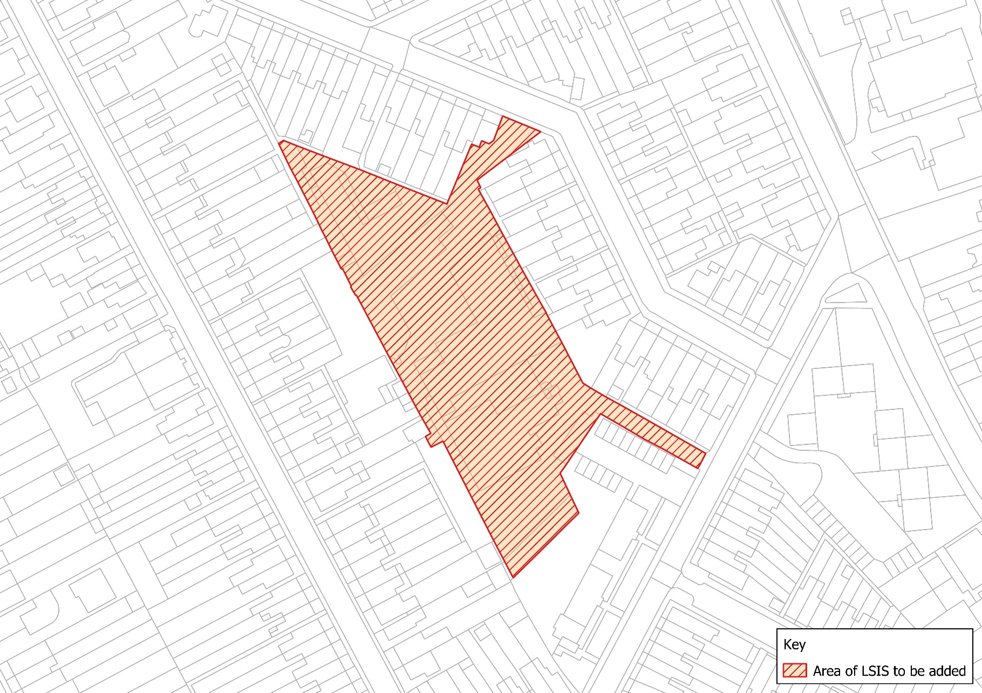
Justification for change:
Identified in Barnet Employment Land Review 2017 as a well utilised industrial site.

N

Not to scale

Business Locations

New Business Location areas at Colindale Technology Park (including sites off Cecil Road) together with 30-100 Colindeep Lane are set out in Maps 50-51.

Map 50 Colindale Technology Park and sites off Cecil Road - New Business Location
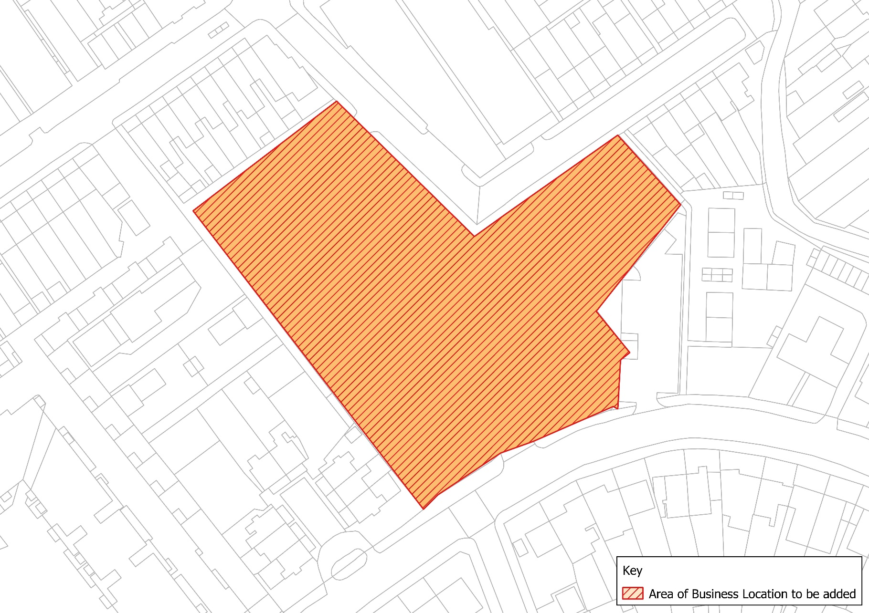
Justification for change:
Identified in the Barnet Employment Land Review as a well utilised business park. The sites on Cecil Road provide important local light industrial services.

N

Not to scale

Map 51 30-100 Colindeep Lane – New Business Location
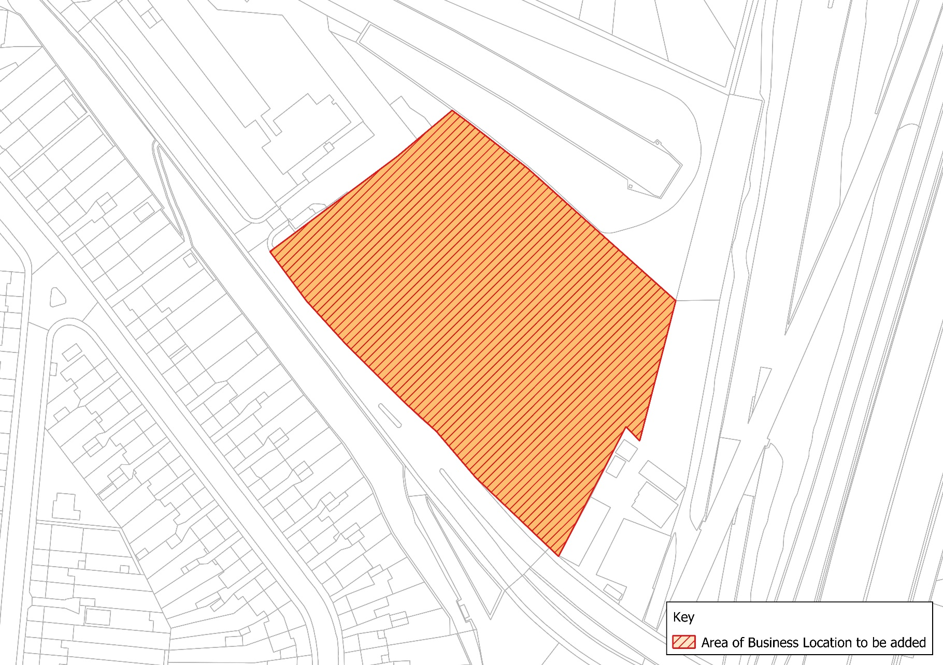
Justification for change:
Identified in the Barnet Employment Land Review as a well utilised area in employment use a range of uses with a predominance of light industrial a warehousing uses.

N

Not to scale

'Notifiable Installations'

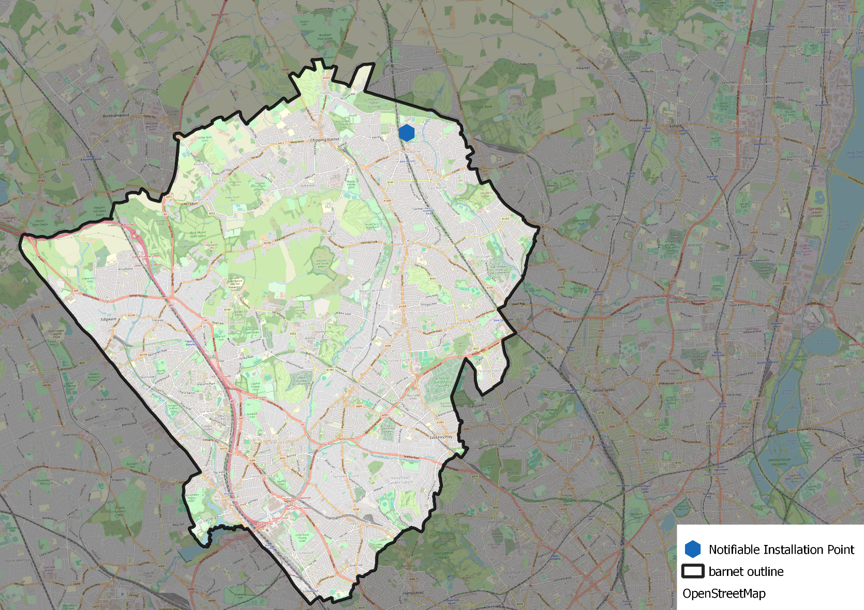
Map 52 Notifiable Installations
Not to scale
N

